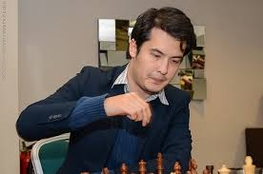
David Howell vs Ivan Saric (Gibraltar 2018):
Can you find White's best move?
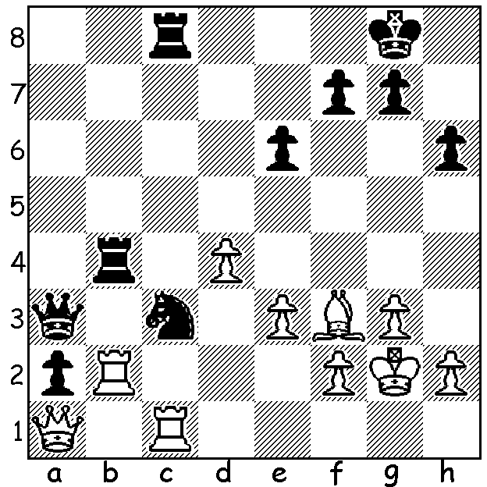

David Howell

Last week you read about the Tradewise Gibraltar Open
with 276 entries (not 150 as reported last week) which
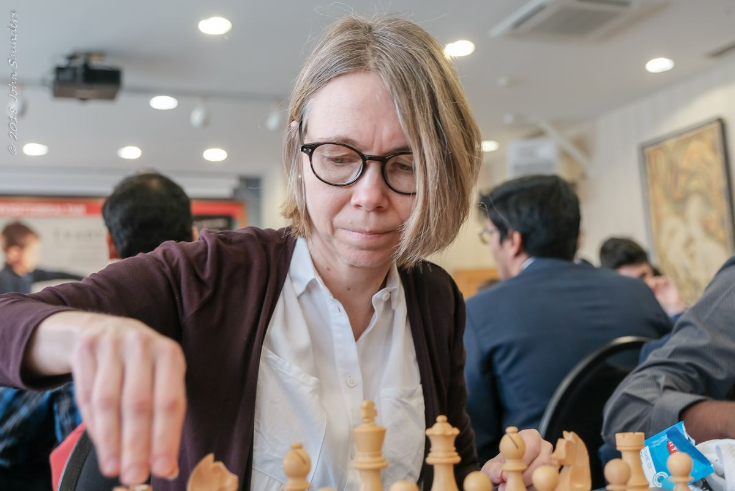
resulted in a play-off involving Hikaru Nakamura,
Maxime Vachier-Lagrave, Levon Aronian and Richard
Rapport. Nakamura's hopes of a fourth successive title
were dashed by a 1.5-2.5 loss to MVL, some revenge for
MVL who lost to Nakamura in the 2016 play-off. The
Game 3 loss was Hikaru's only loss in Gibraltar in the past
four years. Levon Aronian defeated Richard Rapport in the
other semi-final and then accounted for MVL by 2.5-1.5,
taking home first prize of £25,000. Winner of the Women's first prize was Swedish veteran 54 year old Pia Cramling
with a score of 6.5/10, one point behind the top places. Pia Cramling
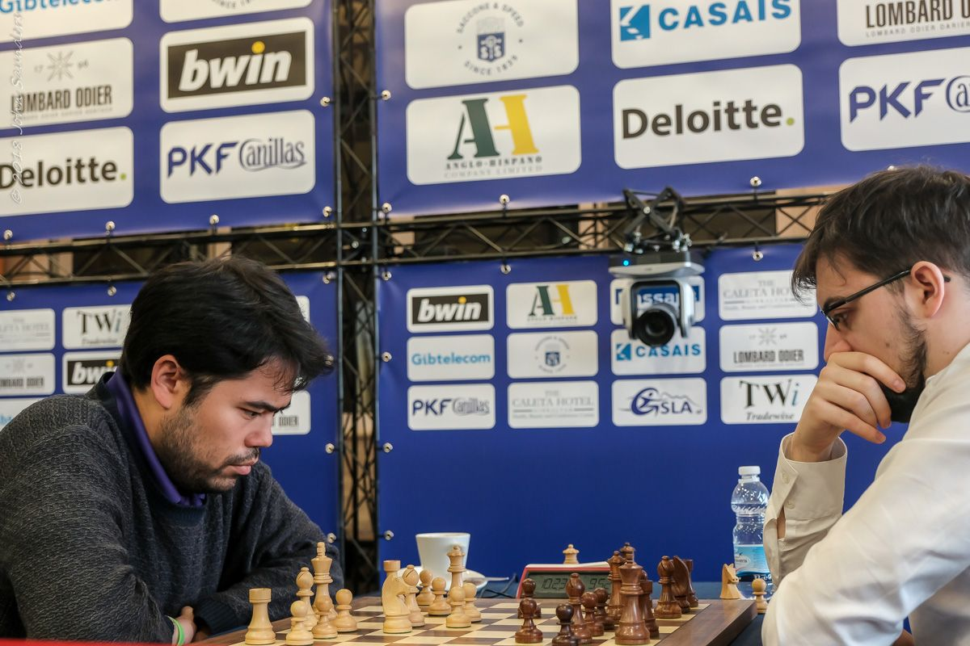
After two draws at 10 min + 5 sec MVL won Game 3
(3 min + 2 sec) before holding the final game in a wild
struggle:

Hikaru Nakamura vs Maxime Vachier-Lagrave
2018 Gibraltar Open, Semi Play-Off, Game 4
Grunfeld Exchange
1.d4 Nf6 2.c4 g6
3.Nc3 d5 4.cxd Nxd5
5.e4 Nxc3 6.bxc3 Bg7 Nakamura v MVL
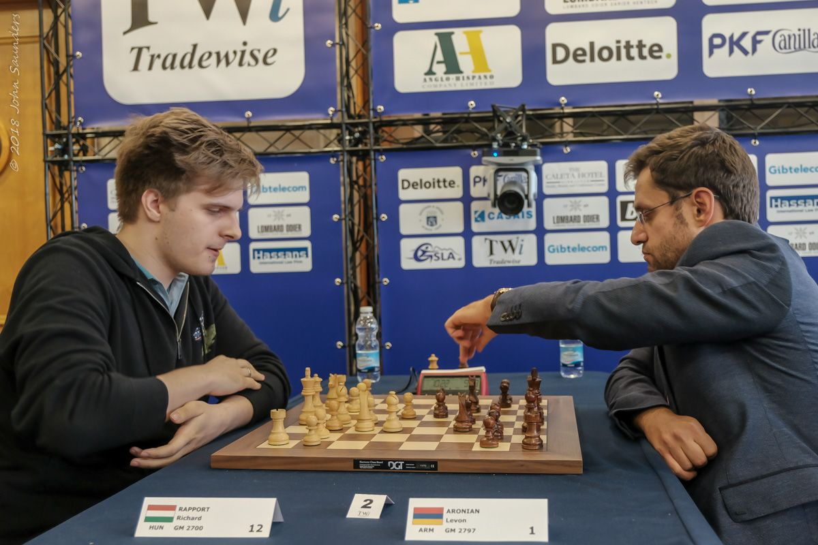
7.Qa4+ Qd7 8.Qb3 0-0
9.Be3 c5 10.d5 b5
11.Bxc5(a) Qc7 12.Bd4 Bxd4
13.cxd4 Qa5+ 14.Kd1 Bd7
15.Bd3 Rc8 16.Ne2 Na6
17.Rc1 Nb4 18.Bb1 Rc4!
19.Rxc4 bxc4 20.Qc3(b) Rb8
21.Kd2 Qa6(c) 22.a3 Nxd5
23.exd5 Rb3 24.Qc1 Qa5+
25.Nc3 Qb6 26.Ne2 Rb2+
27.Ke3 Rb3+ 28.Nc3 Qa5 Rapport v Aronian
29.Kd2 Qb6 30.Ke2 Qxd 431.Nd1 Bb5
32.Bc2 c3+ 33.Kf3 Qxd5+ 34.Kg3 Qd6+
35.f4 Rxa3 36.Ne3 e5 37.f5 e4+
38.Kh3 Bd7? 39.Rd1 Qf4 40.Rf1?(d) Qh6+
41.Kg3 Ra5 42.Nc4 Qxc1 43.Rxc1 Rc5
44.Ne3 gxf 45.Ra1 a5 46.Kf4 Kg7
47.Ra3 Be6 48.Nd1 Rd5 49.Rxc3 Rd2
50.Kg3 f4+ 51.Kxf4 Rxg2 52.Rg3+(e) Rxg3
53.hxg3 f5 54.Ne3 Kf6 55.Ba4 Bc8
56.Nd5+ Kf7 57.Ne3 Kf6 58.Nc4 Be6
59.Nxa5 e3!(f) 60.Bb5 Bd5 61.Be2 Kg6
62.Bd3 Be4 63.Bc4 h5 64.Nb3 h4
65.g4 h3! Draw

a) Not 11.Bxb5? Bxc3+! 12.Kd1/e2 Qg4+.
b) Not 20.Qxc4? Rc8.
c) Leaving the knight trapped but obtaining a dangerous attack.
d) With seconds on his clock White plays to safeguard his king. However 40.Rxd7 wins with all Black's efforts (40...Ra5, Ra6, Ra1, gxf, g5, Qh6+) doomed – eg 40...Qh6+ 41.Kg6 Ra1 42.Rd8+ Kg7 43.f6+! Kxf6 44.Ng4+.
e) Avoiding the possibility of a drawn K, B & wrong RP v K.
f) Deflection offer – 60.Kxe3 Kg5 61.Bd1 h5/h4.

SOLUTION: 1.Rxa2! Qxa2 2.Qxa2 Nxa2 3.Rxc8+ & White won the endgame.

