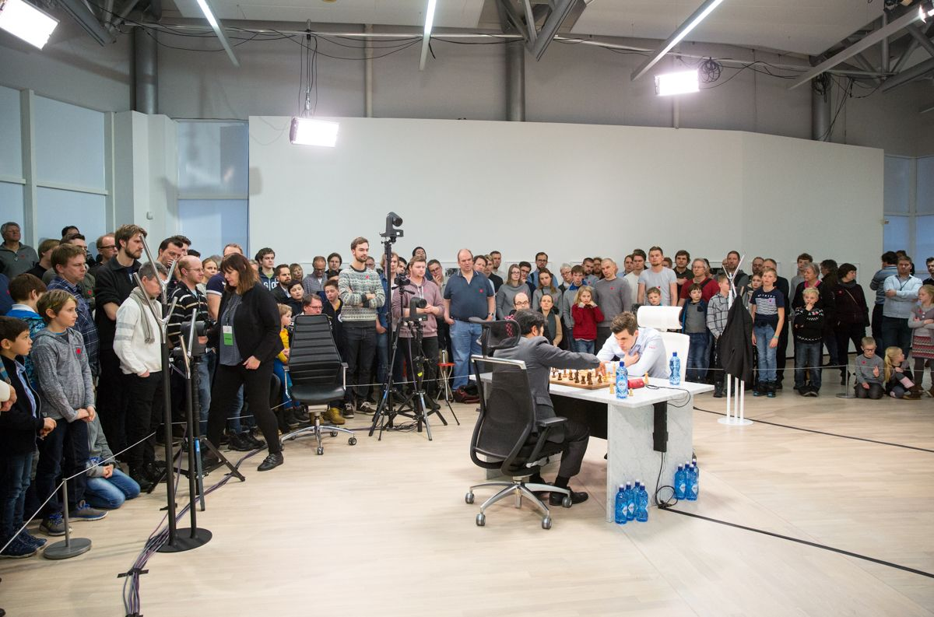
Carlsen vs Nakamura (Chess 960):
White to play and win (3 moves):

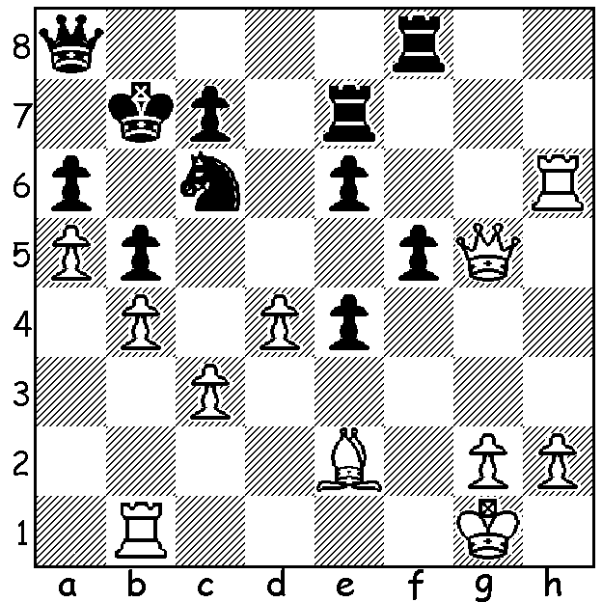
Today's column is about a form of chess many will not even have heard of, much less played. It's played with the pieces rearranged randomly at the starting position and is known as Fischer Random Chess (White and Black identical as in regular chess). A match was recently played in Norway between Norwegian world champion Magnus Carlsen and American Hikaru Nakamura named '960 Chess' (960 refers to all the possible starting positions). For four days they played two games a day alternating colours with the same position with a time limit of 45 min for 40 moves, then 15 min (no increment) with a win counting 2 pts. On the final day they played another 8 games with time limit of 10 min + 5 sec increment with wins gaining 1pt. The positions became fairly standard as players can castle as usual (in one game, with kings on f1/f8 and rooks on g1/g8 the game began 1.0-0 0-0).The match was fully televised live in Norway and finished with Carlsen winning 14-10 and earning over US$114,000 while Nakamura took away over US$76,000. The games often went many moves with one going 138 moves with Carlsen losing on time with K, R & B v K & R (he could have claimed a draw). Here's a game from the event with Carlsen possibly not realising his opponent could castle on move 20:

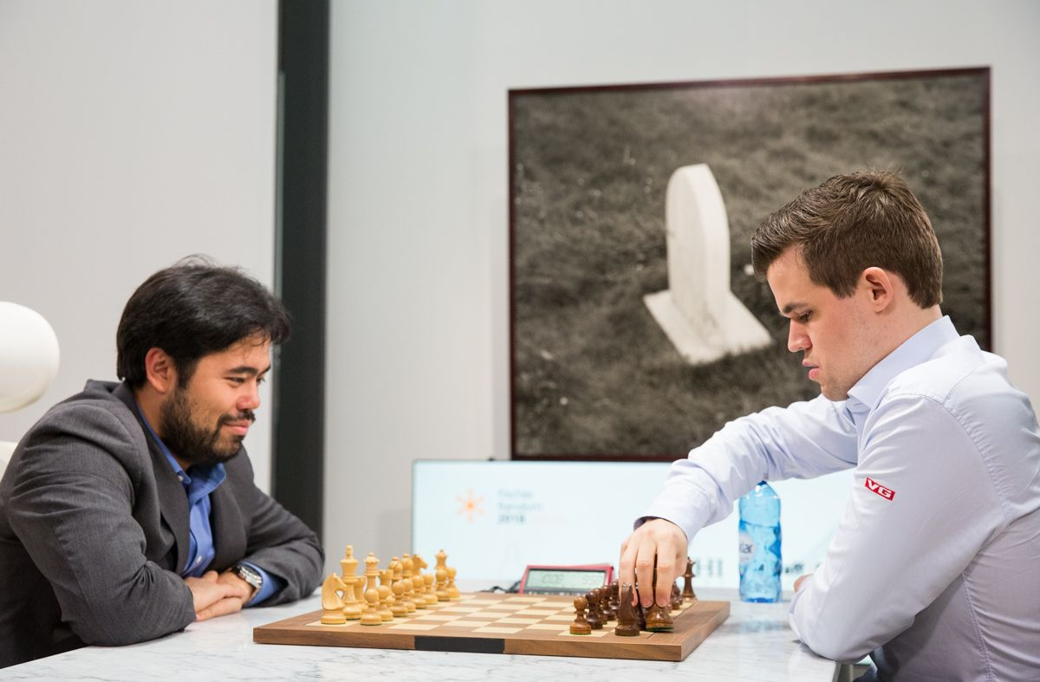
Hikaru Nakamura vs Magnus Carlsen
960 Chess, Game 15 (Blitz)
Starting position:
RKBBQRNN
1.e4 e5 2.Ng3 Nf6
3.d4 d6 4.f4 exd
5.Nf3 c5 6.e5 dxe
7.fxe Nd5 8.Ne4 Be7
9.e6 Bxe6 10.Qg3+ Kc8
11.Be2 Ng6 12.Nfg5 Qc6
13.Nxh7 Rd8 14.Nhg5 Bxg5
15.Nxg5 Qc7 16.Qa3 c4 Carlsen replies to 1.0-0 with 1...0-0.
17.Nxe6 fxe6 18.Bg4 Rd6
19.Bg5 c3 20.0-0! cxb 21.Qxb2 Ne3
22.Bxe3 dxe3 23.Rae1 a5 24.Rxe3 Raa6
25.Bh5 Ne7 26.Qxg7 Kb8 27.Rb3 Rac6
28.Bf3 Nd5 29.Qxc7+ Kxc7 30.Be4 Rd7
31.h4 Rc4 32.Re1 b6 33.h5 a4
34.Rf3 Nc3 35.Bd3 Rh4 36.Bg6 Nxa2
37.Ra1 Nb4 38.Rxa4 Rd1+ 39.Rf1 Rd2
40.Ra3 Nd5 41.Raf3 b5 42.R3f2 Rdd4
43.g3 Rhg4 44.Kh2 Rg5 45.Rf7+ Kd6
46.Kh3 Ne3 47.R1f3 Nf5 48.Rh7 Rdg4
49.Bxf5 exf5 50.h6 Rh5+ 51.Kg2 Rg6
52.Ra3 Kc5 (52...Rxh6 53.Rxh6 Rxh6 54.Ra6+)
53.Rf3 Rgxh6 54.Rxh6 Rxh6 55.Rxf5+ Kc4
56.g4 b4 57.Kg3 Rc6 58.Kh4 Kc3
59.Rf4 Ra6 60.g5 Ra2 61.g6 Ra7
62.Kh5 Rb7 63.Rf2 Re7 64.Rg2 resigns

SOLUTION: 1.d5! (deflection) 1...exd 2.Rxc6! (destroying the guard) and if 2...Kxc6 3.Qxe7.

