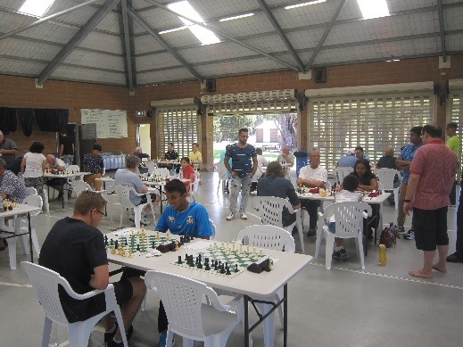
Bone 1850: White to play and win (3 moves):
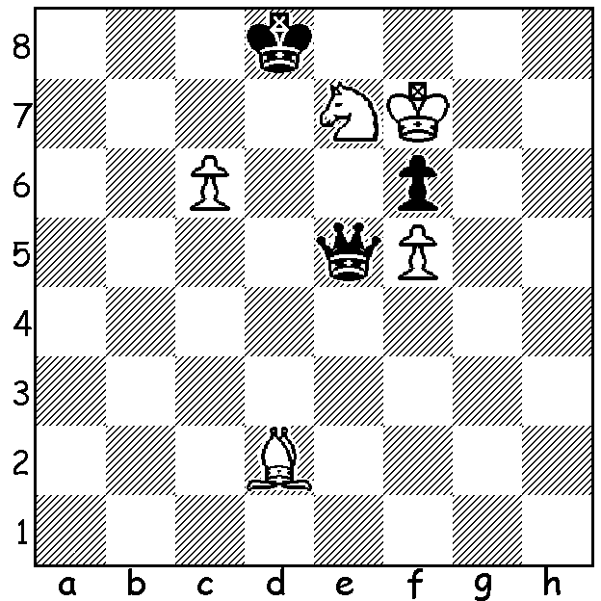
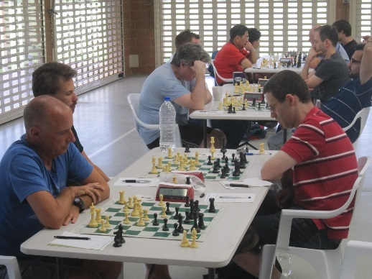
The first WA Grand Prix event of 2018, the
Perth Open (38 players), was played late last
month at Leeming Primary with a number of
WA's leading players participating as well as
two strong players from Germany and some
of the state's most promising juniors. Joint
winners were Ihsan Ferozkohi and WA's top
junior FM Patrick Gong (5/6) with our top
rated player FM Tristan Boyd, Derwent Maggs
and Jens Mueller (Germany) =3rd on 4.5. Leo
Padva also from Germany with 4.5 was 1st in 1st (top) and final round of Perth Open
the Under 2000 division with WFM Kathryn (pictures by Alan Wolstencroft)
Hardegen and Craig Kinsman close behind on 4.
Albany's Gary Donaldson (4/6) won the Under 1700 division and Ari Petridis, Riley Stolk &
Angus Wylie (all 3/6) were the Under 1000 and Unrated winners.

The game this week highlights the skills of 2017 WA Grand Prix overall winner Andrew Hardegen who withstands a fierce attack on his king before winning with a counterattack:

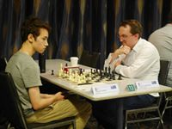
Robert Maris vs Andrew Hardegen
2017 West Australian Championship, Rd 3
Slav Defence, Chebanenko Variation (4…a6)
1.d4 d5 2.c4 c6
3.Nf3 Nf6 4.Nc3 a6
5.a4 e6 6.Qc2 Nbd7(a)
7.e4 dxe 8.Nxe4 Nxe4
9.Qxe4 Bb4+ 10.Bd2 Qa5
11.Qc2 0-0 12.Bd3 e5!?(b)
13.Bxh7+ Kh8 14.0-0-0 Nf6
15.Bxb4(c) Qxb4 16.Ng5(d) exd!
17.h4(e) g6! 18.Bxg6(f) fxg6 Andrew Hardegen (Black)
19.h5(g) Qc5! 20.hxg6+ Kg7
21.f4 Bf5 22.Qb3 b5 23.Nh7(h) Nxh7
24.Rxh7+ Kf6 25.g4(i) Bxg4(j) 26.Rg1 Bf5
27.Rh6 Rh8! 28.Rxh8 Rxh8 29.g7 Rg8
30.Qg3(k) Qxc4+ 31.Kd2 Qc2+ 32.Ke1 Re8+
White resigns

a) An alternative is 6…dxc – 7.e4 (7.e3 is more circumspect) 7…b5! 8.axb cxb 9.Nxb5 axb5! 10.Rxa8 Bb7 11.Ra1 Bxe4 12.Qd1 Bb4+ 13.Bd2 Bxf3 14.gxf3 Nd5 15.Bg2 Qg5 with a big advantage to Black.
b) To increase pressure Black bravely sacrifices a pawn and exposes his king
c) 15.Bf5 Bxd2+ 16.Rxd2 exd 17.Nxe4 Re8 18.Bxc8 Raxc8 and the two weakened castled positions provide chances for both sides.
d) An appealing move but Black is able to beat off the attack.
e) Not 17.Rxd4? Qc5.
f) If 18.h5 Bf5 19.Rd3 Rae8 20.hxg Re1+21.Rxe1 Bxd3 22.Qd2 Qxc4+ 23.Kd1 Qxa4+ 24.Kc1 Qa1#.
g) If 19.Qxg6 Qxc4+ 20.Kd2 (20.Kb1 Qg8) 20…Bf5!! 21.Qxf5 d3! 22.Rc1 Qb4+ 23.Kd1 Qb3+ 24.Ke1 Qxb2 wins.
h) If 22.Rd3 or 22.Qe2 Rae8.
i) 25.Kxg6? loses to 25.Qg3+ Kxh7 26.Rh1+
j) The right pawn to capture – 24…Bxg6 25.g5+ Ke6 27.f5+ Rxf5 28.Re1+ Kd6 29.Qg3+ Re5 30.Rxe5 Qxc4+ (30.Qxe5? Rd7+ wins) 31.Kd2 Bxh7 32.Rxb5+ and the ensuing king hunt will at the least win the queen.
k) This loses quickly but a piece down White cannot enter the ending with 30.Kd2 Qxc4 31.Qxc4 bxc4.

Forthcoming Events (check details for both events on cawa.org.au)
WA ALLEGRO CHAMPIONSHIP (Rapidplay) Sunday 18 March at Leemimg Primary (9 rounds, 15min + 2sec).
SW OPEN 24 & 25 March in Mt Barker.

SOLUTION: 1.c7+! Kxc7 2.Bf4! Qxf4 3.Nd5+ or 1...Qxc7 2.Ba5! Qxa5 3.Nc6+.

