Another endgame composition:
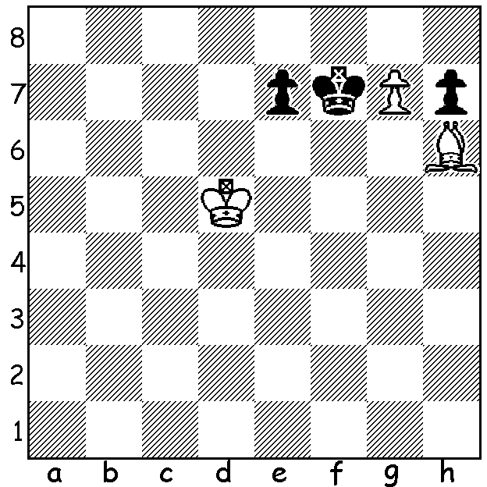
White to play and mate in 4 moves:

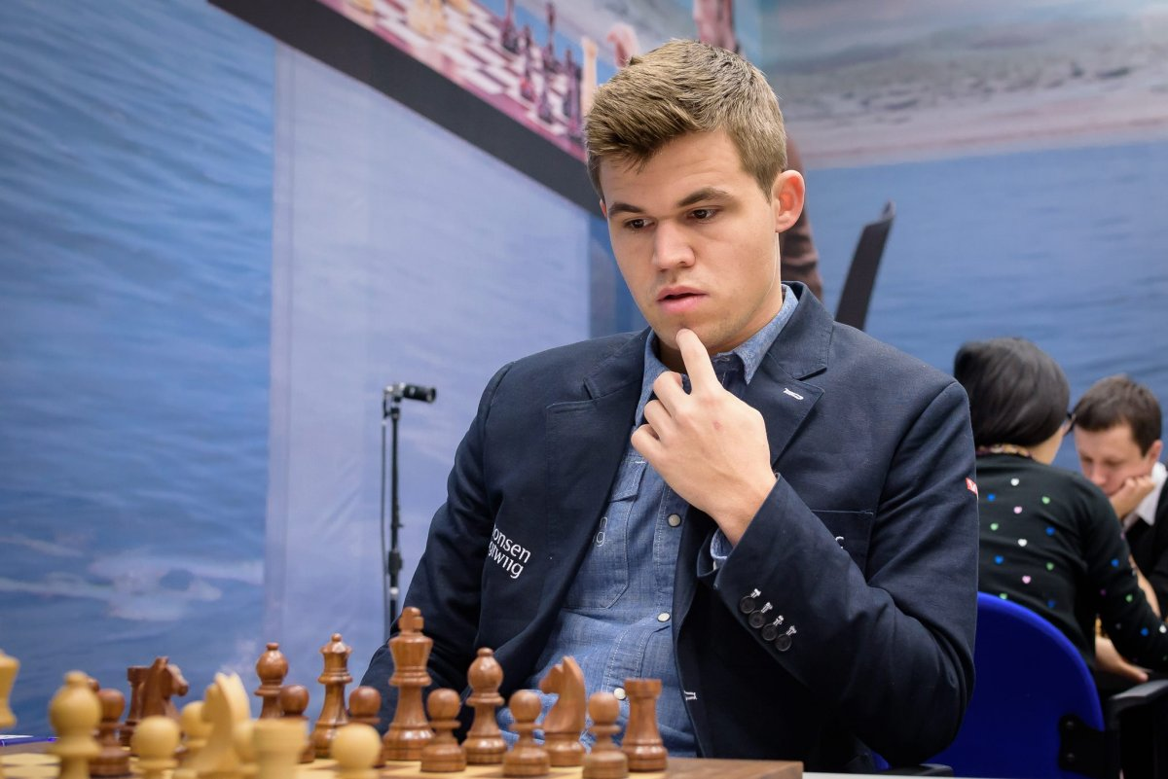

Magnus Carlsen

After his victory over Hikaru Nakamura in the 960 Chess, world champion Magnus Carlsen was then off to play in the American Pro Chess League. The league comprises groups of 8 teams in 4 regional divisions. A team has between 8 and 16 players with 4 playing in a match with each player playing all four players in the opposing team with a time limit of 15 mins + 2 seconds. For each match one free agent is allowed with the other 3 being local players and the average team rating being under 2500. The top 4 teams in each region qualify for the KO final stage. Playing for the Norway Gnomes against the Delhi Dynamite Magnus had a very varied day. In game 1 he played Durkins Attack (1.Na3) losing the exchange early but rallying and mating after his opponent went pawn grabbing. In Game 3 he played the original Hippopotamus Opening with the game going 1.f3 e5 2.Nh3 d5 3.Nf2 Nf6 4.g3 Bc5 5.Bg2 Bxf2+! Carlen's king became completely exposed with no pawn cover but he nearly succeeded in holding the game. Game 4 saw him at his best with another oddball opening, scoring a brilliant win using a David Smerdon line.

Vaibhav Suri vs Magnus Carlsen
2018 Pro Chess League
Scandinavian Defence
1.e4 d5 2.exd Nf6 3.d4 Bg4
4.f3 Bf5 5.c4 e6 6.dxe Nc6
7.exf+? Kxf7 8.Be3 Bb4+ 9.Kf2 Re8
10.Nc3 Rxe3!(a) 11.Kxe3 Nxd4!(b) 12.Kf2(c) Bc5
13.Na4 Bc2 14.Nxc5 Bxd1 15.Rxd1 Qe7
16.b4 Re8 17.Bd3 Qe3+ 18.Kf1 b6
19.Ne4 Nxe4 20.Bxe4 c5 21.bxc5 Rxe4
22.fxe4 Qf4+ 23.Ke1 Qxe4+ 24.Kf2 Qc2+
25.Ke1 bxc5 White resigns

a) All in Smerdon's book on the Scandinavian.
b) Even more spectacular is 11...Bc2!! (12.Qxc2 – 12.Qd2 loses to Ng4+!! - 12...Qxd4+ 13.Ke2 Re8+).
c) If 12.Qxd4 Qe7+ wins – 13.Kd7 Rd8 / 13.Kf2 Bc5 / 13.Kf4 Bd6+ mates.

The 2018 Candidates Tournament got under way in Berlin last Saturday with the eight contestants being Levon Aronian (Armenia), Fabiano Caruana & Wesley So (USA), ex-world champion Vladimir Kramnik, Sergey Karjakin & Alexander Grischuk (Russia) Shakriyar Mamedyarov (Azerbaijan), Ding Liren (China) Notable non-qualifiers are ex-world champion Vishy Anand (India), Maxime Vachier-Lagrave (France) and Hikaru Nakamura (USA), rated respectively 10th, 6th & 7th in the March ratings. Each contestant will play all the others twice, once with White, once with Black. Winner will take on reigning champion Magnus Carlsen (Norway) for the world title later in the year. Sportsbet has Aronian as favourite at 4-1. Can you name each player below?

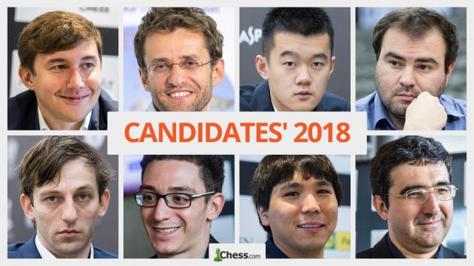
Forthcoming Events (check details for both events on cawa.org.au)

WA ALLEGRO CHAMPIONSHIP (Rapidplay) Sunday 18 March starting 11am at Leeming Primary (9 rounds, 15min + 2sec). Entry / enquiries andrewhardegen@iinet.net.au or 0407421084.

SW OPEN 24 & 25 March in Mt Barker.

SOLUTION: 1.g8=Q+!! (White surrenders his only pawn to deflect the king) 1...Kxg8 2.Ke6 Kh8 3.Kf7 e6/5 4.Bg7#.

PLAYERS: Karjakin, Aronian, Ding, Mamedyarov
Grischuk, Caruana, So, Kramnik

