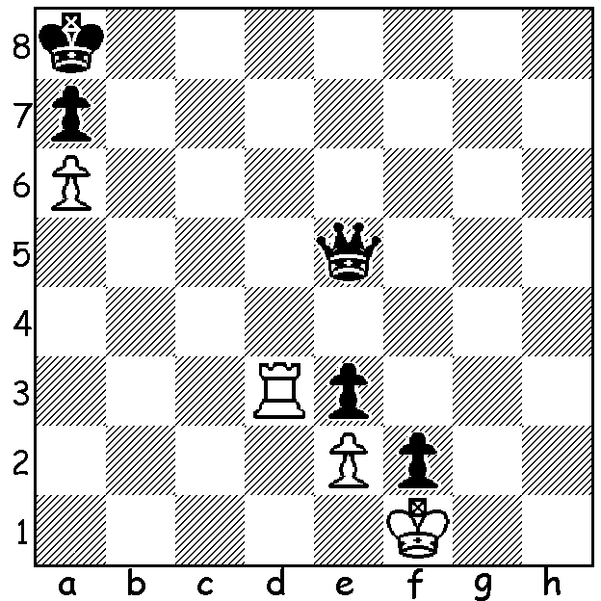

Herlin 1847:
White to play.
Has he any chance?

Last week I listed the eight players in the Candidates being held in Berlin, each vying to qualify as challenger for Magnus Carlsen's world title. Today's article is written a little in advance (March 14) as I shall be out of Australia briefly but I shall certainly try to follow the tournament to the end. I was impressed by Fabiano Caruana's win with the Catalan in Rd 1 against Wesley So but was thrilled by ex-world champion Vladimir Kramnik's win as Black using, very appropriately, the Berlin Defence against favourite Levon Aronian in Rd 3 in which he went for an early pawn attack against White's castled king:

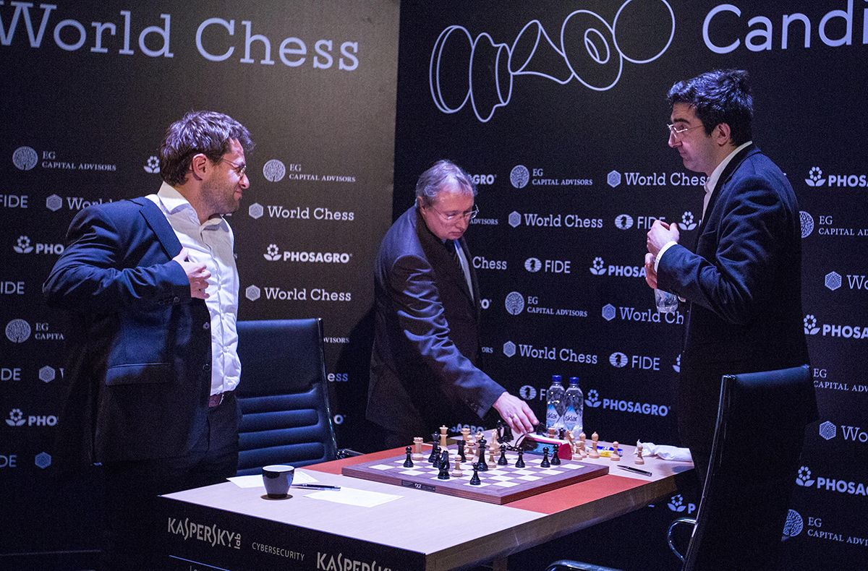
Levon Aronian vs Vladimir Kramnik
2018 Candidates, Rd 3
Ruy Lopez, Berlin Defence
1.e4 e5 2.Nf3 Nc6
3.Bb5 Nf6 4.d3(a) Bc5
5.Bxc6 dxc6 6.0-0 Qe7
7.h3 Rg8! 8.Kh1(b) Nh5
9.c3(c) g5 10.Nxe5 g4!
11.d4(d) Bd6 12.g3 Bxe5
13.dxe5 Qxe5 14.Qd4 Qe7
15.h4 c5 16.Qc4?(e) Be6
17.Qb5+ c6 18.Qa4(f) f5!
19.Bg5 Rxg5! 20.hxg5 f4 Aronian and Kramnik after game
21.Qd1 Rd8 22.Qc1 fxg
23.Na3 Rd3 24.Rd1 Bd5!
25.f3 gxf! 26.exd5(h) Qe2
27.Re1 g2+ White resigns(i)

a) Kramnik, who successfully revived the Berlin Defence in his successful World Championship challenge to Gary Kasparov in 2000, played the White side in Rd 2 against Sergey Karjakin, employing the main line 4.0-0 Nxe4 5.d4 Nd6 6.Bxc6 dxc6 7.dxe Nf5 8.Qxd8 Kxd8.
b) Probably best: 8.c3 g5 9.d4 (not 9.Bxg5 Bxh3!) 9...exd 10.cxd Bb6 11.Nxg5 h6 12.Nf3 Bxh3: or 8.Be3 Bxe3 9.fxe3 g4, both with an advantage to Black.
c) The alternaive is 9.Nc3 (9...g5 10.Nxe5 g4 11.d4 Bd6).
d) Not 11.Nxg4 Bxg4 12.hxg4 Qh4+ 13.Kg1 Ng3 mating.
e) The best chance was 16.Qd3, preventing Black's next, and White can fight on.
f) Again Qd3 was now best (18.Qe2 f5! 19.exf?? Bd5+).
h) If 19.exf Nxg3+ 20.fxg3 Bd5+ 21.Kg1 Qe2 22.Rf2 Qe1+ 23.Rf1 Qxg3#.
i) If 26.Rxd3 Qxe4! 27.Re3 f2+ 28.Rxe4 Bxe4#.
j) 28.Kh2 g1=Q+ 29.Kxg1 f2+ 30.Kg2 fxe1=Q#.

Kramnik lost an exciting endgame in Rd 4 vs Fabiano Caruana who took the lead with 3/4 with Kramnik and Shakhriyar Mamedyarov both on 2.5.

The SOUTH WEST OPEN will be played tomorrow and Sunday at the Frost Pavilion, Mount Barker starting each day at 10 am. There will be a separate Junior Tournament if sufficient entries. Enquiries & entry to Norbert Muller 0419950619.

The GUFELD CUP, due be played on Easter Sunday & Monday, April 1-2, has been POSTPONED

SOLUTION: 1.Rd8+ Qb8 2.Rg8! Qxg8 stalemate.

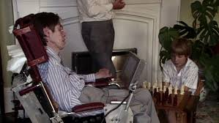
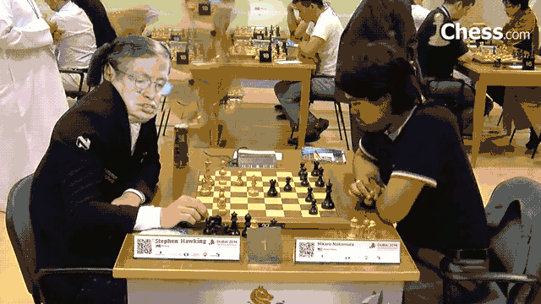
Stephen Hawkins playing chess with his son and in a tournament

