Kramnik – Caruana (2018 Candidates, Rd 4): after 1.Rbg8 White, threatening 2.Rxg5+ and expecting to win, is shocked by Black's brilliant reply which saves (& in fact wins) the game:
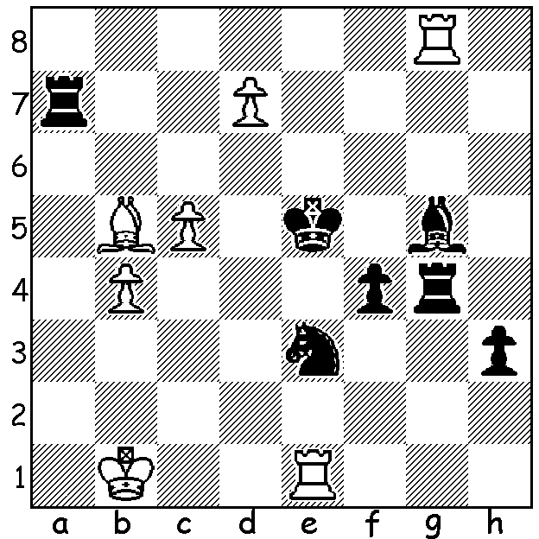
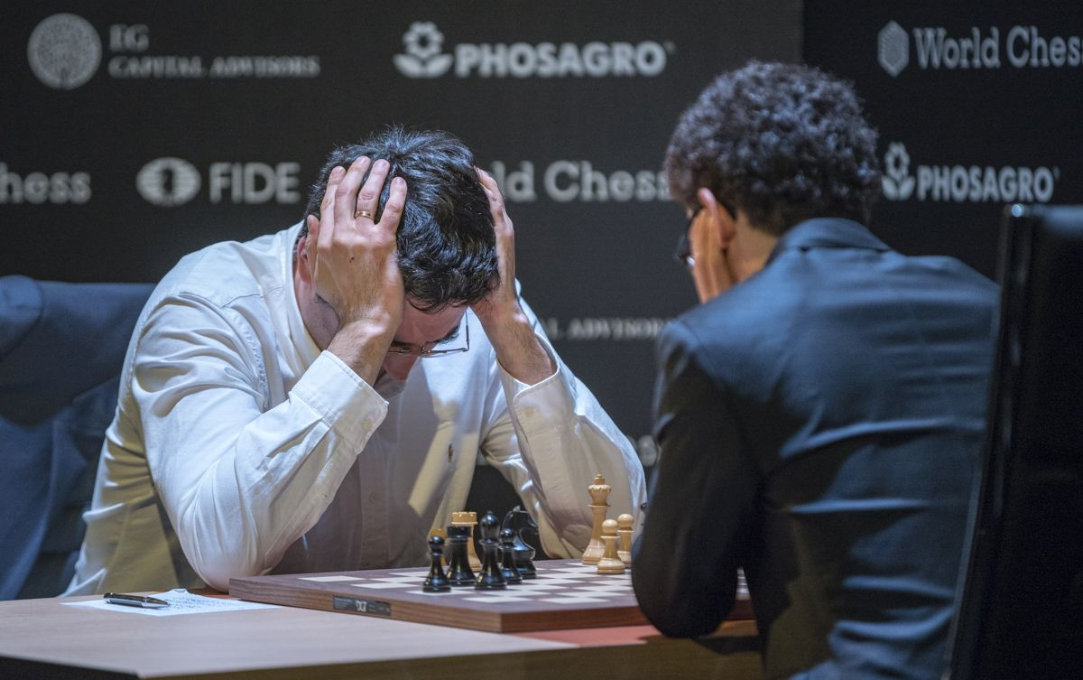

The Candidates tournament in Berlin, with eight of the world's best players competing in a double all-play-all to find a challenger to world champion Norwegian Magnus Carlsen in November, finished with American Fabiano Caruana winning with 9/14. For most of the event he was in the lead but suffered his only loss to Carlsen's previous challenger, Russian Sergey Karjakin in the 12th round. However wins in his final two games enabled him to come out on top, a point ahead of Shakriyar Mamedyarov (Azerbaijan) and Karjakin. Other scores: Ding Liren (China, the only undefeated player) 7.5, Alexander Grischuk (Russia) & former world champion Vladimir Kramnik (Russia) 6.5, Wesley So (USA) 6, Levon Aronian (Armenia) 4.5. Caruana will be hoping to become the second American after the legendary Bobby Fischer to become world champion. Here is his fine defensive effort in an exciting win against the tournament favourite:
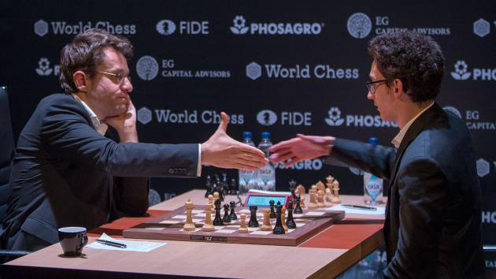
Levon Aronian vs Fabiano Caruana
2018 Candidates, Rd 7
Queens Gambit, Delayed Acceptance
1.d4 Nf6 2.c4 e6
3.Nf3 d5 4.Nc3 dxc
5.e4 Bb4 6.Bg5 h6
7.Bxf6 Qxf6 8.Bxc4 c5
9.0-0 cxd 10.e5 Qd8
11.Ne4 0-0 12.Qe2 Be7
13.Rad1 Qc7 14.Bd3 Nd7
15.Rc1 Qa5 16.g4!?(a) Nxe5
17.Nxe5 Qxe5 18.f4 Qa5(b) Aronian resigns against Caruana
19.g5 Qd8 20.h4(c) Bd7 21.gxh g6
22.h5 Kh8 23.Kh2 Bc6 24.Rf3(d) Bd6
25.Qf2 Bc7! 26.Kh3 Qe7(e) 27.Ng5 e5!(f)
28.Rxc6! bxc6 29.Nxf7+ Rxf7 30.hxg6 Rf6
31.g7+ Kg8 32.Bc4+(g) Kh7 33.Qh4 e4
34.Rg3 Bxf4 35.g8=Q+ Rxg8 36.Bxg8+ Kh8
37.Rg7 Qf8!(h) White resigns

a) Offering a pawn to work up a dangerous pawn storm against Black's king.
b) Not 18...Qd5 (19.g5 Bd7 20.gxh gxh 21.Rc5! Bxc5 22.Nf6+).
c) 20.Rf3 may have been better (20...Bd7 21.Rg3 Bc6 22.gxh g6 23.Ng5 Qd5 24.Kh2 with h4/h5 to come).
d) Possibly a mistake - 24.hxg fxg 25.Qg4 Qd5 26.Rc5! (26.Rxc6 bxc6 27.Qxg6 Rg8 28.Qf7 Raf8 29.Ng5 Qg2+!! 30.Kxg2 Rxf7wins – seen by both players) 26...Bxc5 27.Qxg6 Qd7 28.Nxc5 Qe7 29.Qg7+! Qxg7 30.hxg7+ Kxg7 31.Nxe6=.
e) If 26...Qd5 27.Rc5!
f) Not 27...Bxf3? 28.Qxf3 Bd6 29.Qe4 with a strong attack on the white squares.
g) The way to continue was 32.Qh4! e4 33.h7+ Kxg7 34.Rg3+ Kh8 35.Rg8+! Rxg8 36.hxg8=Q+ Kxg8 37.Bc4+ Kg7 38.Qg5+ Kh7 39.Qg8+ Kh6 40.Qg5+ with a perpetual check.
h) The final twist - 37...Qd6? 38.Rh7+ Kxg8 39.Qg4+ Rg6 Rg7+! mating.

SOLUTION: 1...Bf6!! leaving his g4 rook en prise. Now 2.Rxg4 is met by 2...Kf5 threatening the rook and 3...Ra1# and if 2.Rxe3+ fxe3 3.Rxg4 h2. White was forced to play 2.d8=Q & play continued 2...Bxd8 3.Rxg4 Bf6 4.Rg6 Rb7 5.Be2 Rxb4+ 6.Ka2 Nc2 7.Rc1 Nd4 8.Bd3 Ra4+ 9.Kb1 Nb3! 10.Re1+ Kd5 11.Kc2 Nd4+ 12.Kb1? (12.Kc1=) 12...Nf3 13.Rd1? (played with 2 sec on his clock – 13.Rxf6=) 13...Ra1+ 14.Kc2 Rxd1 & wins (15.Kxd1 h2 16.Rh6 Bh4 & queens).

