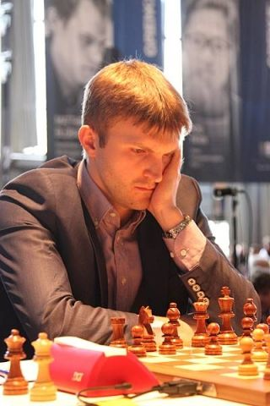

Bluebaum vs Vitiugov (right)
(2018 Grenke Classic, Rd 1):
Black to play and win (3 moves):

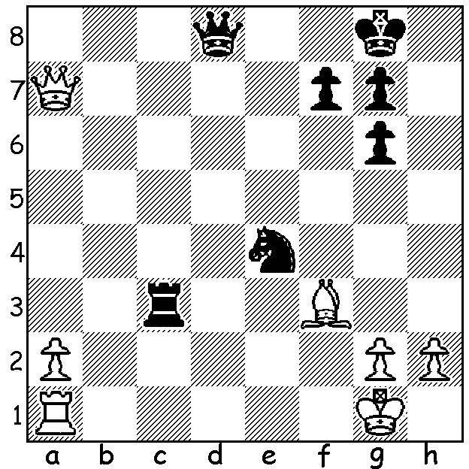

The Grenke Chess Classic (Germany), a 10 player round robin, finished earlier this week. There were three possible winners with a round to go, Fabiano Caruana, the recent Candidates winner, who held a half point lead over front runner, Russian Nikita Vitiugov, and world champion Magnus Carlsen. Winner was Fabiano Caruana (6.5/9, +4 =5) after defeating Vitiugov with Black while Carsen (2nd on 5.5, +2 =7) could only draw with ex-world champion Vishy Anand. Third were Vitiugov, Levon Aronian and Maxime Vachier-Lagrave with 5. Other scores: Matthias Bluebaum 4, Vishy Anand, world's best woman Hou Yifan, Arkadij Naiditsch 3.5, Georg Meier 3. A mouth-watering Round 1 draw paired world Magnus Carlsen with his challenger:

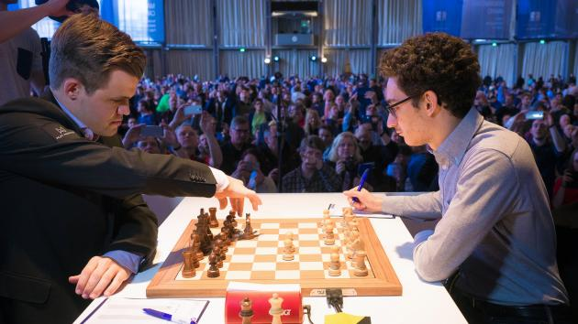
Fabiano Caruana vs Magnus Carlsen
2018 Grenke Classic, Rd 1
Kings Indian Defence

1.d4 Nf6 2.c4 g6
3.Nf3 Bg7 4.e3(a) 0-0
5.Be2 d6 6.Nc3 Nc6
7.d5 Nb4 8.a3 Na6
9.Nd4(b) e5 10.dxe fxe
11.0-0 e5 12.Nb3 c6 .
13.e4(c) Nc7 14.f4 Ne6
15.f5 Nd4! 16.Be3(d) Nxe2+(e) 17.Qxe2 gxf!
18.exf d5 19.cxd cxd 20.Rad1 d4
21.Bg5 Qb6 22.Qc4+ Rf7 23.Na4 Qc7
24.Qxc7 Rxc7 25.Nac5 b6 26.Bxf6 bxc5!(f)
27.Bxg7 Kxg7 28.Nd2 Bb7 29.f6+ Kf8!(g)
30.Rde1 Re8 31.Ne4 Bxe4 32.Rxe4 c4
33.g4 Rb8 34.Rxe5 Rxb2 35.Rd5 c3
36.Rd8+ Kf7 37.Rh8 Rbb7? (h) 38.Rxh7+ Kg6
39.Rxc7 Rxc7 40.Kf2 c2 41.Rc1 d3
42.Ke3 Rd7 43.Kd2 Kxf6 44.h4 Ke5
45.Rf1 Kd4 46.h5 Re7 47.Rf4+ Kd5
48.Rf1 Kc4 49.Rf4+ Kd5 50.Rf1 Kc4
51.Rf4+ Kb3 52.Rb4+ Kxa3 53.Rc4 Kb3
54.Rc8 a5(i) 55.h6 Re2+ 56.Kxd3 Rh2
57.g5 Rh3+ 58.Kd2(j) Rh2+ 59.Kd3 DRAW

a) A quiet line (4.e4 is usual). Perhaps Caruana didn't wish to reveal his possible opening lines for the big match.
b) Not 9.b4? Nxd5!
c) Preventing ….d5 but creating a hole at d4 which Black immediately seeks to occupy.
d) White cannot play 16.Nxd4 exd4 17.Qxd4 Ng4 18.Qd2 Qb6+ 19.c5! Qxc5+ 20.Kh1 gxf! (not 20...Nf2+? 21.Rxf2 Qxf2 22.Bc4+)
e) Planning expansion in the centre backed up by the advantage of the the two bishops.
f) Preventing a blockade with Ne4.
g) Not 29...Kf7 which might allow a knight fork on d6.
h) 37...Rcb7 wins – 38.Rxh7+ Kg6 39.f7 Rb8 40.Rh5 c2 41.h4! R2b6! (preventing the perpetual).
i) 54...Rh7! blocking the advancing pawns and following with the advance of the a pawn would win – 55.Rb8+ Ka2 56.Rc8 a5 57.Kxd3 Kb1! 58.Rc8 Kd1 59.Rxc2 Rd7+. Now White escapes with a draw
j) Not 58.Ke4? Rc3.

The WA JUNIOR CHAMPIONSHIPS will take place next week at Leeming Primary: Under 8, 10, 12 on Monday 16th at 10am, Under 14, 16, 18 on 17th - 19th at 10am, Open Lightning on 19th at 1pm. Check cawa.org.au for details and entry form.

SOLUTION: 1...Ra3! 2.Qxa3 Qd5+ 3.Kf1 Qf2# or 3.Kh1 Qxa1+ mating (2...Qb6+ also wins – 3.Kh1 Nf2+ 4.Kg1 Nh3+ 5.Kh1 Qg1+! 6.Rxg1 Nf2#, Philidor's Legacy).

