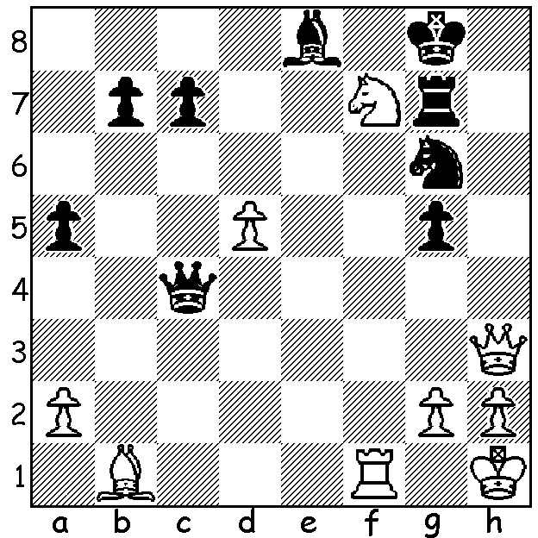

A position from the 2018 European Championship,
won by Croatian Ivan Saric with 8.5/11:
Maxim Matlakov vs Tamir Nabaty:
White to play and win (2 moves):

While the events at the Grenke Chess Classic in Germany, won by Fabiano Caruana, took centre stage, a remarkable achievement catapulted 13 year-old Vincent Keymer into the spotlight. In a
field of 787, which included 49 Grandmasters, the young German, who was seeded 99th, won the Grenke Open with an amazing 8/9, a performance rating of 2798. This qualifies him to play in the Classic next year although he has expressed doubts on whether he would feel strong enough to compete in such an august field. Here is his last round victory against one of the world's younger stars, 22 year-old Hungarian Richard Rapport:

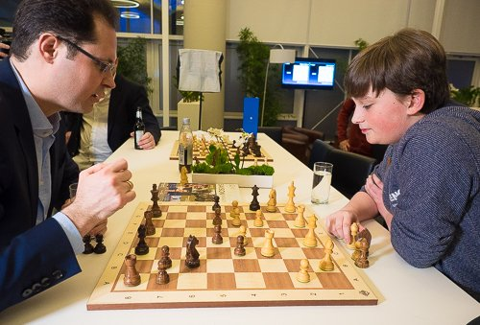
Richard Rapport vs Vincent Keymer
2018 Grenke Open, Rd 9
Queens Gambit, Orthodox Defence
1.d4 d5 2.c4 e6
3.Nc3 Nf6 4.Bg5 Be7
5.e3 h6 6.Bh4 0-0
7.Rc1 Nbd7 8.cxd exd
9.Bd3 c6 10.Bg3 Re8
11.h3 Bb4 12.Nf3 Ne4
13.Bf4 c5 14.0-0 Bxc3
15.bxc3 Nb6 16.Ne5 f6
17.Ng4!?(a) c4 18.Bb1 h5
19.Nh2(b) g5 20.Qxh5 gxf4 Vincent Keymer with his coach Peter Leko
21.f3 Nd6 22.Qh7+ Kf8
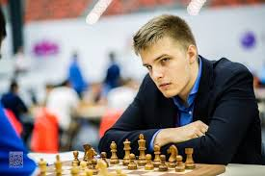
23.Qh6+ Ke7 24.Qg7+ Ke6
25.Rfe1 Re7 26.Qg4+ f5
27.Bxf5+! Nxf5 28.Qg6+(c) Kd7
29.Qxf5+ Kc6 30.Qxf4 Be6
31.e4 Qg8 32.Qh6 Kc7
33.Kh1 Rf8(d) 34.Re2 Rh7
35.Qd2 Kb8 36.Rce1 dxe
37.fxe Bd7 38.Rf2 Re8
39.Qf4+ Ka8 40.Nf3 Rf8
41.Qh2 Na4 42.Re3 a6
43.Qe5 Bxh3! 44.Kg1(e) Rg7
45.Nh4 Rxf2 46.Kxf2 Rxg2+ Richard Rapport
47.Nxg2 Qxg2+ 48.Ke1 Qf1+
49.Kd2 Bg4 50.Qe8+ Ka7
51.Qxa4 Qf2+ White resigns

a) 17.Ng6 seems natural but White instead tempts Black into winning a piece.
b) 19.Nh6+ gxh6 20.Qxh5 was an alternative.
c) 28.e4 seems better.
d) Black's king has found safety and he can now use the open lines to train his heavy pieces on White's kingside pawns.
e) If 44.gxh3 Rxh3+ 45.Rh2 Rg3 & wins (threat 46...Rfxf3 47.Rxf3 Rg1#).

A month ago I wrote about the PRO Chess League, a 32 team worldwide rapid tournament played between January and April. The Australian Eagles progressed to the knock-out stage before losing 7-9 to Chengdu Pandas, who reached the final, losing to Armenian Eagles. Leading scorers in the 14-man Australian squad were Anton Smirnov 30.5/48, Alexy Sarana (free agent) 21.5/32, Brandon Clarke 19.5/28 and Perth based Temur Kuybokarov 15.5/28. I am indebted to Fred Maris, who was official observer at Temur's games, for providing me with much of this information.
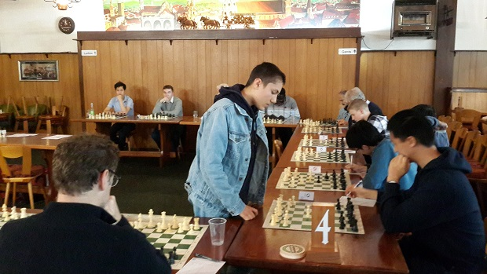
Temur Kuybokarov giving a simul in Perth

SOLUTION: 1.Qh8+!! (obstruction, blocking h8, & deflective sacrifice, opening b1-h7 diagonal) 1...Nxh8 2.Nh6#.

