
Anna Sharevich vs Irena Krush
(2018 US Womens Ch):
How does White create a winning
attack against Black's king?
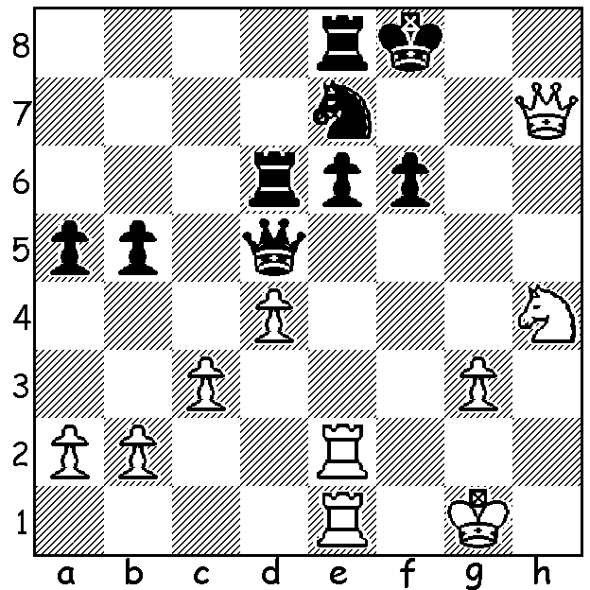

After six rounds the US Championship & US Womens
Championship, each with 12 players, have had plenty of Samuel Shankland
excitement with over half of games in the first four rounds
ending decisively (27/48). Biggest surprise was Zviad Izoria's win in Rd 4 against Fabiano Caruana, who plays champion Magnus Carlsen for the world title in November. Izoria was tied in last place and is a self-admitted non-professional (although he did win $50,000 for winning the 2005 HB Global Chess Challenge). In the Championship it was expected to be a tussle between the top three, Hikaru Nakamura, champion four times between 2005 & 2015, Caruana, champion in 2016
and Wesley So, defending champion. However it is an outsider, Samuel Shankland 4.5/6, in the lead before the rest day. Other leading scores: Caruana, So 4, Varuzhan Akobian 3.5, Hikaru
Nakamura 3 (6 draws).
However it's the women in the spotlight this week where another outsider, fifteen year old Annie Wang, leads with 5/6. Other leading scores: 2016 champion Nazi Paikidze 4.5, seven times champion Irina Krush 4, four-times winner Anna Zatonskih 3.5.

Nazi Paikidze vs Anna Sharevich
2018 US Womens Championship
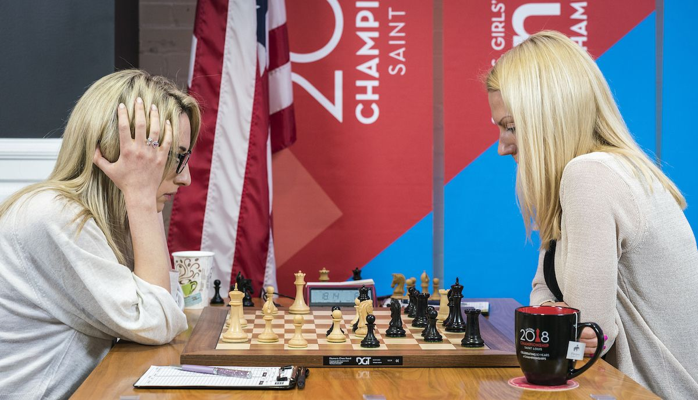
Caro-Kann, Two Knights Variation
1.e4 c6 2.Nc3 d5
3.Nf3 Bg4 4.h3 Bxf3
5.Qxf3 d4 6 Ne2 e6
7.d3(a) Nf6 8.g4 Na6
9.Bg2 Qa5+ 10.c3 Rd8
11.0-0 dxc 12.bxc3 Nc5
13.d4!(b) Ncxe4 14.c4 Nd2
15.Bxd2 Qxd2 16.Rfd1 Qg5
17.Qb3! Rd7 18.d5 cxd
19.cxd e5(c) 20.Rac1 Be7
21.Rc8+(d) Bd8 22.Qa3!(e) h5
23.f4! exf 24.Nd4 Qe5(f) Paikidze v Sharevich
25.Nf5 Nxd5 26.Bxd5 Rxd5
27.Qa4+ Resigns(g)

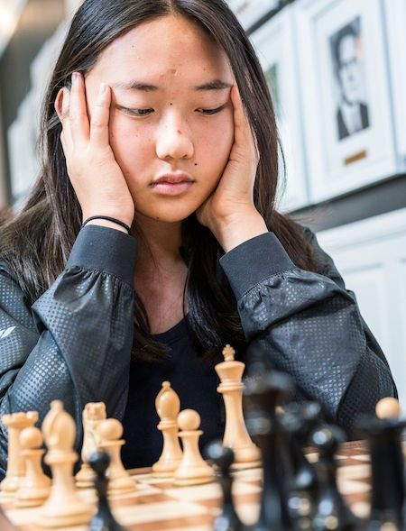
a) 7.Qb3 forces 7...b6 weakening the white squares, else
Black loses a pawn (7...Na6 8.Nxd4!).
b) A strong pawn sacrifice for an attack.
c) If 19...Nxd5 20.Bxd5 exd5 21.Rac1 Qd8 22.Qa4 Bd6
23.Rxd5 0-0 24.Ng3 & White wins a rook for the knight.
d) 21.d6 Bd8 22.Bxb7 / 23.Bc6 wins the exchange (R for B).
e) Unable to castle, Black's fate is sealed.
f) The undeveloping 24.Ng8! is the only faint chance but
25.Qa4 keeps Black shackled (25...Ne7 26.Ne6!).
g) 27...b5 28.Qxb5!! Rxb5 29.R(either)xd8# would be a
fitting ending to a beautifully played game. Paikidze was
the 2016 winner while Sharevich has represented Belarus
in six Olympiads.

In contrast the Gashimov Memorial in Azerbaijan, in which Annie Wang
Carlsen is competing, finished in draws in all 15 games of the
first three rounds with Veselin Topalov's win against Shakhriyar
Mamedyarov being the only decisive result in Rd 4.

SOLUTION: 1.Re5!! Qc6 (1...fxe5 2.Rf1+ Nf5 3.Ng6#) 2.Rh5
(also 2.Rg5!) 2...Rd5 3.Qh8+ Ng8 4.Ng6+ Kf7 5.Qh7#.

