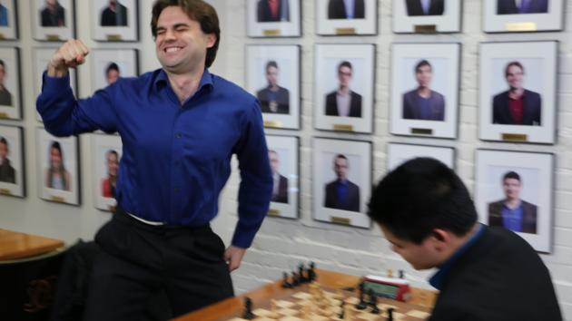
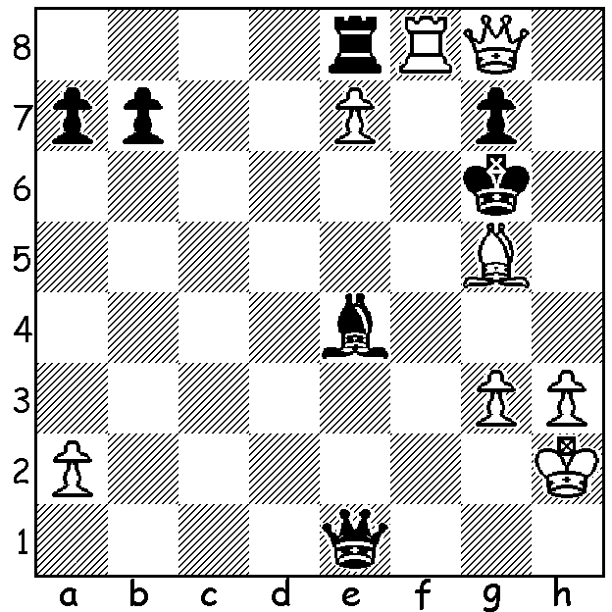

White, facing a mate in 1, mates in 3 or 4: A jubilant Sam Shankland
Shankland vs Zierk 2008: on winning US Championship

Last week's report on the US Championship had Sam Shankland leading world championship contender Fabiano Caruana by a half point at roughly the half way stage. He was still a half point ahead of Caruana going into the final round. And, although Caruana won, Shankland was able to register his 6th win to pip his more fancied rival. His score of 8.5/11 was the equal best since the start of the 12 player format in 2013. Shankland, born in 1991, also became only the seventh American to become a 'Super Grandmaster' (a rating of 2700+). His victory, which earned him $50,000, was probably even more exciting for him than being in the US winning team in the 2014 Olympiad and gaining the reserve gold medal, with 8/9. Other leading scores: Caruana 8, Wesley So 6.5, Hikaru Nakamura (and others) 5.5. Here is one of the most exciting game from the tournament:

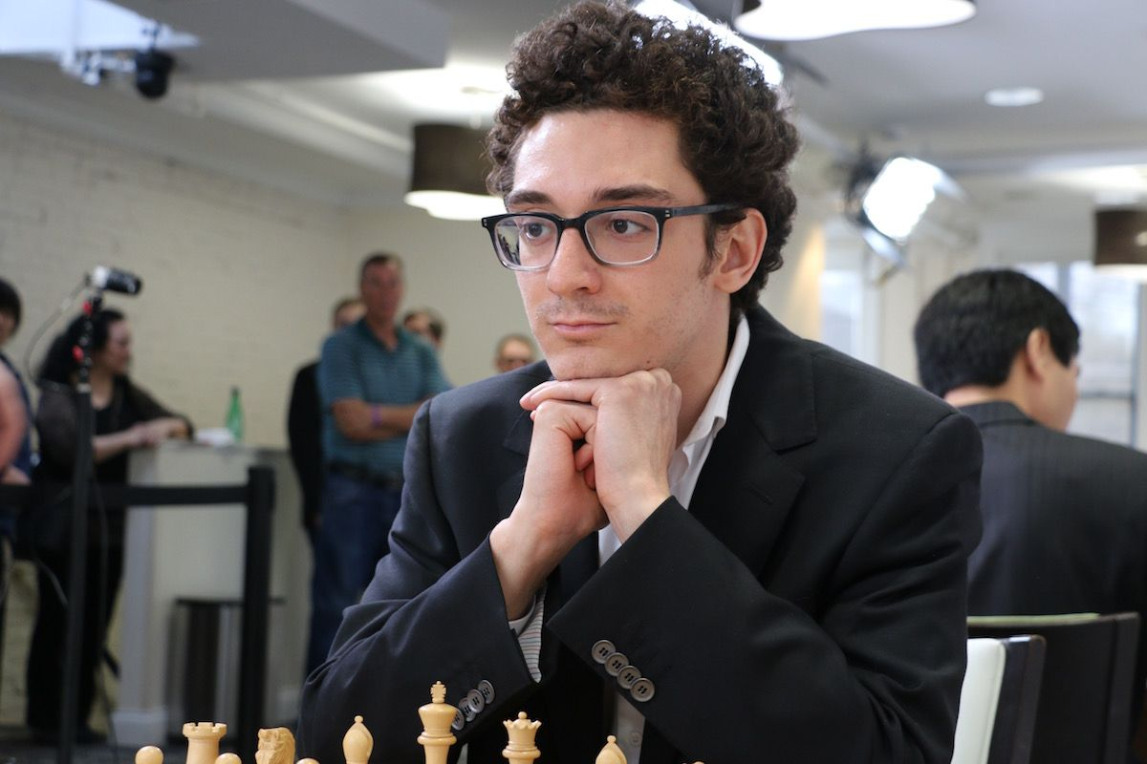
Fabiano Caruana vs Varuzhan Akobian
2018 US Championship, Rd 7
French Defence, Steinitz Variation
1.e4 e6 2.d4 d5
3.Nc3 Nf6 4.e5 Nfd7
5.f4 c5 6.Nf3 Be7
7.Be3 Nc6 8.Qd2 b6(a)
9.Bb5 Qc7 10.0-0-0 a6(b)
11.Bxc6 Qxc6 12.f5! c4(c)
13.f6!(d) gxf 14.exf6 Bxf6
15.Rhf1 b5 16.Qf2 b4
17.Ne2 b3 18.Ne5! Bxe5 Fabiano Caruana
19.Qxf7+ Kd8 20.dxe5 bxa
21.Kd2 Rf8 22.Qxh7 Rxf1 23.Rxf1 d4
24.Qg8+(e) Kc7 25.Nxd4 Qd5 26.Qxe6 Qa5+ (f)
27.c3 Nxe5 28.Rf7+! Nxf7 29.Bf4+ Kb7
30.Qxf7+ resigns

a) Far less popular than 7...0-0.
b) It might be tempting to play 10...g6 to hold up White's intended f5 even though it leaves weakness on the black squares.
c) If 12..exf 13.dxc Bxc5 14.Nxd5.
d) White's pawn sacrifice enables him to attack on the half open f file.
e) Protecting g2.
f) The tempting 26.Qxg2+ 27.Rf2 Qxf2+! 28.Bxf2 a8=Q loses to 29.Qd6+ Kb7 30.Qd5+ Kb8 31.Nc6+ Kb7 32.Nd8+ Kc7 33.Qd6+ Kxd8 34.Bh4+ Ke8 35.Qe7#.

In the US Womens Championship leader 15 year old Annie Wang went into the final round unbeaten with a half point lead over 2016 champion Nazi Paikidze but lost to defending champion Sabina-Francesca Foisor. Paikidze then successfully offered a draw to Rusa Goletiani in a complex position, necessitating a play-off of firstly two games of 25 min + 5 sec. Wang won the first game but lost the second. In the final game, an Armegeddon, White has 5 min + 2 sec and had to win while Black has 4 min + 2 sec (colours by lot) but could win or draw to take the title. Wang, perhaps unwisely, played the same defence for over 10 moves as she had in the previous game and again was well beaten. A tragedy for Wang after twice being on the verge of taking the title but a second US title for Paikidze.

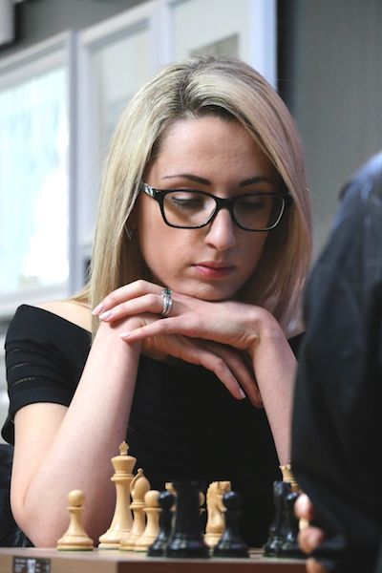

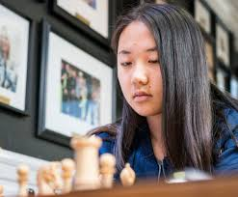

Annie Wang and Nazi Paikidze

SOLUTION: 1.Rf6+! Kh5 (1...Kxg5 2.Qxg7+ Kh5 3.Rh6#) 2.Rh6+! Kxg5 3.Qxg7+ Kf5 4.Qf6#.

