Mamedyarov vs Navara (Gashimov Memorial 2018):
White's next move gives him a winning position: Mamedyarov at Gashimov Memorial
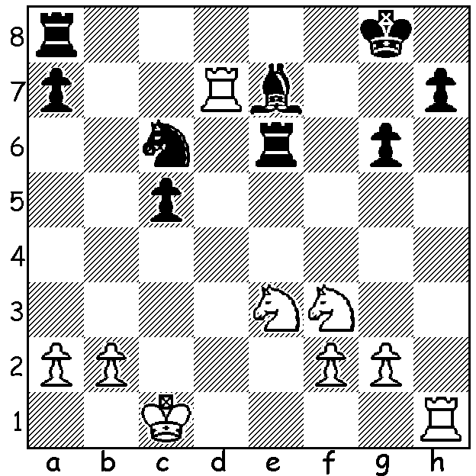
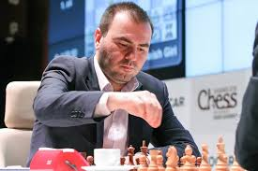

While Fabiano Caruana was coming second in the US Championship in St Louis, his rival for the world championship in November, Magnus Carlsen, was competing in the 10 player Gashimov Memorial in Shamkir, Azerbaijan. After a quiet start with his first four games drawn Carlsen won three of his last five games to win the tournament after a final round quick draw with runner-up Ding Liren, scoring 6/9. In all 34 of the 45 games were drawn, including all games in the first three rounds. Other scores: Ding Liren 5.5, Sergey Karjakin 5, Teimour Radjabov, Shakhriyar Mamedyarov, Anish Giri 4.5, Veselin Topalov 4, David Navara 2.5. One of Carlsen's wins was against Anish Giri, one of the very few players with whom Carlsen didn't have a plus score (+1, =18, -1).

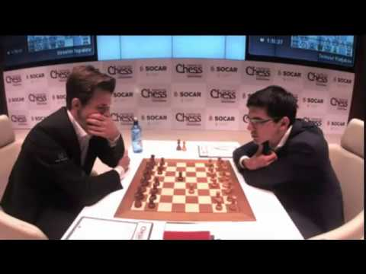
Anish Giri vs Magnus Carlsen
2018 Gashimov Memorial, Rd 7
English Opening
1.c4 e5 2.Nc3 Nf6
3.Nf3 Nc6 4.g3 d5
5.cxd Nxd5 6.Bg2 Nb6
7.0-0 Be7 8.a3 a5
9.d3 0-0 10.Be3 Be6
11.Rc1 a4 12.Nd2 f5
13.Bxb6 cxb6 14.Nxa4 Bg5
15.Nc3 e4 16.Kh1 Qd7
17.Rb1 Rad8(a) 18.Nc4 Qf7
19.b3 exd 20.exd f4
21.Ne4 Be7 22.gxf(b) Qxf4 23.a4(c) Nb4
24.Qe2 Qh6(d) 25.Rbd1 Nd5 26.Rg1 Kh8
27.Bf1 Rf4 28.Ne5 Rdf8(e) 29.f3 Rh4
30.d4 Nf4 31.Qd2 Bxb3 32.Rb1 Bxa4(f)
33.Bb5! Bxb5 34.Rxb5 Qe6 35.Qb2 Bd8
36.Ng5 Qe8! 37.Rb3 Bxg5 38.Rxg5 Ne6
39.Rg4 Rxg4 40.fxg4 Qd8 41.Rh3(g) Qd5+
42.Kg1 Qe4 43.Qb4 Rf6(h) White resigns

a) Black's initiative on the d file and impending kingside attack are more than compensation for the pawn minus.
b) White cannot allow ...f3.
c) White's knights are well placed on two central outposts.
d) It would be a mistake to regain the pawn - 24...Nxd3 25.Rbd1 Nb4 26.Rxd8 Bxd8 27.Ned6 Bd7 28.Bxb7 or 24...Rxd3 25.Ng5 Bxc4 26.Qxe7.
e) 28...Rh4 immediately was better - 29.f3 Ne3 30.Rd2 Nf5.
f) The need to defend the kingside has left the queenside pawns without protection.
g) 41.Rd3 would lose his queen to 41...Qd5+ 42.Kg1 Rf1+!
h) Not 43...Qxd4+?? 44.Qxd4 Nxd4 45.Ng6+.

The WEST AUSTRALIAN CHAMPIONSHIP will be played on successive Sundays from May 20 to July 1. Other titles besides WA Champion available are Womens Champion, Senior Champion and Reserves Champion. Entries must be submitted by Thursday 17 May to DOP Norbert Muller (norbert.muller@iinet.net.au, 0419950619). Check cawa.org.au for details.

SOLUTION: 1.Rxh7! (if 1...Kxh7 2.Ng5+).

