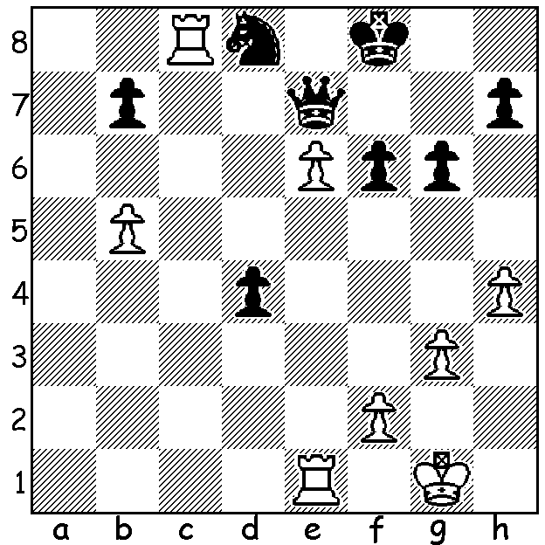

Peter Roza vs David Ellis (Metro Ch 2018):
Black's 1...Kg7 to win the e pawn is met with
a brilliant rejoinder:

The Metropolitan Chess Club, based in Nedlands, has recently completed its club championships, grouped into three divisions. Championship winner was Ihsan Ferozkohi, one of Perth's most active and successful players, with 7.5/9 (+6, =3 to Craig Kinsman, Gordon Dunlop & Alan Jackson). Second was Adam Kelly with 7/9 (+7, -2 to Ferozkohi & David Ellis) and third Craig Kinsman (5.5). Robin Shaw (8.5/9) won the B Division and David Berry (7/8) the C. Here are wins from the winner and runner-up. In the second players follow a book line for 18 moves while in the first I suspect both players were improvising from the beginning, although it is a book line for 8 moves:

Ihsan Ferozkohi vs Adam Kelly
2018 Metropolitan Championship
Reti Opening (Reversed Grunfeld)
1.g3 d5 2.Bg2 c5
3.Nf3 Nc6 d4 Nf6
5.0-0 Bg4 6.Ne5 Bh5
7.Nxc6 bxc6 8.dxc Qa5
9.Qd4 Bxe2 10.b4 Qa4
11.Nc3 Qxc2 12.Re1 Bg4(a)
13.Bg5 Qg6 14.Bxf6 Qxf6(b)
15.Re5 Be6 16.b5 g6
17.bxc Bg7 18.Rae1 0-0
19.Bxd5 Rfe8(c) 20.f4 Bxd5
21.Qxd5 Rad8 22.Qf3 Kf8
23.c7 Rc8 24.Qb7 e6
25.Nd5! Qxe5 26.fxe5 and wins.

a) 12...Bc4 seems better, protecting the d pawn.
b) If 13...gxf6 15.Bxd5!! (15...0-0-0 16.Qc4 Rxd5 17.Qa6+ Kd8 18.Qxc6).
c) Interesting is 19...Bh3 20.Bh1 Qf5! 21.Nd5!

Adam Kelly vs Craig Kinsman
2018 Metropolitan Championship
Queens Pawn, Modern Benoni Defence
1.d4 Nf6 2.c4 c5
3.d5 e6 4.Nc3 exd
5.cxd d6 6.e4 g6
7.Bd3 Bg7 8.h3 0-0
9.Nf3 b5! 10.Bxb5 Nxe4
11.Nxe4 Qa5+ 12.Nfd2 Qxb5
13.Nxd6 Qa6 14.N2c4 Nd7
15.0-0 Ne5 16.Nxc8 Raxc8
17.Nxe5 Bxe5 18.Re1 Rfe8
19.a3 Bd4 20.Rb1 Qf6(a)
21.Be3 Bxb2(b) 22.d6 Red8
23.d7 Rc7 24.Rxb2! Qxb2
25.Bh6 Qb8 26.Qd6(c) resigns

a) 20...Rxe1+ 21.Qxe1 Qd3 22.Be3 Bxe3 23.Rd1 Bxf2+ 24.Kxf2=.
b) A fatal error - 21...Qf5 should be played (22.Bxd4 Rxe1+ 23.Qxe1 cxd4=).
c) Not 26.Qa1 f6 but now if 26...f6 26.Qe6+.

NIGEL SHORT, a former challenger for the world title against Gary Kasparov, has nominated for President of FIDE, challenging long time incumbent Kirsan Ilyumzhinov. Nigel was in Australia two years ago giving simuls across the country, including Perth where he lost only one of 31 games (vs Patrick Gong).

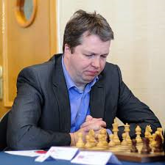
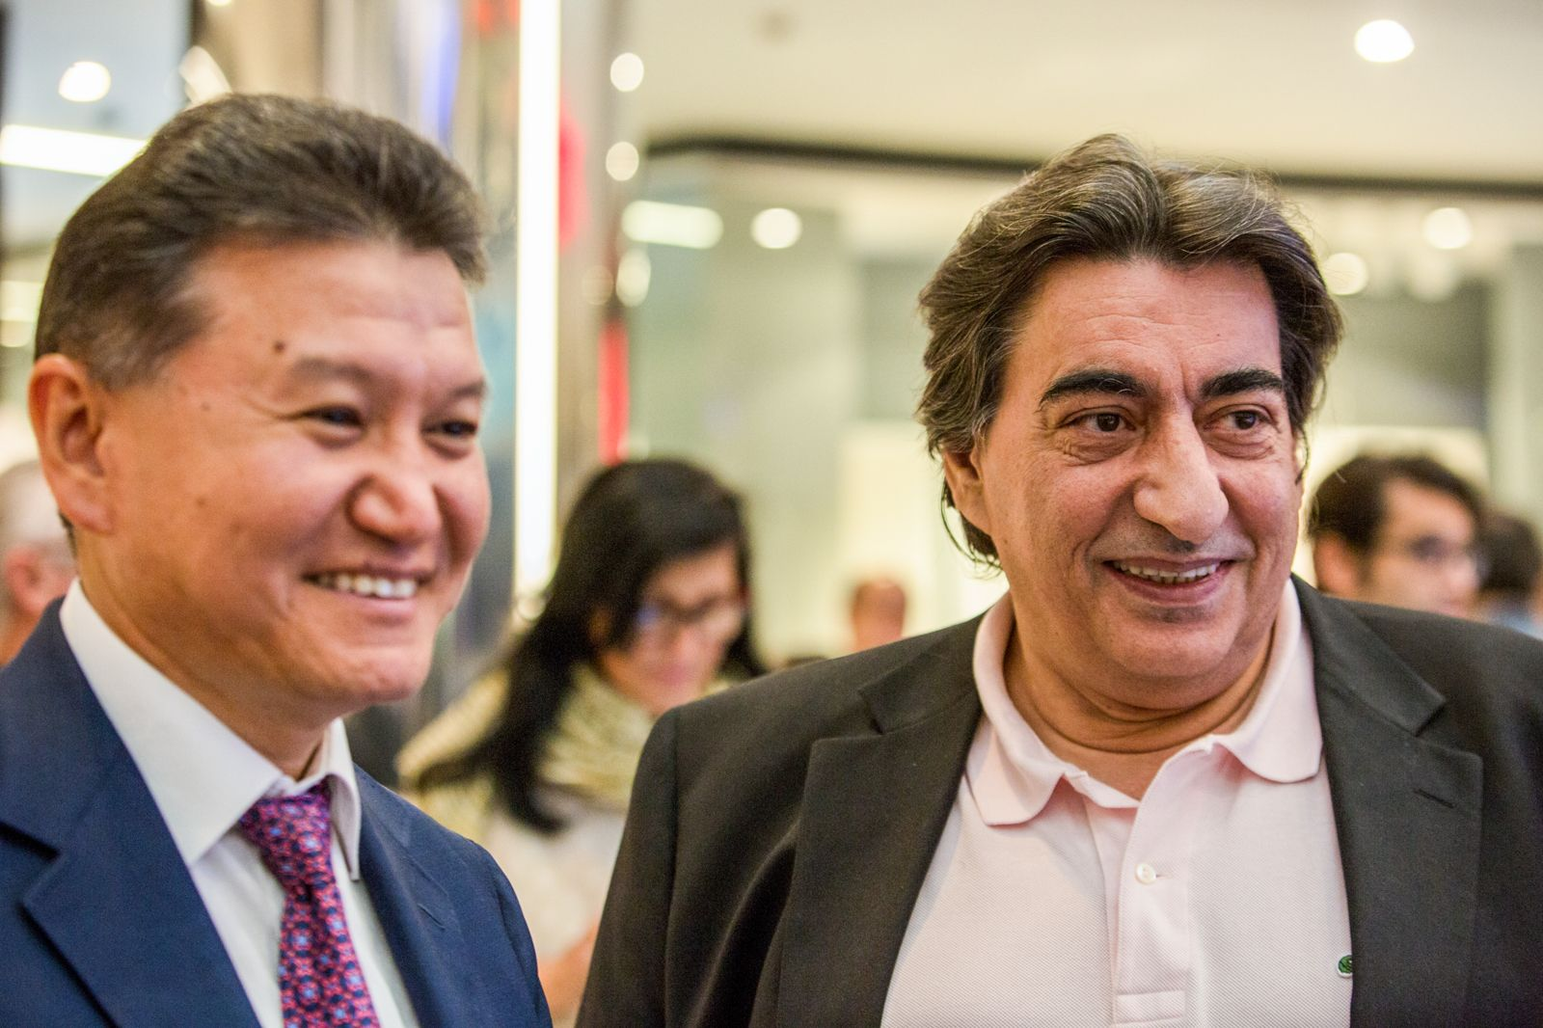

Nigel Short (R), challenger to FIDE President
Kirsan Ilyumzhinov (L) and his Deputy Georgios
Makropoulos (centre), who is also standing.

SOLUTION: Very short of time (as usual for Peter) White finds the brilliant 2.Rc7!! (unprotected skewer and deflection): if 2...Qxc7 3.e7 wins (3...Nf7 e8=N+!). Black played 2...Kf8 but lost the N v R ending. Black should have won with 1...d3.

