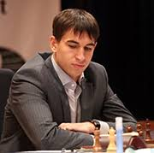
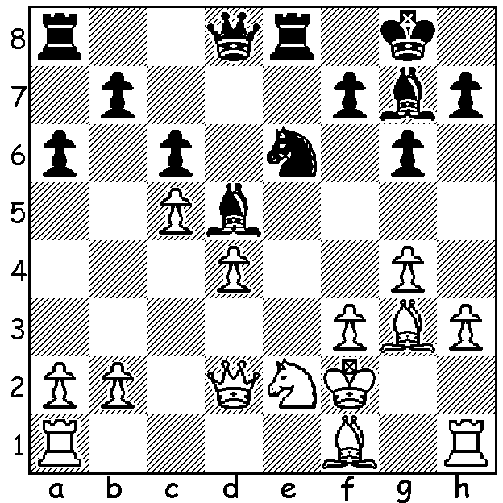

Dmitry Andrekin (2Vladimirovich90) temiksmozg vs 2Vladimirovich90
(Titled Tuesday May 1):Black wins quickly:

What do top chess players do for fun when there's no big tournament to play or prepare for? For some, it seems, taking part in a blitz online event and commentating the games as they play. In chesscom's Titled Tuesday on May 1 Fabiano Caruana and Anish Giri were the leading GMs in a 275 player field but were forced to take =2nd place behind Tigran Levonovich Petrosian (9/10). Petrosian (no relation to the late world champion Tigran V Petrosian) was born in 1984 and learnt chess at the age of five. He has twice been Armenian champion and was a member of Armenia's gold medal team in both 2008 and 2012.

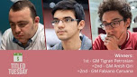
Petrosion (L), Giri (C), Caruana (R)

Alan Pichot vs Anish Giri
chesscom's Titled Tuesday, May 1
Ruy Lopez, Marshall Gambit
1.e4 e5 2.Nf3 Nc6 3.Bb5 a6
4.Ba4 Nf6 5.0-0 Be7 6.Re1 b5
7.Bb3 0-0 8.c3 d5 9.exd Nxd5
10.Nxe5 Nxe5 11.Rxe5 c6 12.d3 Bd6
13.Re1 Qh4 14.g3 Qh3 15.Re4 Nf6
16.Rh4 Qf5 17.Nd2 Ng4 18.Qf3 Qg6
19.Qxc6 Nxf2?! 20.Qxa8(a) Nxd3 21.Ne4(b) Be7
22.Bg5 Qb6+! 23.Kg2 Bb7 24.Bxf7+(c) Kh8(d)
25.Qxf8+ Bxf8 26.Rd1?(e) Qf2+ 27.Kh3 Qf5+
28.g4 Qf3+ White resigns (f)

a) Not 20.Kxf2? Bxg3+ 21.hxg3 Qxc6.
b) Trying to develop White is prepared to return a piece but this prevents the queen getting back to defend the king: better 21.Qf3.
c) White misses 24.Be3!
d) Black could safely play 24...Kxf7! - 25.Rf1+ Kg8 26.Rxf8+ Bxf8 27.Qe8 Qf2+ 28.Kh3 Qf1+ 29.Kg4 Ne5+! (deflection) 30.Qxe5 Bc8+ 31.Kh5 g6#.
e) White had to defend the f file with 26.Rf1.
f) 29.Ng3 Qg2#.

A very early game from the winner:
Tigran L Petrosian vs Le Tien Dung
World Under 10 Championship 1994
Scotch Gambit
1.e4 e5 2.Nf3 Nc6 3.d4 exd
4.Bc4 Nf6 5.e5 d5 6.Bb5 Ne4
7.Nxd4 Bd7 8.Bxc6 bxc6 9.0-0 Be7
10.f3 Nc5 11.f4 f6? 12.f5! fxe?
13.Qh5+ Kf8 14.Ne6+ Bxe6 15.fxe6+ Bf6
16.Qf7#
SOLUTION: Black, Dmitry Andreikin, won with 1...Bxf3+! 2.Kxf3 Ng5+ 3.Kf4 Re4# (also 3...Qf6#): if 3.Kg2 Qd5+ 4.Kg1/Kh2 Nf3+.

