Anton Smirnov vs Leonard McLaren 2014 (White to play): White's last move 1.b4! (forcing 1...Nd7) plans to transpose into a winning endgame. How far can you analyse? Can you see 12 or more moves ahead?
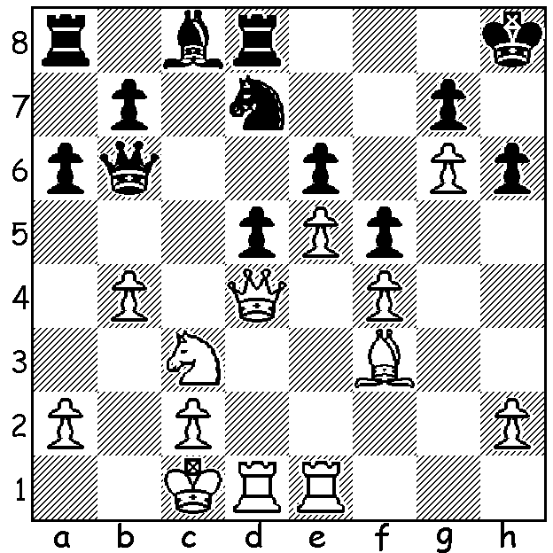
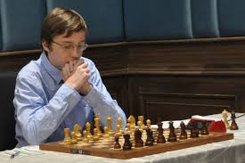

The Australian teams have been published for the coming Chess Olympiad to be held in Batumi, Georgia, starting 23 September:- OPEN 1.Anton Smirnov, 2.Zong-Yuan Zhao, 3.Max Illingworth, 4.Bobby Cheng, 5.James Morris: WOMEN 1.Heather Richards, 2.Julia Ryjanova, 3.Jilin Zhang, 4.Giang Nguyen, 5.Irena Berezina. Australia came =24/180 in the Open and =59/140 in the Women's and with possibly even stronger selected teams this year even better positions can be hoped for. Georgia is 14,000 km from Sydney with travel expected to take around 33 hours. Unfortunately no government assistance is provided so the cost is borne by the players themselves and the rest of the Australian chess community. I would encourage every WA player to join me in supporting our teams. See acfappeal.aunz.org to make a contribution.
Anton Smirnov was born in 2001 and has made sensational progress in such a short time. He was Australian Junior Champion in 2014, Australian GP winner in 2015, scored 7.5/9 as Bd 5 in the 2014 Tromso Olympiad, Norway, and 8.5/10 on Bd 4 in the 2016 Baku Olympiad, Azerbaijan. He became a GM in 2017, the same year he held Sergey Karjakin to two draws in the Chess World Cup before losing in the rapidplay tie break. Here's an opportunity to marvel at his brilliance at the age of 15:

Anton Smirnov vs Evandro Barbosa
2016 Chess Olympiad
Grunfeld Defence
1.d4 Nf6 2.c4 g6 3.Nc3 d5
4.Bg5 Bg7 5.Bxf6 Bxf6 6.cxd c5
7.dxc5 Nd7 8.e3 0-0 9.Bc4 Nxc5
10.Nge2 Qb6 11.Qd2 Bf5 12.0-0 Rac8
13.Rac1 Rfd8 14.b3 a6 15.Nd4 Ne4
16.Nxe4 Bxe4 17.Rfd1 Kg7 18.Ne2 Qd6
19.f3 Bf5 20.e4 Bd7 21.Qe3 b5
22.Bd3 Bb2 23.Rb1 Ba3(a) 24.b4!(b) a5
25.e5 Qc7 26.d6! exd 27.exd Qb8(c)
28.Nf4 Bxb4 29.Nh5+!?(d) gxh5 30.Qg5+ Kh8
31.Qf6+ Kg8 32.Bxh7+! Kxh7 33.Rd5 Qb6+
34.Kf1 Rc5 35.Qxf7+ Kh8 36.Qxh5+ Kg7
37.Qg5+ Kh7?(e) 38.Rxb4! axb4 39.Rxc5 Be8
40.Qh4+ Kg7 41.Qd4+ resigns(f)

a) The bishop diversion to the queenside combined with the vulnerable placement of the king on g7 leads to trouble.
b) Threatening to trap the bishop with 25.Rb3: 24...Bxb4? loses the bishop to 25.Qd4+.
c) Again the bishop is lost after 27...Qxd6 28.Bxb5! Qc7 29.Bxd7 Rxd7 30.Qxa3.
d) A speculative sacrifice but there was a better continuation - 29.Rxb4! axb4 30.Qe5+ Kg8 (30...Kh6 31.g4) 31.Nd5 / 32.Nf6+.
e) 37...Kf8 would force White to take a perpetual check.
f) Black cannot ward off the mating attack from queen and rook.

SOLUTION: 2.Nxd5! exd5 3.e6 Qxd4 4.Rxd4 Nf6 5.e7 Re8 6.Bxd5 Bd7 (clearly 6...Nxd5 loses) 7.Bf7 Bc6 8.Bxe8 Rxe8 9.Rd8 and Black is helpless: continued 9...Bf3 10.Re6 Bc6 11.Rxc6 bxc6 12.Rxe8+ Nxe8 13.c4 and Black soon resigned.

