Fabiano Caruana vs Wesley So (Norway 2018): Black has sacrificed a rook for the attack.
Can you analyse the two most likely Black moves and decide which is better?

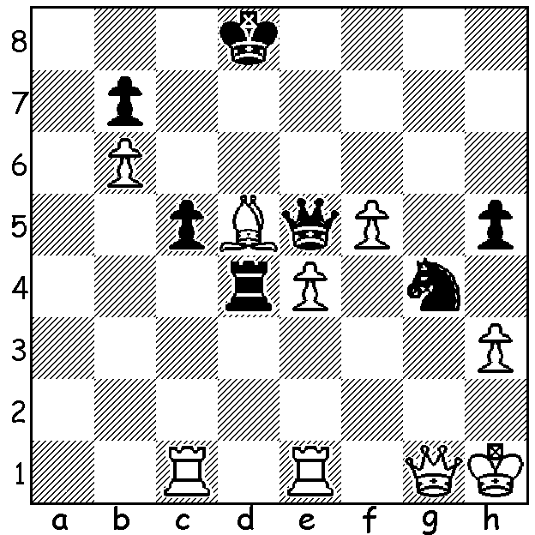
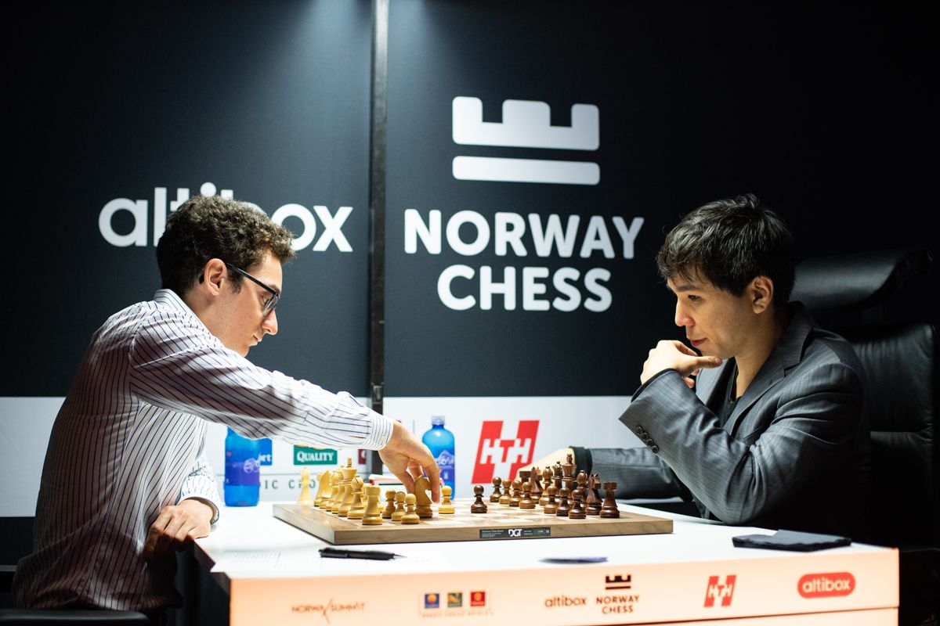

The Altibox Norway Tournament with ten of the world's top players appeared jinxed with firstly Azerbaijani GM Shakhtiyar Mamedyarov contemplating withdrawing before Rd 1 with severe toothache and then Chinese GM Ding Liren actually withdrawing before Rd 4 after a cycling accident on rest day (he did participate and win a My Kitchen Rules type competition among the contestants partnering Vishy Anand despite his broken hip). World Champion Magnus Carlsen set the early pace after defeating his coming challenger for the world title Fabiano Caruana in Rd 1, even remaining in the lead after a Rd 6 loss to Wesley So. However after eight rounds Carlsen, Caruana, and So were all bunched together on 4/7 with Anand, Hikaru Nakamura and Levon Aronian (3.5) also in the running for top place. After Carlsen took a quick draw against Maxime Vachier-Lagrave with an unforced repetition of moves, the Caruana-So game would decide the final result with a draw leading to a possible 5-way play-off. However So made a decisive error (see above) enabling Caruana to take his third big tournament win for the year after the Candidates and Grenke Classic. Scores: Caruana 5/8, Carlsen, Nakamura, Anand 4.5, So, Aronian, Mamedyarov 3.5, MVL and Sergey Karjakin 3.

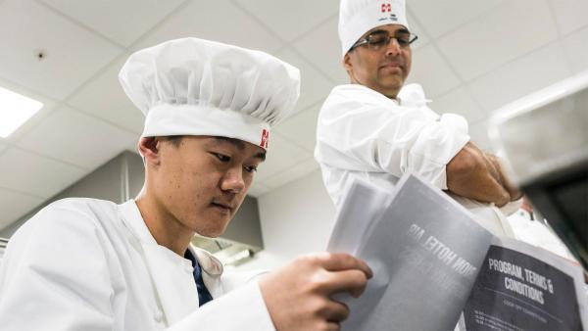
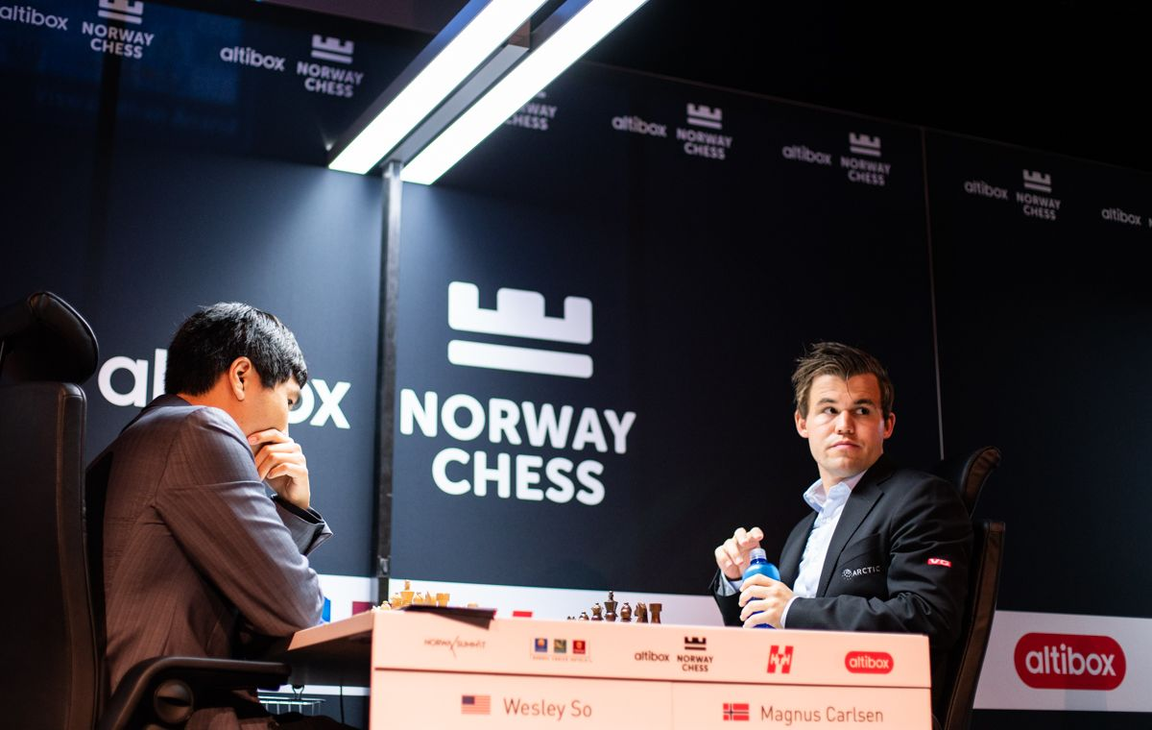

Ding Liren, with broken hip, winning the So, taking 8 minutes on 3rd move
cooking competition with Vishy Anand. against Carlsen.

Wesley So vs Magnus Carlsen
2018 Altibox Norway, Rd 6
Queens Gambit, Slav Exchange Variation
1.d4 d5 2.c4 c6 3.cxd cxd
4.Bf4 Nf6 5.Nc3 Nc6 6.Nf3 a6
7.Rc1 Bf5 8.e3 Rc8 9.Be2 e6
10.0-0 Nd7 11.Na4 Be7 12.h3(a) 0-0
13.a3 Na5 14.Nc5 Nc4 15.b4 Nxc5
16.dxc5 Nxa3 17.Nd4 Be4 18.f3 Bg6
19.Qb3 Nc4 20.Bxc4 dxc4 21.Qxc4 Qe8
22.Bg3 e5 23.Nb3 Bd8?(b) 24.Qd5 Qb5
25.Bxe5 Be7(c) 26.Qd2 Rfd8 27.Bd6 Bf6
28.e4 h6 29.Nd4 Bxd4+ 30.Qxd4 Re8
31.Rfe1 Kh7 32.g4 f6 33.f4 Qc6
34.f5 Bf7 35.h4 Ra8 36.Rc2 a5
37.g5 Bh5 38.g6+(d) Kh8 39.b5 Qxb5
40.Rb2 Qc6(e) 41.Rb6 Qc8 42.Qd5 a4
43.Rxb7 Rg8(f) 44.c6 Ra6 45.c7 Rxd6
46.Qxg8+! resigns(g)

a) White needs to be wary: 12.a3 would invite a strong attack with 12...g5! 13.Bg3 h5: now if 12...g5 13.Bh2 h5 14.Nd2 g4 15.hxg hxg 16.Bxg4.
b) A miscalculation.
c) Realising his intended 25...Qxb4 fails to 26.Bd6 Re8 27.c6!
d) Avoiding any possible counter attack after 38.gxf Rg8.
e) 40...Qd7 was better.
f) White threatened 39.Rxg7!
g) 46...Qxg8 47.Rb8 Rc6 48.Rd1 Rxc7 49.Rxg8+ Kxg8 50.Rd8#. This is So's first win against Carlsen in Classic Chess and Carlsen's first Classic loss in 2018.

SOLUTION: The two possible moves are 1...Rd3 and 1...Rd2. So, who had plenty of time to consider as a new time control had just started, took only a few seconds to play 1...Rd3 and the game continued 2.Qg2 Rg3 3.hxg4 Rxg2 4.Kxg2 & White won comfortably. If he had played 1...Rd2 the game would be drawn after 2.hxg4 hxg4 3.Qg2 Qh8+! 4.Kg1 Rxg2+ 5.Kxg2 Qh3+ 6.Kf2 Qf3+ with a perpetual check.

