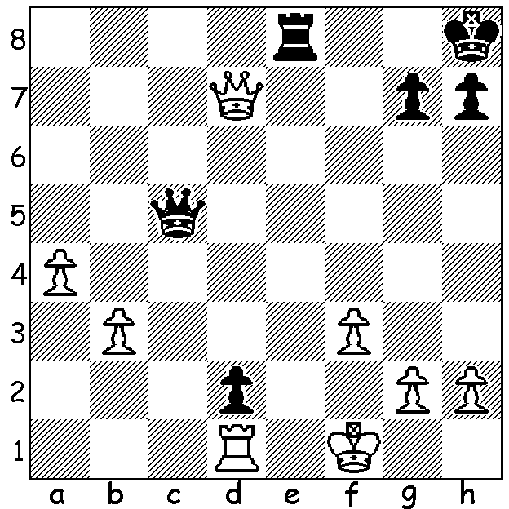

I shall be concentrating on pawns in future
articles so here are two starters. With White
two pawns up and expecting to capture Black's
dangerous passed pawn, Carlos Guimard
(Black) brings off a surprise win (3 moves):

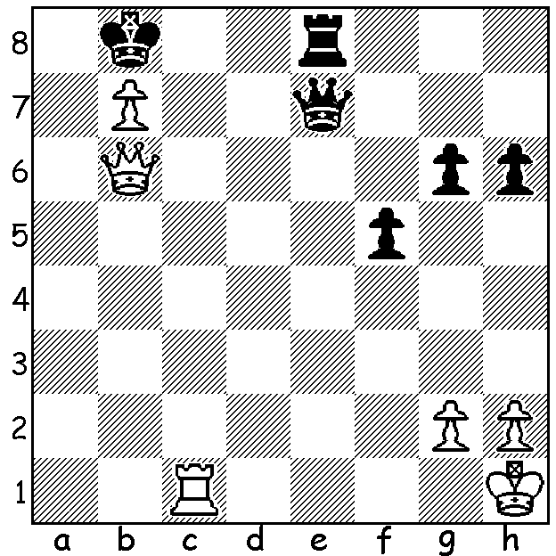

A similar position (Gulko-Grigorian)
but there's a difference at the end resulting
in a won endgame for White (4 moves):

Last month I reported on Sam Shankland
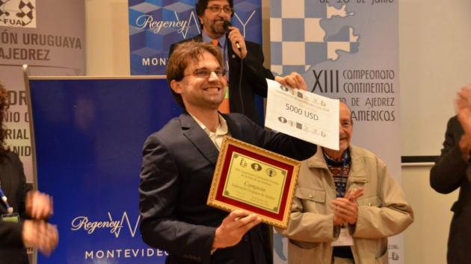
winning the strong US Championship with
a score of 8.5/11, the equal best score since
the start of the 12 player format in 2013.
Shankland followed this up with victory in
the 6 player Capablanca Memorial in Havana,
Cuba, with 7.5/10, a point an a half ahead of
second place. Then earlier this month he
scored his third tournament victory in a row, winning the American Continental Champion-
ship in Moevideo, Uraguay, with 9/11 which qualifies him for the FIDE World Cup. Here
is one of his wins from the event against a A happy Sam Shankland at presentation
rival US GM:

Jeffrey Xiong vs Sam Shankland
2018 American Continental, Rd 10
Sicilian Najdorf/Dragon
1.e4 c5 2.Nf3 d6 3.d4 cxd
4.Nxd4 Nf6 5.Nc3 a6 6.h3 g6
7.g4 Bg7 8.Be3 0-0 9.Qd2 b5
10.Bg2 Bb7 11.a3 Nbd7 12.g5 Nh5
13.Bf3 Ne5 14.Bxh5 gxh5 15.0-0-0 Rc8
16.Kb1 Rxc3! 17.Qxc3 Bxe4 18.f3 Nxf3
19.Rhf1 Qd7 20.Qb3 Ne5 21.Rf4 Bg6
22.Rdf1 e6 23.Rf6 Rc8 24.Bc1 Rc4
25.Qe3 Qa7 26.Nf5 Qxe3 27.Nxe3 Rh4
28.R6f4 Rxh3 29.a4 h6 30.axb axb
31.Rb4 Nd3! 32.cxd3 Bxd3+ 33.Ka2 Bxf1
34.Nxf1 Rh1 35.Rf4 hxg 36.Rf2 Bd4
37.Be3 Rxf1 38.Bxd4 Rxf2 39.Bxf2 h4
40.Kb3 f5 41.Kb4 h3 White resigns

SOLUTION: a) 1.Re1+! Rxe1 2.Qg1+!! Kxg1 3.dxe8=Q#.
b) 1.Rc8+! Rxc8 2.Qa7+!! Kxa7 3.bxc8=N+! / 4.Nxe7.

