A winning combination from an in-form
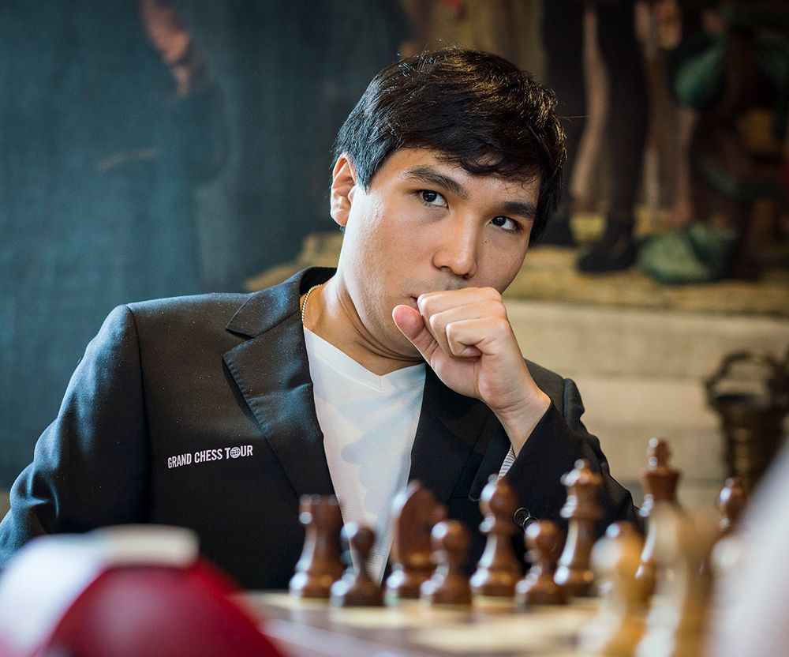
Wesley So vs Fabiano Caruana on Day
of the Leuven Rapidplay: Black to play
and win (3 moves):

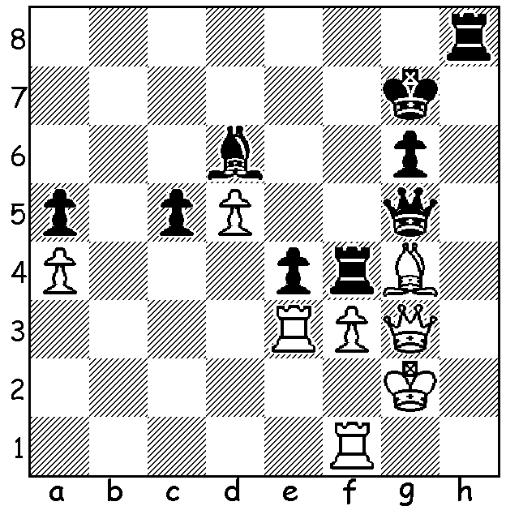

Ten of the world's top players are competing in the 2018 Grand Chess Tour (World Champion Magnus Carlsen has passed this year) with Rapid and Blitz events in Leuven in Belgium, Paris and St Louis as well as the Sinqufield Cup (Classical Chess event), also in St Louis, Missouri. Finally the top four players will compete in KO finals at the London Classic. Total prize money tops $1 million with the winner taking $375,000. In Leuven Wesley So was winner of the Rapidplay with 14/18, followed by Levon Aronian and Maxime Vachier-Lagrave on 11. Although he scored only 8/18 in the Blitz, So won the combined tournaments with 22/36, a half point ahead of Sergey Karjakin and MVL. Other combined scores: Hikaru Nakamura 21, Aronian 20.5, Alexander Grischuk 17.5, Shakhriyar Mamedyarov 17, Vishy Anand 9.5, Fabiano Caruana 6.5, Anish Giri 6. Here is an exciting game featuring the imaginative attacking flair of Levon Aronian and the cool defence of Sergey Karjakin:

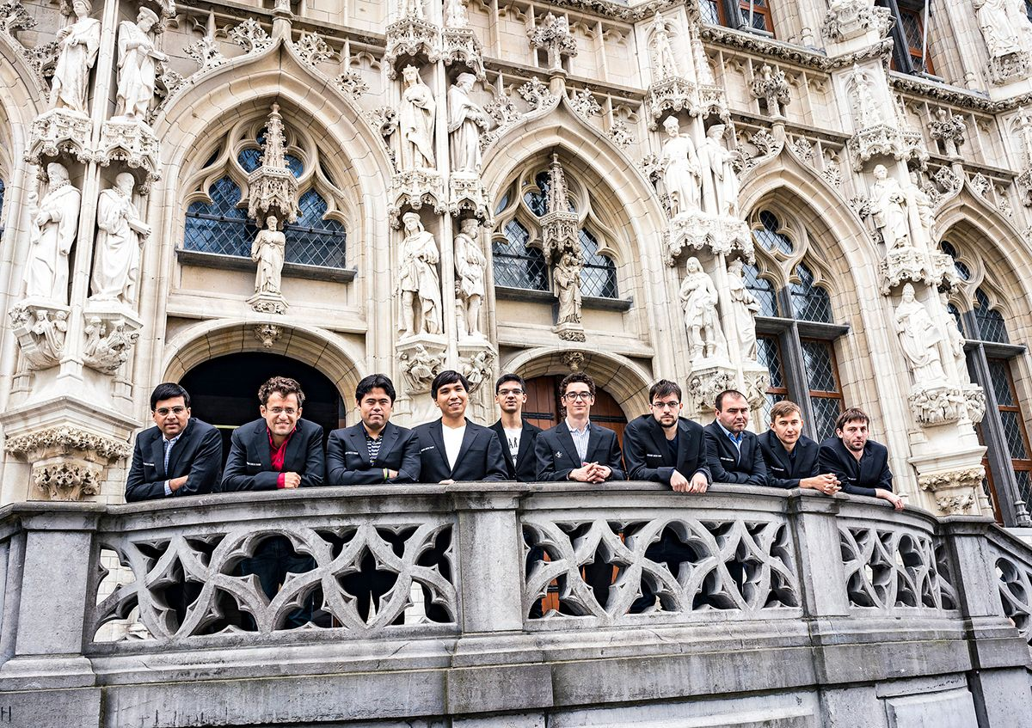
Contestants at Leuven (can you name them from L - R?)

Levon Aronian vs Sergey Karjakin
2018 Grand Chess Tour, Leuven Rapidplay
Giuoco Piano
1.e4 e5 2.Nf3 Nc6
3.Bc4 Bc5 4.0-0 Nf6
5.d3 d6 6.Re1 a6
7.c3 h6 8.Nbd2 0-0
9.Bb3 Ba7 10.Nf1 Re8
11.Ng3 Be6 12.Bc2 d5
13.exd Bxd5 14.Be3 Bxe3
15.Rxe3 Qd7 16.h3 Re7
17.Qd2 Rae8 18.Rae1 g6
19.Nh4 Nh7 20.Nh5!?(a) Kh8
21.d4 gxh5 22.Rg3 Re6
23.exe Qd8 24.Nf5?(b) Nxe5
25.Rg7 Nf3+! 26.gxf3 Rxe1+
27.Kh2 Rh1+! White resigns(c)

a) An imaginative sacrifice. If 20...gxh5 21.Rg3+ Ng5 22.Rxg5+! hxg523.Qxg5+ Kh7 24.d4+ e4
25.Nf5 f6 26.Qxh5+ Kg8 27.Qg6+ Kh8 28.Qxf6+ Rg7 29.Nxg7 Qxg7 30.Re3 winning
b) 24.Qf4 is better as Black now works up a deadly counter attack.
c) The queen is lost.

WA Championship: The final round of the state championship will be played on Sunday. Leading scores after 6 rounds are: WA Championship: The final round of the state championship will be played on Sunday. Leading scores after 6 rounds are: Stephanus Kurniawan 5.5/6, Patrick Gong 5, Ihsan Ferozkohi 4.5, Andrew Hardegen, Jay Lakner, Craig Kinsman 4. Final round pairings pit Stephanus against Ihsan, Patrick against Jay and Craig against Andrew.

SOLUTION: 1...Rxg4! and White resigns: 2.Qxg4 Rh2+ (not 2...Qxe3 Qd7+) 3.Kg1 Qxe3+ (a dual discovered attack with the queen targetting the e3 rook and the bishop giving the rook protection to check on h2)
Players L - R: Anand, Aronian, Nakamura, So, Giri, Caruana, MVL, Mamedyatov, Karjakin, Grischuk.

