The problem and game have something in
common but not necessarily similar results.
In Wesley So vs Maxime Vachier-Lagrave
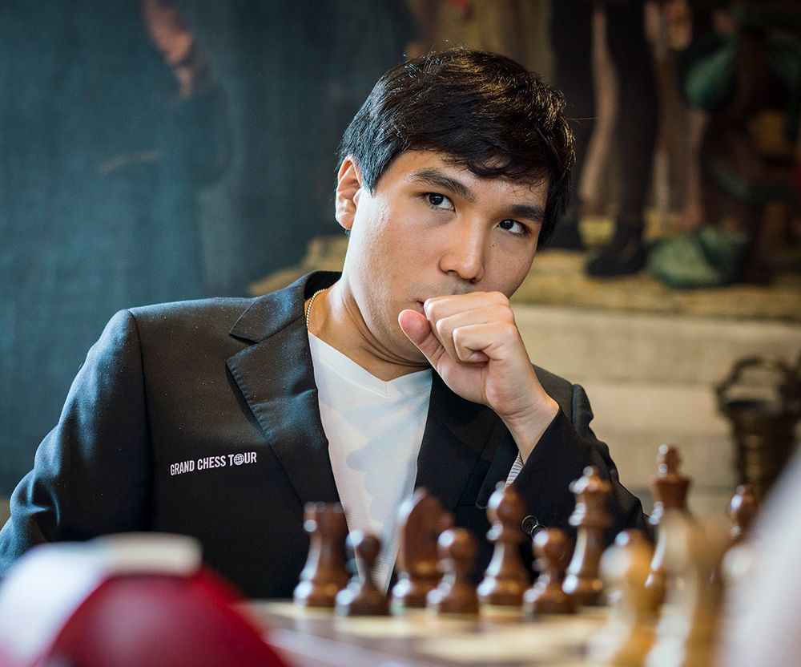
(Paris Rapidplay 2018) in reply to 1...Rc7
can White safely play 2.Qxb6?
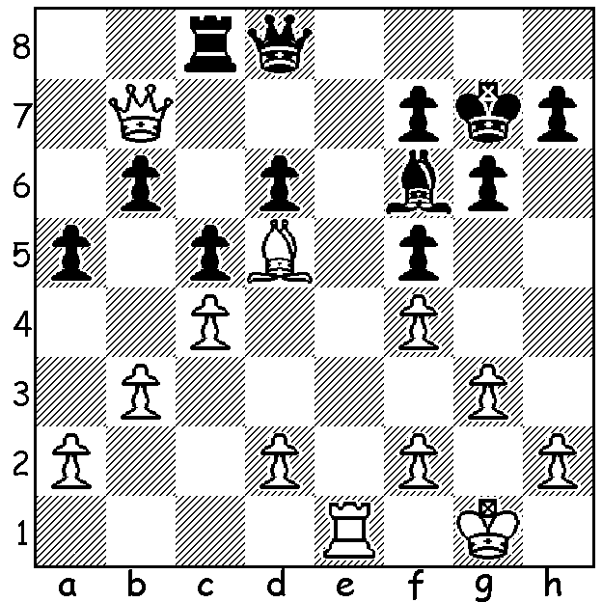

Wesley So

After Leuven the Grand Chess Tour contestants took the train to Paris for the second series of Rapidplay and Blitz games. So continued to impress to lead the Rapidplay with 12/18, one point ahead of Hikaru Nakamura and Sergey Karjakin. However it was Hikaru Nakamura with 13/18 in the Blitz who finished overall first with 23/36 followed by Karjakin (21.5) and So (21). The final day (2nd Blitz day) was marked by an unusual number of blunders, some really elementary, as players felt the effects of playing so many games in such a short time, 72 in 16 days in Leuven & Paris combined. Vishy Anand and Hikaru Nakamura played one of the most interesting and exciting games of the tournament:

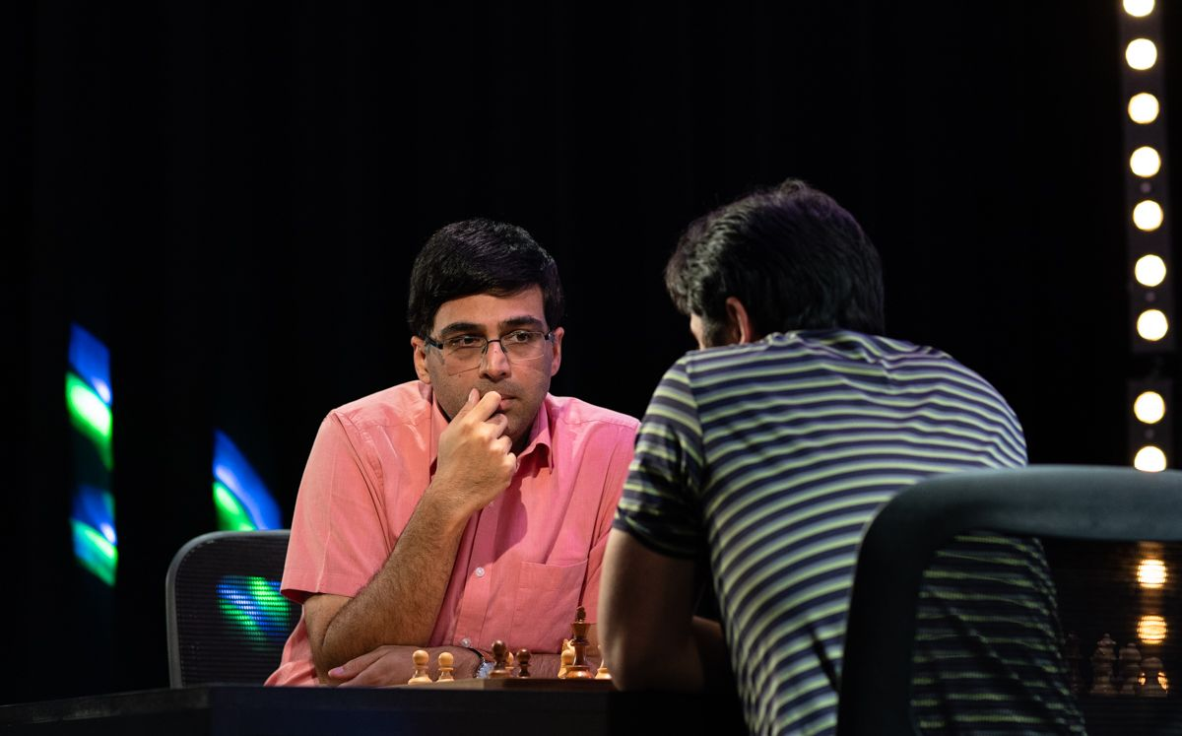
Viswanathan Anand vs Hikaru Nakamura
2018 Grand Chess Tour, Paris Rapidplay
Modern Defence
1.e4 d6 2.d4 g6
3.Nf3 Bg7 4.Bc4 Nf6
5.Qe2 0-0 6.0-0 Bg4
7.c3 Nc6 8.h3 Bxf3
9.Qxf3 e5 10.d5 Ne7
11.Bd3 Nd7 12.c4 f5
13.Qd1 c6 14.Nc3 cxd
15.cxd Kh8 16.Be3 Ng8
17.Rc1 a6 18.Rc2 Bh6(a) Anand above facing Nakamura below
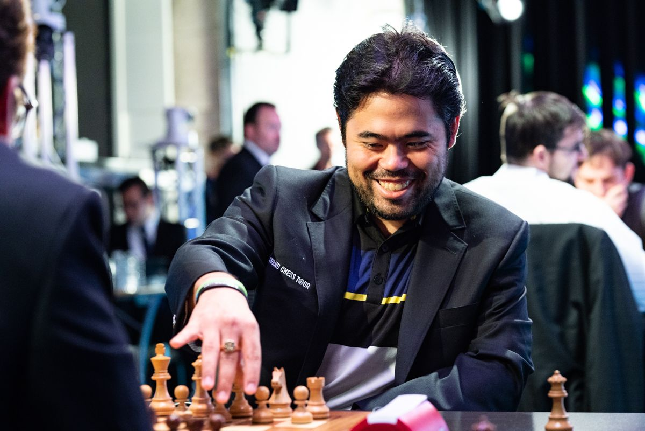
19.Bxh6 Nxh6 20.Qd2 f4
21.Rfc1 Ng8 22.f3 Ngf6
23.Nd1 a5 24.Nf2 Nc5
25.Bb5 Qb6 26.Rxc5! dxc5
27.a4 c4!(b) 28.Qc3! Qd6
29.Qxc4 Rac8! 30.Qxc8 Rxc8
31.Rxc8+ Kg7 32.Nd3 Nh5
33.Kf1!(c) Qb6 34.Nc5 Kh6!(d)
35.Ke1 Ng3?(e) 36.Kd1 Kh5
37.Kc2 Kh4 38.Kb1 Nh5
39.Ka2 Kg3 40.Nd3 Qd4
41.Rc2 Nf6 42.Nc5 Qd1 43.Kb3 g5
44.Nd3 Nd7 45.Kc3?(f) Nb6 46.Nxe5?(g) Qe1+
47.Kb3?(h) Qb4+ 48.Ka2 Nxa4 49.Bxa4 Qxa4+
50.Kb1 Qd4 51.Nc4 a4! 52.d6(i) Qd1+
53.Rc1 Qd3+ 54.Rc2 b5 55.Nd2 b4
56.Kc1 b3 57.Rc3 Qxd6 White resigns

a) Black completes his plan of exchanging his 'bad' bishop (blocked in by his own pawns).
b) To use the open c file if White captures.
c) To find safety on the queenside.
d) Black will use his king in attack.
e) Better 35...Kg5!
f) White fails to play 45.d6 when any result is possible.
g) Again 46.d6 (46...Qg1 47.Rf2! winning the knight).
h) Correct was 47.Rd2 (47...Nxd5+ 48.exd5 Qxe5+ 49.Kc2 with a likely draw).
i) 52.Rd2 Qxc4 53.d6 loses to 53...a3! decisively opening up the position.

SOLUTION: 1...Rc7 set a trap, but one into which White happily fell: 2.Qxb6!! Re7! 3.Rxe7 (3.Qxd8?? Rxe1+ 4.Kg2 Bxd8) 3...Qxb6 4.Rxf7+ Kh8 5.Rxf6 (playing to win with R, B +2p for Q). The game finished surprisingly quickly with 5...Qb4 6.Rxd6 Qxd2 7.Rc6 Qd4 8.Kg2 Kg7 9.Rc7+ Kh8 10.h4! h5 11.a4 and being in zugzwang Black resigned (11...Qc3 12.Rxc6 Qxb3 13.Rxa5 and the passed pawns will march).

