The legendary Mikhail Tal is on the receiving Mikhail Tal
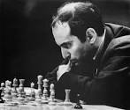
end vs Anatoly Lutikov (USSR Ch 1964/65):
White to play and win (3 moves)
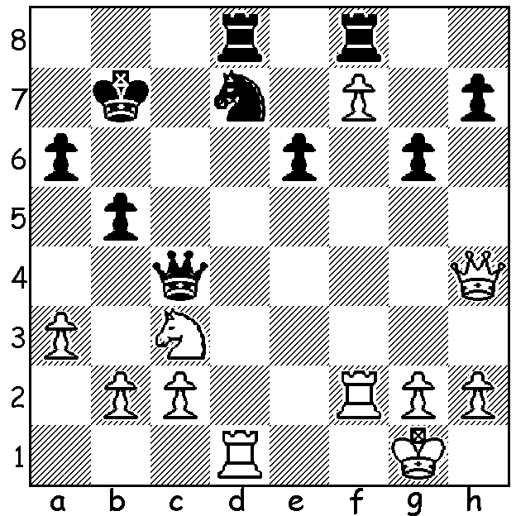

'Pawns are the soul of Chess.' Thus spake Philidor and I intend in a series of articles to show that pawns are the most important and influential pieces on the board. From the outset pawn structure determines the position, open or closed, who will attack, whether in the centre or on either the kingside or the queenside. Pawns provide cover for the king in the middle game and are used to open up the position, opening diagonals and files, as well as providing outposts for the pieces. Pawns are often an integral part of a mating attack, sometime administering the coup de grace. In endings success comes from promoting a pawn or winning material from the threat to do so. Here's a famous game showing the power of pawns heading for promotion:

Alexander McDonell vs Louis Charles La Bourdonnais
Match, London 1834
Sicilian Defence
1.e4 c5 2.Nf3 Nc6
3.d4 cxd 4.Nxd4 e5
5.Nxc6(a) bxc6 6.Bc4 Nf6
7.Bg5 Be7 8.Qe2 d5
9.Bxf6 Bxf6 10.Bb3 0-0
11.0-0 a5 12.exd cxd
13.Rd1 d4 14.c4(b) Qb6
15.Bc2 Bb7(c) 16.Nd2 Rae8(d)
17.Ne4 Bd8 18.c5 Qc6
19.f3 Be7 20.Rac1 f5(e)
21.Qc4+ Kh8 22.Ba4 Qh6
23.Bxe8(f) fxe4 24.c6 exf!
25.Rc2(g) Qe3+ 26.Kh1 Bc8
27.Bd7(h) f2 28.Rf1 d3
29.Rc3 Bxd7 30.cxd7 e4
31.Qc8 Bd8 32.Qc4 Qe1!
33.Rc1 d2 34.Qc5 Rg8
35.Rd1 e3 36.Qc3 Qxd1!
37.Rxd1 e2 White resigns(i)

a) Better 5.Nb5 as this gives Black the chance to gain pawn domination in the centre.
b) Unwisely making Black's d pawn passed.
c) Of course not 15...Qxb2 16.Bxh7+ winning the queen.
d) The correct rook as the other is needed to support the advance of the f pawn.
e) This results in the loss of the exchange but that's a small price to pay.
f) 23.Nd6 gives White some chance.
g) If 25.cxb7? Qe3+ 26.Kh1 fxg+ 27.Kxg2 Rf2+ 28.Kh1 Qf3+ 29.Kh1 Qg2#.
h) The attempt to block the rook with 27.Bf7 loses to 27...Bg4 28.Rf1 (28.c7 fxg+ 29.Rxg2 Bxd1 30.c8=Q Qe1+31.Rg1 Bf3#) 28...d3 29.Rcf2 d2 winning.
i) In 'The World's Greatest Chess Games (Burgess, Nunn & Emms)
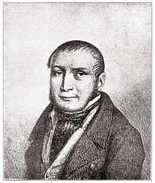
it cites the following lessons:
i) A large mobile pawn centre is a strategic asset:
ii) Don't be afraid to sacrifice to press forward:
iii) When pawns are far advanced, close to promotion,
always be on the lookout for tactical tricks involving promotion.

La Bourdonnais (France) and McDonnell (Ireland)
played a series of six matches in 1834. The overall
score was 45 wins to La Bourdonnais, 13 draws and
27 wins to McDonnell. The matches confirmed La
Bourdonnais, who had previously defeated the leading
French and English players, as the world's leading
player who could be considered the first world champion.

SOLUTION: 1.Qxd8! Rxd8 2.Rxd7+! Rxd7 3.f8=Q. La Bourdonnais

