PAWNS Part 2
Two puzzles this week with similar conclusions (as is the game):
i) A former Australian champion Max Fuller (ii) Sherzer vs Mathe 1989: With Black brings off a smart finish while living in the threatening 1...Qh1+ 2.Kg4 Qd1+ UK (White v Steedman 1979) Max Fuller 3.Kh3 Qxh5, can White win?

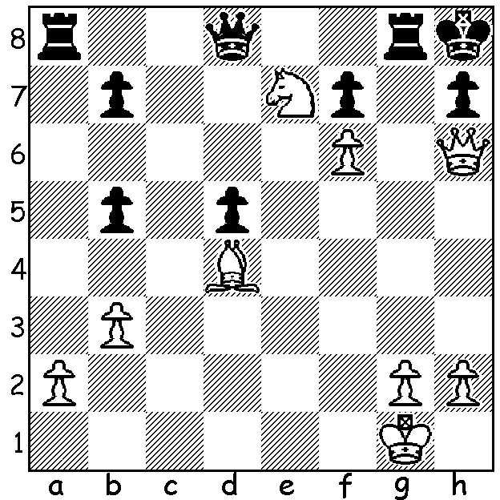
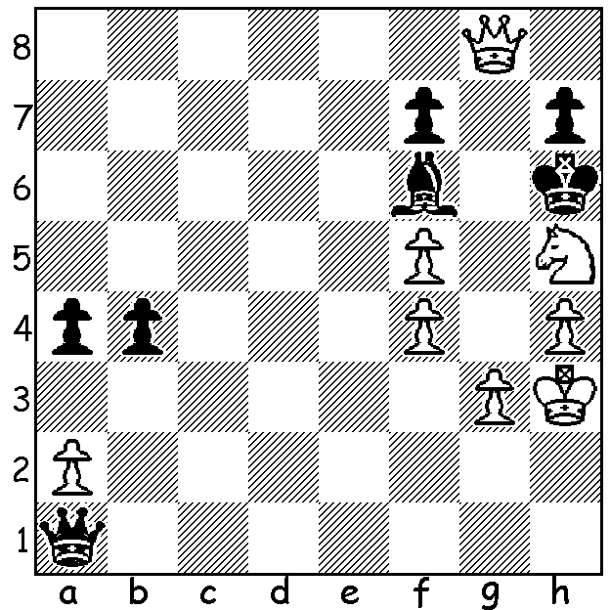
In this, the second article on pawns, the theme this week is the mating pawn and I'm using a game of my own as an illustration. One of White's little soldiers has an amazing journey crossing three files and advancing five ranks files to administer the coup de grace:


David Ellis vs Robert Maris
1994 WA Championship
Reti Opening
1.Nf3 d5 2.c4 c6
3.b3 Bg4 4.g3 Nd7
5.Bb2 f6 6.Bg2 e5
7.0-0 d4 8.d3 Bd6
9.Na3 f5 10.Nc2 a5
11.Qd2 Ngf6 12.e3 dxe
13.Nxe3(b) 0-0 14.Nxg4 Nxg4
15.a3 Qc7 16.b4 axb
17.axb c5(c) 18.b5 Ngf6
19.Ng5 Rxa1(d) 20.Rxa1 Re8
21.Ra7 e5 22.dxe Qb6(e)
23.e5! Qxa7 24.Qxd6 Qb6
25.Bd5+ Kh8(f) 26.exf6!! Re1+
27.Kg2 Qxd6(g) 28.fxg#

a) Gaining the two bishops and leaving Black vulnerable on the white squares on both sides.
b) Preventing 18.c5 but exposing his b pawn and leaving d5 unguarded..
c) Black would have been reluctant to cede control of the a file but if 19...Rfe8 20.Ne6! Qb6 21.Qg5.
d) If 22...fxe 23.Bxe4! Nxe4? 24.Qd5+ Kh8 25.Nf7+ Kg8 26.Nh6+ Kh8 27.Qg8+! Rxg8 28.Nf7# (this smothered mate is known as Philidor's Legacy).
e) Again 25...Nxd5 26.Qxd5+ leads to the smothered mate.
f) Black generously allows White his moment of glory a queen down. What bishops! And what about that d pawn journey from d2 to g7?

SOLUTION: i) Qg7+! Rxg7 2.fxg7#.
ii) Yes he can! 1.Qg5+!! Bxg5 2.f/hxg5+ Kxh5 3.g4#.

