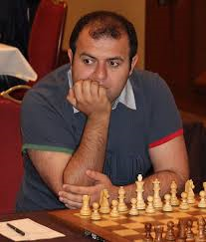
Mamedyarov vs Reinderman
(European Ch 2005):
White to play and win:
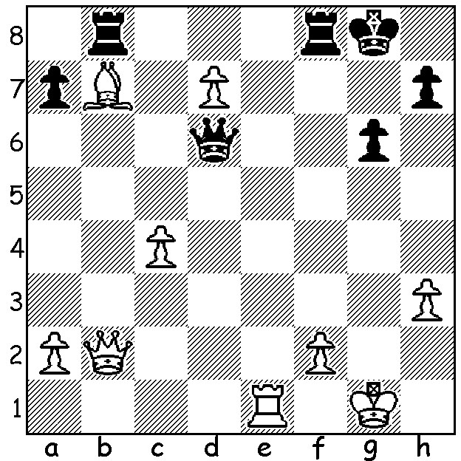

I conclude my series of articles on pawns with a look at the sacrifice of a piece for two pawns in the opening to gain an imposing centre which cramps and restricts the development of the opponent's pieces. Firstly a game from the legendary David Bronstein (1924-2006) who came within a whisker of winning the World Championship in his drawn match (12-12) with Mikhail Botvinnik in 1951:

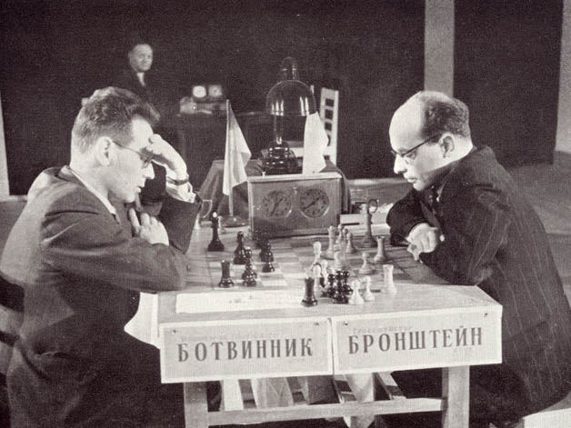
David Bronstein vs Ernst Rojahn
1956 Olympiad, Moscow
Two Knights Defence
1.e4 e5 2.Nf3 Nc6
3.Bc4 Nf6 4.Ng5 d5
5.exd Na5 6.d3 h6
7.Nf3 e4 8.dxe4!? Nxc4
9.Qd4 Nb6(a) 10.c4 c5?(b)
11.Qd3 Bg4 12.Nbd2 Be7
13.0-0 0-0 14.Ne5 Bh4
15.b3 Nbd7 16.Bb2 Nxe5
17.Bxe5 Nd7 18.Bc3 Bf6
19.Rae1 Bxc3 20.Qxc3 Qf6
21.e5 Qf5 22.f4 Bg6 Bronstein (rt) v Botvinnik (World Ch 1951)
23.Ne4 Rab8 24.Qf3 Bh7
25.g4 Qg6 26.f5 Qb6 27.Qg3 f6
28.e6 Ne5 29.h4 Kh8 30.g5 Rbc8
31.Kh1 Qd8 32.g6 Bxg6 33.fxg6 b5
34.d6 Qb6 35.d7 Nxd7 36.exd7 Rcd8
37.Nxf6! Qc6+(c) 38.Qg2 resigns

a) 9...Nd6 is better.
b) A poor move giving White a passed d pawn.
c) If 37...Rxf6 38.Re8+ or 37...gxf6 38.g7+.

The second game comes from the present world number 3, Shakhriyar Mamedyarov from Azerbaijan who seems to have a penchant for this kind of sacrifice. See how Russian champion Peter Svidler, a many times Russian champion, is swamped by White's pawns:

Shakhriyar Mamedyarov vs Peter Svidler
2009 World Blitz Championship
Ruy Lopez, Exchange Variation
1.e4 e5 2.Nf3 Nc6 3.Bb5 a6
4.Bxc6 dxc6 5.0-0 Qd6 6.Na3 Be6
7.Qe2 f6 8.Nc4 Qd7 9.Rd1 c5
10.c3 b5 11.Ncxe5!? fxe5 12.Nxe5 Qe7
13.d4 g6 14.a4 b4 15.d5 Bd7
16.Nxd7 Qxd7 17.e5 Qf5 18.cxb Bg7
19.g4! Qf7(a) 20.bxc5 h5 21.e6 Qf6
22.d6 hxg 23.Qe4 Rd8 24.Qc6+ Kf8
25.Qxc7 Re8 26.d7 Rd8 27.Bf4 Bh6
28.Bd6+ Kg7 28.Be5 resigns

a) If 19...Qxe5 20.Qxe5 Bxe5 21.Re1 winning.

Even more outrageous a sacrifice is the Halloween Gambit in the Four Knights, sacrificing a piece for only one pawn: 1.e4 e5 2.Nf3 Nc6 3.Nc3 Nf6 4.Nxe5!? Nxe5 5.d4. But that's another story.

SOLUTION: 1.Re7!! and if 1...Rf7 2.Re8+ Rf8 3.Bd5+: the game concluded 1...Qxe7 2.Bd5+ Qf7 3.Bxf7+ Kxf7 4.Qd4 winning. The game, a Dutch Leningrad, was another piece sacrifice for a strong centre: 1.d4 f5 2.g3 Nf6 3.Bg2 g6 4.Nf3 Bg7 5.0-0 0-0 6.b3 d6 7.Bb2 Qe8 8.c4 Ng4 9.h3 Nh6 10.Nc3 e5 11.dxe dxe 12.e4 f4 13.Nd5 Na6 14.gxf c6 15.fxe5!? cxd5 16.exd.

------------------------------------------------------------------------------------------------------------------------

