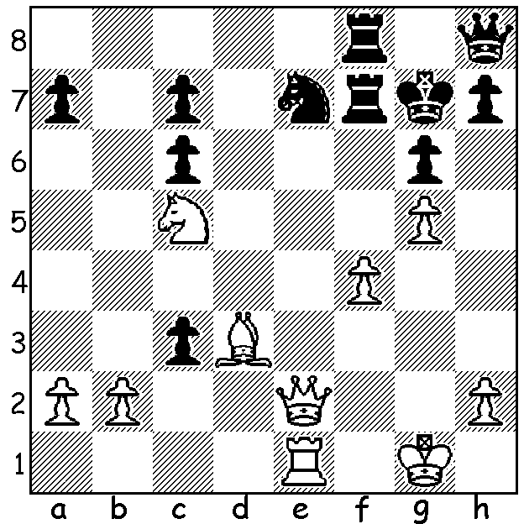
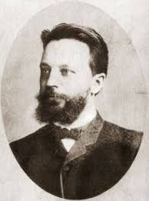
Chigorin vs Schiffers 1880:
White mates in 5 (2 variations): Mikhail Chigorin

Since returning from holiday I've been catching up with news of the WA State Championship. Leader Stephanus Kurniawan, who has been playing very little in the past few years, faced a difficult game in his last round against a consistent winner in WA events, Ihsan Ferokzohi. White, with considerable skill, built up an ideal position from the opening but had to withstand a sacrificial attack from Black which almost certainly would have succeeded had it not been for one serious pawn weakness: The win by Stephanus secured his first and well deserved title with 6.5/7, dropping only a half point to runner-up Patrick Gong (6/7) who also drew with Andrew Hardegen who was third with 5. Other prize winners: Reserves Champion - CAWA President Alan Wolstencroft (4), Seniors Champion - a former WA Champion Craig Kinsman (4.5), Ladies Champion - Natalie Maris (3.5) and leading Junior - Rebo Fu (3.5):

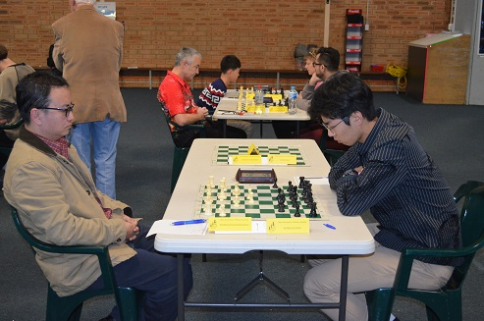
Stephanus Kurniawan vs Ihsan Ferokzohi
2018 WA Championship, Rd 7
French Defence, Chigorin Attack
1.e4 e6 2.Qe2 c5
3.Nf3 g6 4.g3 Bg7
5.Bg2 Ne7 6.0-0 0-0
7.d3 Nbc6 8.a4 b6
9.Na3(a) d5(b) 10.c3 Bb7
11.h4(c) Na5 1 2.Qc2 d4(d)
13.b4! cxb 14.cxb Rc8
15.Qb1 Nac6 16.Bd2 Ne5 Kurniawan v runner-up Patrick Gong
17.Nxe5 Nxe5 18.b5 a5(e)
19.Qb3 Rc5 20.Nc4 Bg7 21.Bc1! Re8
22.Ba3 Rc7 23.Nd6(f) Rf8 24.Rac1 Ba8
25.Rxc7 Qxc7 26.Rc1 Qb8 27.Bh3(g) Be5
28.Nc4 Bxg3!?(h) 29.fxg3(i) Qxg3+ 30.Bg2 Bxe4!
31.Qc2 Bxg2(j) 32.Qxg2 Qxh4 33.Nxb6(k) Rd8
34.Bxe7 Qxe7 35.Qg3 e5 36.Re1 f6
37.Nc4 Qb4 38.b6 Qxa4 39.Qf3 Qb4
40.Re2 Kg7(l) 41.Qb7+ Kg8 42.Rf2 Qb1+
43.Kg2 Qc1 44.Rd2 a4 45.Qc7 Rf8
46.b7 Qb1 47.Nb2 a3 48.b8=Q a2
49.Qbb7 resigns

a) The Chigorin Attack (2.Qe2) was a precurser to the quite popular Kings Indian Attack against the French (1.e4 e6 2.d3 d5 3.Nd2). I sometimes met the Chigorin Attack with 2....e5.
b) The main alternative is the more flexible 9...d6.
c) This is usually played after e5, locking the centre as a prelude to a kingside attack on the black squares. White here keeps his options open in case a queenside attack gives better prospects.
d) This advance presents White with a opportunity to secure the important outpost on c4 for his knight and also lessens the effectiveness of Black's bishops.
e) Locking the queenside but making the b pawn seriously weak with White's knight occupying c4.
f) Not 23.Nxb6?? Rc3.
g) Now Black has to consider White piece sacrifices on f7 and e6.
h) A speculative and possibly desperate sacrifice to expose White's king. The safer move was 27...Bf6.
i) Better seems 29.Bxe7 but perhaps he feared 29...Bxf2+ 30.Kxf2 Qf4+. However White escapes with 31.Ke2 Qh2+ 32.Kd1.
j) If 31...Bxd3 32.Qf2 Qxf2 33.Kxf2 winning.
k) Without this move White would be much worse. Now the passed b pawn decides.
l) 40...Rf8 would have made White's task harder.
m) Not 44.Rxf6?? Qg5+.

You might like to watch PAWN SACRIFICE tonight (Friday) on SBS, a 2014 film on the Fischer vs Spassky match in Reykjavik.

SOLUTION: 1.Qxe7+! Rxe7 2.Rxe7+ Rf7 (2...Kg8 3.Bc4+ Rf7 4.Re8+ Kg7 5.Ne6#) 3.Ne6+ Kf8
4.Re8+ Rf8 5.Rxf8#.

