Spassky vs Fischer
(Wld Ch 1972, Game 5):
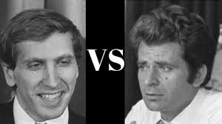
Black to play and win.
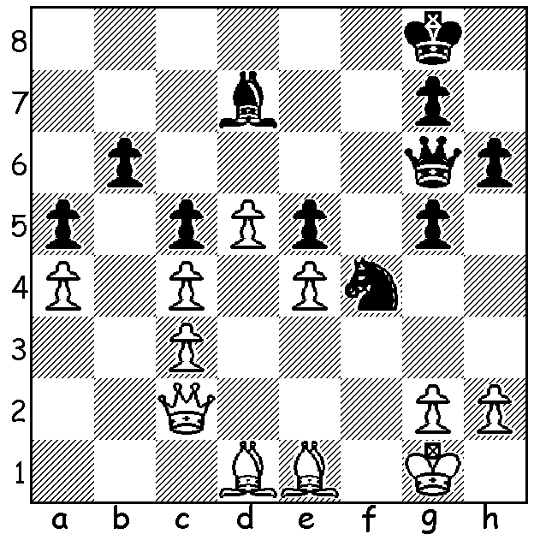

Fischer Spassky

Did you watch the film last Friday on SBS about the 1972 World Championship match between Bobby Fischer and Boris Spassky, 'Pawn Sacrifice'? It seemed a fairly accurate depiction of the match with much archival material included and generally devoid of artificial sensationalism. However there were a few examples of inaccuracies (or what I considered inaccuracies): we saw Fischer condemning the way the Russians (USSR) played as a team in Candidate tournaments to decide on a challenger to the world champion (a grievance remedied by changing from an All-Play-All to a Knock Out competition) but the background was the Chess Olympiad which IS a team competition; Fischer was shown to have immediately realised his blunder in Game 1, in grabbing the h pawn and getting his bishop trapped while it was in fact an error in calculation and moreover he did not immediately resign as in the film but continued in a very difficult ending where he had a real chance of salvaging a draw; during Game 5 we saw Spassky dismantle his chair looking for some electical appliance planted by the Fischer team but although there were accusations and official examinations I'm not sure if Spassky's purported action actually happened; Fischer was shown giving a Simul with clocks which was unlikely (I played in Simuls against both Keres and Gligoric and certainly clocks were not used). The actor playing Spassky certainly looked the part although the main actor was considerably shorter than the 6' 2'" Fischer. The film went faithfully through the problems created by Fischer and concluded its coverage of the match with Fischer taking the lead with a wonderful win in Game 6 which showed Spassky applauding at the end (a fact I was unaware of but did check out). What the film sought to show, as it traced Fischer's life from childhood, was that the mental problems which were clearly evident after Fischer retired were in fact there from much earlier in his life as an adult. The film also showed a supremely confident Spassky early on in the match wanting to continue when there was a very strong chance of an early disqualification of the challenger. It also revealed how important the USA government saw the match in the context of the Cold War with both President Richard Nixon and Secretary of State Henry Kissinger personally imploring Fischer not to pull out. Here then is the famous Game 6 Fischer win:

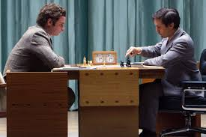
Robert Fischer vs Boris Spassky
1972 World Championship, Game 6
Queens Gambit, Tartakovers Defence
1.c4 e6 2.Nf3 d5
3.d4 Nf6 4.Nc3 Be7
5.Bg5 0-0 6.e3 h6
7.Bh4 b6 8.cxd Nxd5
9.Bxe7 Qxe7 10.Nxd5 exd5
11.Rc1 Be6 12.Qa4 c5
13.Qa3 Rc8 14.Bb5 a6
15.dxc bxc 16.0-0 Ra7
17.Be2 Nd7 18.Nd4! Qf8(a) Spassky (L) & Fischer as portrayed
19.Nxe6 fxe6 20.e4! d4?(b) in the film 'Pawn Sacrifice'.
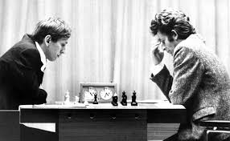
21.f4 Qe7 22.e5 Rb8
23.Bc4 Kh8 24.Qh3 Nf8
25.b3 a5 26.f5 exf
27.Rxf5 Nh7 28.Rcf1 Qd8
29.Qg3 Re7 30.h4 Rbb7
31.e6 Rbc7 32.Qe5 Qe8
33.a4 Qd8 34.R1f2 Qe8
35.R2f3 Qd8 36.Bd3 Qe8
37.Qe4 Nf6(c) 38.Rxf6! gxf6
39.Rxf6 Kg8 40.Bc4 Kh8
41.Qf4 resigns
The real Fischer (L) and Spassky.
a) Better 18...Kf8, ...Nf8 or ...Nf6.
b) Now Black is weak on the white squares.
c) If 37...Rxe6 38.Rf8+! Nxf8 39.Rxf8+ Qxf8 40.Qh7#.

The WILLETTON OPEN (WA Grand Prix event) will be played 18/19 August at Leeming Primary. See cawa.org.au for details or contact me (ellisd19@bigpond.com or 0439798607).

SOLUTION: 1....Bxa4! and White resigns (2.Qxa4 Qxe4 with double threat of 3...Qxg2# & 3...Qxe1#).

