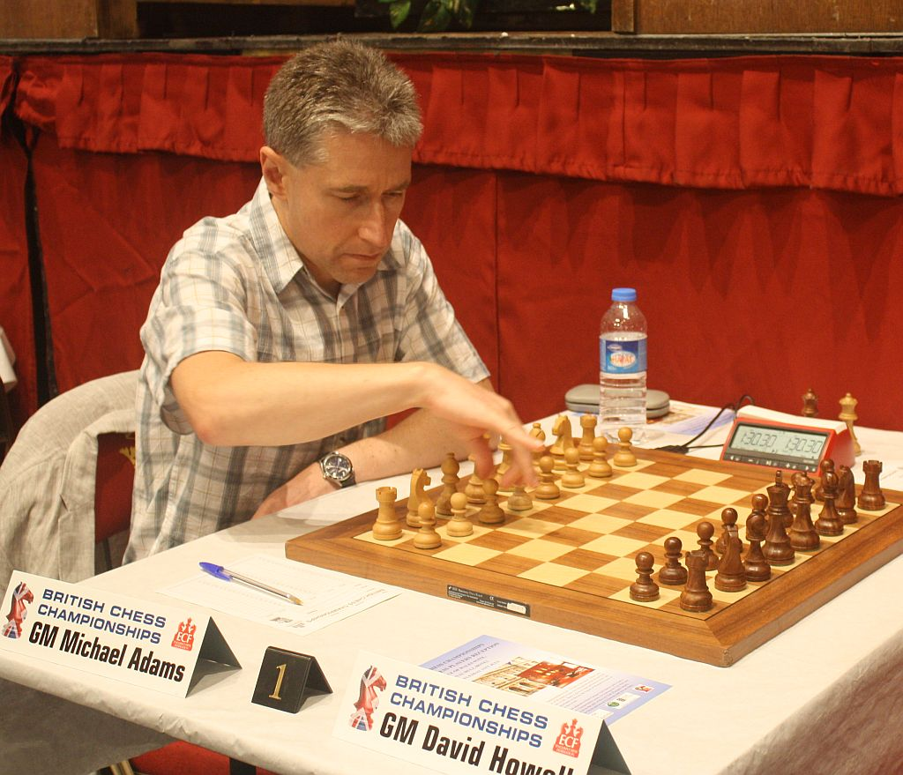
Tamas Fodor vs Michael Adams
(British Championship 2018):
White has just offered the exchange
of queens but is shocked by Black's
reply which forces immediate resignation:
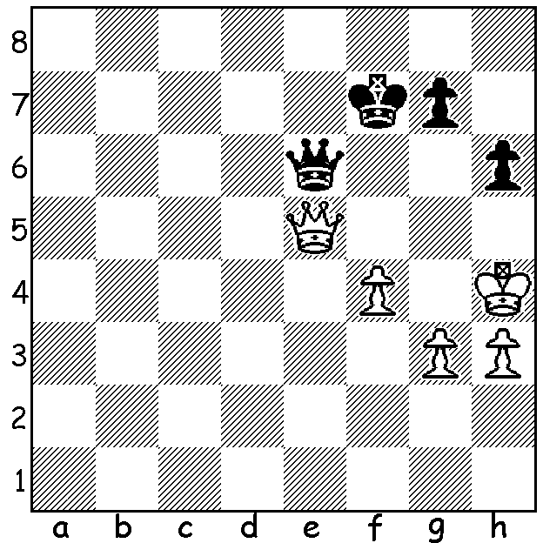

Michael Adams at British Championship

This month 46 year old Michael Adams won his 6th British Championship after a play-off with Luke McShane. Adams hadn't lost a single game in British Championships for 30 years although in many years top international GM tournaments prevented his participation. However he came very close to losing that record in Rd 3 (see above). Going into the final round Adams shared the lead with David Howell and, while Adams could only draw, Howell lost to Luke McShane who won with a queen sacrifice. In the play-off Adams won the two blitz games (5min + 3sec) after he and McShane shared wins in the two rapidplay games (20min + 10sec).

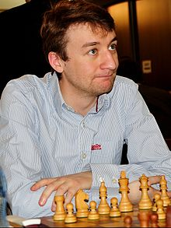
David Howell vs Luke McShane
2018 British Championship, Rd 9
Ruy Lopez, Steinitz Defence Deferred
1.e4 e4 2.Nf3 Nc6
3.Bb5 a6 4.Ba4 d6
5.0-0 Bd7 6.d4 exd
7.Nxd4 Nxd4 8.Bxd7+ Qxd7
9.Qxd4 Nf6 10.Nc3 Be7
11.Bf4 0-0 12.Rad1 Qc6
13.Nd5 Nxd5 14.exd5 Qxc2
15.Rc1 Qf5 16.Rxc7 Bf6 Luke McShane

17.Qd2 Rfc8 18.Rfc1 Rxc7
19.Rxc7 Re8 20.h3 h5
21.b3(a) g5 22.Be3(b) Re5
23.Rxb7 Rxd5 24.Qc1 Be5
25.Rb4 Qd3 26.f4?(c) Qe2
27.Kh2 gxf 28.Bxf4 Rd2!
29.Qc6 Kg7 30.a3 h4!
31.Rc4 Qe3!(d) 32.Qe4 Qg3+!!
White resigns(e) David Howell
a) If 21.Rxb7? Qb1+ 22.Kh2 Re1 winning.
b) 22.Bxd6 Rd8 23.Bb4 Rxd5 is equal.
c) 26.f3 had to be played.
d) Not 31...d5 32.Qh6+.
e) 33.Bxg3 hxg3+ 34.Kg1 Rd1+.

The WILLETTON OPEN (WA Grand Prix 6 Rd Swiss) will be played tomorrow and Sunday, 10.30 - 5.45 each day, at Leeming Primary (details cawa.org.au). Submit entry to me (0439798607 or ellisd19@bigpond.com or on arrival - by 10am please). Entry fee payment on arrival.

I have received information that WA has won the Australian Interstate Correspondence Chess Championship. I hope to provide further details and a game from the event in a future article.

The Harris-Edwards Interclub Competition was played at the Perth Club on 19 July & 5 August with Southern Suburbs winning all three divisions. Regretably the Metropolitan Club declined to enter this year.

SOLUTION: 1...g5+! White resigns (2.fxg Qxe5 or 2.Kh5 Qxh3#). A piece of luck for Adams.

