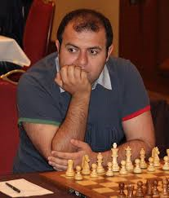
Here's missed combination:
Shakhriyar Mamedyarov vs Levon Aronian
(Paris Rapidplay 2018): White to play and win.
Two sacrifices result in a mate or a winning
endgame (5 moves):
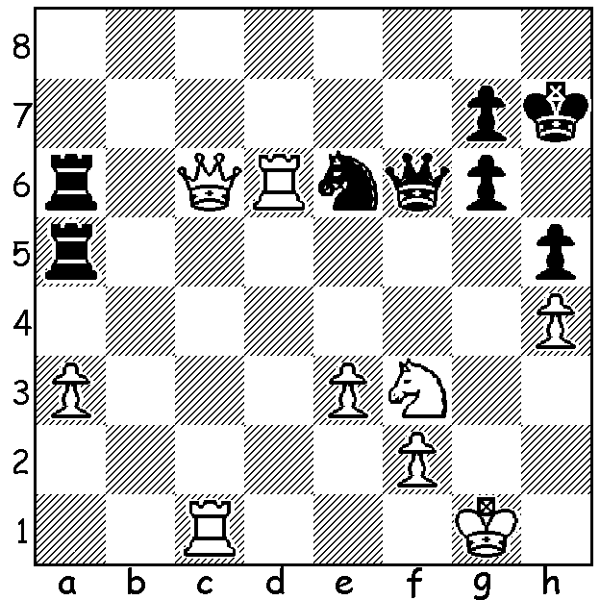

Shakhriyar Mamedyarov

It's seems unbelievable, world champion Magnus Carlsen with White getting his queen trapped on move 15, but it happened on the first day at Biel in Switzerland ina 6 player 10 round event (July 20-31).

Magnus Carlsen vs David Navara
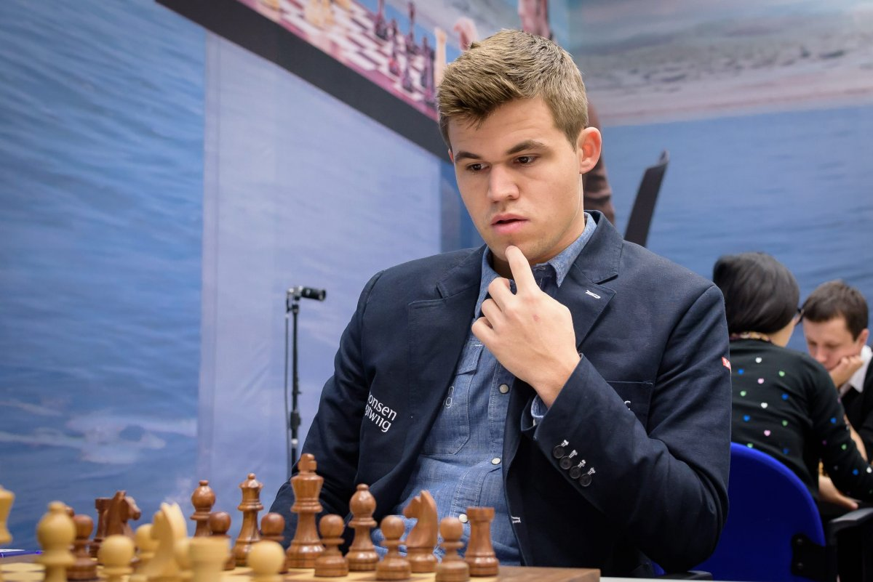
51st Biel GM Tournament 2018, Rd 1
Queens Gambit, Vienna Variation
1.d4 Nf6 2.Nf3 d5
3.c4 e6 4.Bg5 Bb4+
5.Nc3 h6 6.Bxf6 Qxf6
7.e3 0-0 8.Rc1 dxc
9.Bxc4 c5 10.dxc Nd7
11.0-0 Nxc5 12.Nb5 a6
13.Nbd4 b5 14.Be2 e5
15.Nc2 Rd8 16.Nxb4 Rxd1
17.Rfxd1(a) a5! 18.Nd5 Qd6
19.Nxe5! Bb7(b) 20.Bf3 Rc8 Magnus Carlsen
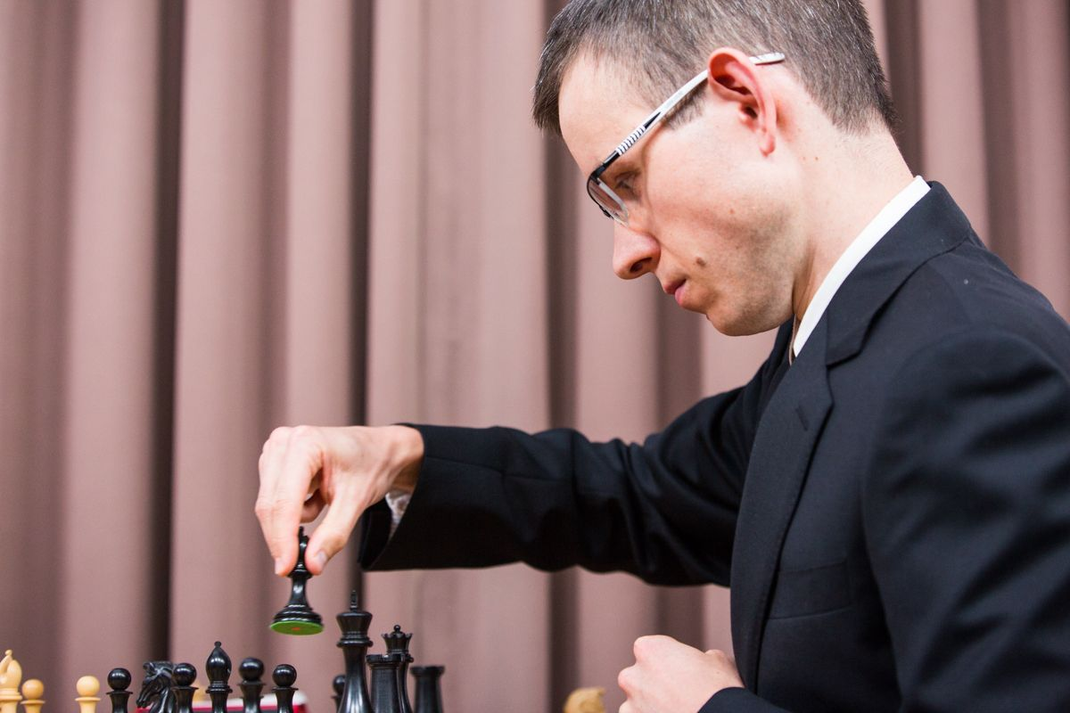
21.Ng4 Qf8(c) 22. h4 Nd7
23.Rxc8 Bxc8 24.a3 h5
25.Nh2 g6(d) 26.Be2 Ne5(e)
27.Bxb5 Bb7 28.Nc3 Qe7
29.Rd4 Qe6 30.Nf1 Qb3
31.Rd2 Nc4 32.Rd7! Nxb2
33.Rxb7 Qxc3 34.Be8 Kf8
35.Bxf7 Qc6! 36.Rxb2 Kxf7
37.Rd2 Qa4 38.Rd3 Qxh4
39.Rd7+ Kg8 40.Rd4 Qe7
41.a4 Qa3 42.g3 Qa1
43.Kg2 g5 44.Nd2 g4!(f)
45.Ne4 Qc1?(g) 46.Nf6+ Kf7
47.Nxh5 Qc6+ 48.Kg1 Qc1+ David Navara
49.Kh2 Kg6 50.Nf4+ Kf6
51.Ng2 Kg5 52.Rf4 Qd1 53.Nh4 Qc2
54.Nf5 Qd3 55.e4 Qd7 56.e5 Qh7+
57.Kg1 Qg6 58.Nd6 Qe6 59.Rf5+(h)

a) You may wonder why no Carlsen move has warranted a ?. The reason is he had planned the sacrifice. Black with knight attacked and development yet to be completed faces danger from the rooks and b4 knight, eg 17...Qc7 18.Nc6 wins or 17...Ne6 18.Nd5 Qd8 (to defend b6) 19.Nc7 winning back the queen with a dominating position: 17...Qb6 is possible but White is still better after 18.Nd5 Qa7 19.b4 Ne6 20.Nxe5. *
b) The counter-sacrifice 19...Qxe5 20. Rxc5 Qxb2 21.Bf3 Be6 22.Ne7+ Kf8 23.Bxa8 Kxe7 was possible with counterplay on the queenside.
c) Meeting the threat of 22.Ndf6+.
d) Again counter attack with 25...Ne5! 26.Bxh5 Nc4 27.Rc1 Bd7 when White's queenside pawns are vulnerable.
e) Safer was 26...Qc5.
f) White will need to defend f3 to prevent posssible perpetuals.
g) The h pawn needed the king's protection with 45...Kg7.
h) Transposing into an easily won K & P ending - 59...Qxf5 60.Nxf5 Kxf5 61.f4 gxf 62.Kf2 Kxe5 63.Kxf3 Kf5 64.Ke3 Kg4 65.Kd4 Kxg3 66.Kc5 Kf4 67.Kb5 Ke5 68.Kxa5 Kd6 69.Kb6 Kd7 70.Kb7 resigns.

Despite such a fine start Carlsen trailed Shakhriyar Mamedyarov by a point with two rounds to go when the two faced each other. Then for the first time since 2008 Mamedyarov defeated Carlsen and won the event with a round to spare. Final scores: Mamedyarov 7.5/10, Carlsen 6, Maxime Vachier Lagrave & Peter Svidler 5.5, David Navara 4, Nico Georgiadis 1.5. Wild card Georgiadis drew with Carlsen in Rd 1 and was pressing for a win against the world champion in the final round before blundering.

* One can imagine the interest of the other competitors on seeing Carlsen's queen trapped, all hoping it would result in a first round loss for the world champion. On a personal note, in the 1992 WA Championship I had the following opening with White against Bernard Anton: 1.Nf3 Nc6 2.d4 d6 3.e4 Bg4 4.d5 Ne5 5.Nxe5 Bxd1. In a short time other players had gathered around my board to see me a queen down. After 6.Bb5+ c6 7.dxc Qa5+ 8.Nc3 Black should play 8...0-0-0 when I had analysed 9.Nc4 Qc7 10.Nd5 Qb8 11.c7 Qa8 12.cxd8=Q+ Kxd8 13.Kxd1. Black instead played 8...bxc and lost in 19 moves after 9.Bxc6+ Kd8 10.Nxf7+ Kc8 11.Bxa8 etc. That year Haydn Barber achieved one of his many state titles and I finished a half point behind in second place.

SOLUTION: 1.Qxa6!! Rxa6 2.Rxe6! Rxe6 3.Ng5+ Kh6 4.Rc8 Qxg5 5.Rh8#: Black can avoid mate with 2...Qxe6 but after 3.Ng5+ Kg8 4.Nxe6 Rxe6 5.a4 the passed a pawn will ensure victory. In the game it was Black who came out on top after 1.Qd7 in a Q & R ending with the insecurity of White's king proving fatal.

