On June I reported on the Australian Open & Women's teams for the Olympiad starting September 23 in Batumi, Georgia, and asked readers to support the fund to help pay the teams' airfares of about $30,000. The teams receive no government support despite representing our country in one of the major sporting events in the world. The Australian Chess Federation has promised to match donations dollar for dollar and so far over 2/3 of the cost of fares have been forthcoming with WA contributions amounting to $725. There are still opportunities for clubs and individuals to donate (check out Australian Olympiad appeal).
Here is a position between two Australian Olympiad stalwarts: David Smerdon vs Ian Rogers 2003: Black has just offered a draw (1.Bxa4 Kxe4=). However White declined and played 1.Kf3. Now who wins?
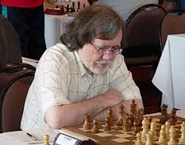

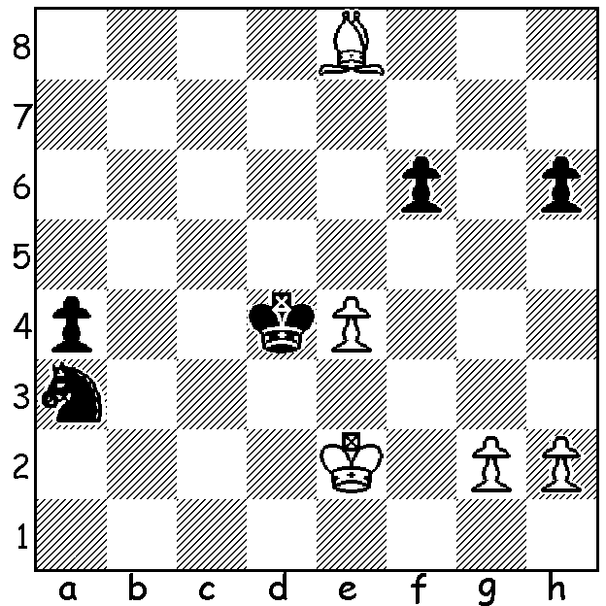
David Smerdon Ian Rogers

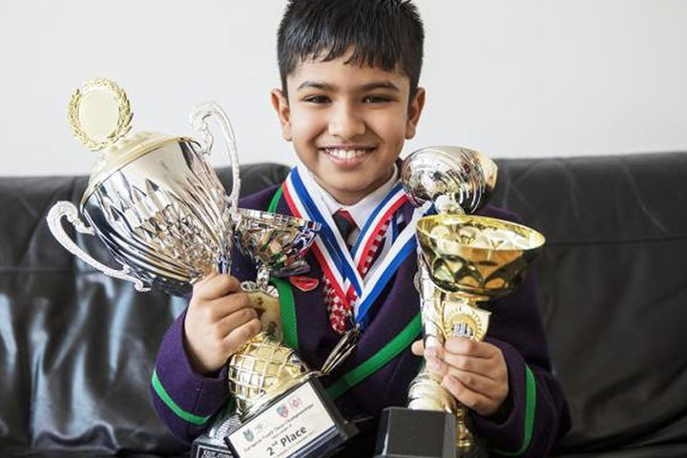
While Michael Adams was winning the
British Championship for the sixth time
a great deal of interest was centred on
Shreyas Royal, a contestant in the British
Major, one of the tournaments run simul-
-taneously with the Championship. Shreyas,
a nine year old who moved with his family
from Bangalore, India, to London in 2012,
scored 5.5/9 coming =14th. During his time
in UK he has achieved a number of successes
including a silver medal in the 2017 European
U8 championship and his rating has risen to
1996. It was thought his family would have to Shreyas Royal
return to India as his father's work visa was set to expire in September (he works as an IT
manager at Tata Group, the main sponsor of the famous annual chess event in the Netherlands). Shreyas' parents appealed to the UK Home Office to allow the family to remain in Britain on the grounds that Shreyas is a national asset and appeals had also been made on his behalf by a number of MPs and the British Chess Federation as well as comedian John Cleese of Fawlty Towers fame. Happily the Home Secretary announced a decison to allow the family to stay as Shreyas is 'one of the most gifted players in his generation'. The struggle of Shreyas and his family has been reported in depth all over the world including a report in the Sunday Times (August 12).

Shreyas Royal vs Nugith Jayawarna
2018 British Major, Rd 9
Kings Indian Defence
1.d4 Nf6 2.c4 g6
3.Nc3 Bg7 4.e4 d6
5.Nge2 0-0 6.Ng3 e5
7.d5 c6 8.Be2 a6
9.dxc bxc(a) 10.Bg5 h6
11.Be3 Qc7 12.Qd2 h5
13.0-0 Be6(b) 14.Rad1 Rd8
15.f4 Ng4 16.f5 Nxe3
17.Qxe3 Bc8 18.fxg fxg
19.Qg5 Kh7 20.Bxh5! gxh5
21.Nxh5 Ra7 22.Rf6!?(c) Qb6+
23.Kh1 Re7 24.Rdf1 Qc7
25.Rh6+! Bxh6 26.Nf6+ Kh8
27.Qxh6+ Rh7 28.Nxh7 Qxh7
29.Qf6+ resigns

a) 9...Nxc6 is better.
b) Logical is 13...h4 14.Nh1 h3.
c) 22.The simple 22.Nxg7 also wins (22...Qb6+ 23.c5! Qxc5+ 26.Kh1 Rg8 27.Rf6 Rgxg7 28.Rh6+ Kg8 29.Qd8+ Kf7 30.Rf1+).

The next WA Grand Prix event is the Gufeld Cup, to be held Sat 8 & Sun 9 September at Leeming Primary School, Meharry Road, Leeming, starting 10.30 each day. Please submit entries to me ellisd19@bigpond.com or 0439798607.

SOLUTION: 1.Kf3 Nb5! and the game concluded 2.Kf4 (2.Bxb5 a3 & queens) 2...a3 3.Bf7 Kc3! 4.Ke3 (4.Kf5 Nd4+ 5.Kxf6 Nb3) 4...Nd4 5.Ba2 Kb2 & White resigns.

