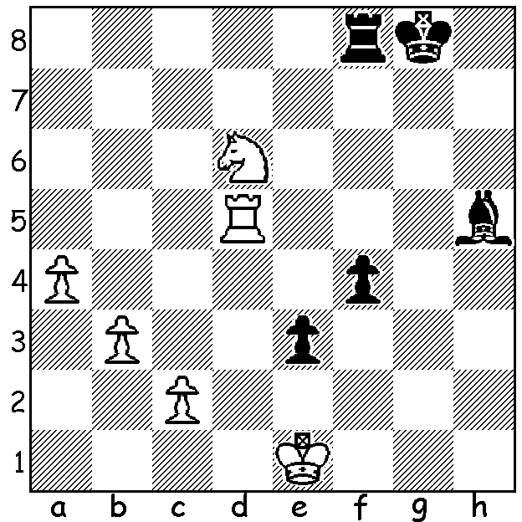

Oscar Gao vs Harry Geronimo
(2018 Willetton Open):
Black plays 1...f3: who wins?

Last week I wrote about the talented nine year old Indian boy Shriyas Royal and the successful struggle of his family to remain in the UK. By coincidence this week's article also features a nine year old, Oscar Gao, who plays at the Southern Suburbs Club. In twelve months he has progressed from losing most of his games to someone who can beat many adults in competition. He has obviously gained a good grasp of opening theory and knowledge of some of the main lines but what stands out is his rapid calculation, taking a fraction of the time his opponents take. He was Under 1200 =1st prize winner er in the recent Willetton Open weekender with 3/6 and is scoring 50% in the present Open tournament at Southern Suburbs.

Oscar Gao vs Andrey Lugovskoy
2018 David Ellis Cup, Rd 1
Two Knights Defence
1.e4 e5 2.Nf3 Nc6
3.Bc4 Nf6 4.Ng5 d5
5.exd Na5 6.Bb5+ c6
7.dxc bxc 8.Be2 h6
9.Nf3 e4 10.Ne5 Qd4
11.Ng4 Bb7 12.Nxf6+ Qxf6
13.Nc3 Qg6 14.0-0 Bd6
15.Bh5 Qf5 16.Nxe4! Bc7
17.Re1 0-0 18.d3 c5
19.Be3 c4 20.Ng3 Qf6
21.d4 Nc6 22.c3 Ne7
23.Qe2 Bd5 24.Qg4 Kh7
25.Qd7 Bd6 26.Qa4 Qh4
27.Qc2+ Kg8(a) 28.Qe2 f5
29.f4 g5 30.Bf2 Qxf4
31.Bf3 Rae8 32.Bxd5+ Nxd5
33.Qxc4 Re5 34.Rxe5 resigns

a) 27...g6 gives Black chances.

Oscar Gao vs David Berry
2018 Willetton Open, Rd 2
Siciilan Najdorf
1.e4 c5 2.Nf3 d6
3.d4 cxd 4.Nxd4 Nf6
5.Nc3 a6 6.a4 Nc6
7.Be3 e6 8.f4 h5
9.Be2 g6 10.Bf3 Bd7
11.0-0 Bh6 12.Nxc6 Bxc6
13.g3 b6 14.Qe2 a5?(a)
15.Qf2 Rb8 16.Rad1 Ng4
17.Bxg4 hxg4 18.e5 d5
19.Ne4! Bg7 20.Nd6+ Ke7(b)
21.b3 Qc7 22.Qe2 f6
23.Bd4 f5 24.Rfe1 Bf8
25.c4!(c) Kd7 26.cxd Bxd5
27.Rc1 Qa7 28.Qb5+ Ke7
29.Rc8! Bg7 30.Rec1 Qd7(d)
31.Qxd7+ Kxd7 32.R1c7#

a) Weakening on the white squares. Better 14...Qc7 (& on move 16).
b) 20...Kf8 is safer.
c) With the Black king in the centre White opens up the position.
d) Nothing can save Black now.

The GUFELD CUP (WA GP) will be played tomorrow & Sunday (10.30am each day). Entries to ellisd19@bigpond.com or 0439798607. Details cawa.org.au

Like a chance to play a soon-to-be Grandmaster? Temur Kuybokarov will give a Simultaneous at Leeming Sunday 16 September. Details cawa.org.au

SOLUTION: After 1...f3? Black planned 2.Rxh5 f2+ 3.Kf1 e2+! 4.Kxe2 f1=Q+. However White wins with 1.Rg5+! Kh7 2.Rxh5+ Kg6 3.Re5. Black should have played 1...Bg6 which is a probable draw after 2.Nb5 Bxc2 3.Nd4 (3...f3! 4.Nxf3! Rxf3 5.Ke2 Rh3 6.Re5).

