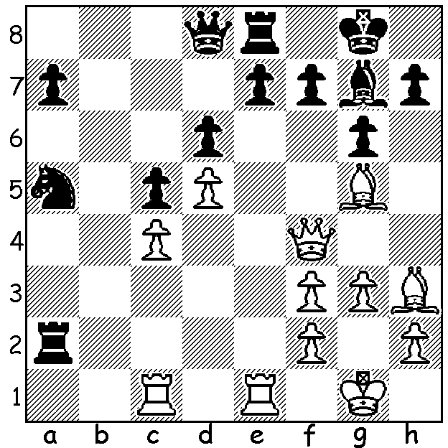

The young Australian IM Junta Ikeda
(born 1991) has been off the radar for
some years but has been active in Europe
with his most recent outing being back in
the Southern Hemisphere at the Malaysian
Open last month where he scored 5.5/9.
Here is his spectacular Rd 2 sacrifice vs
Arian Cabe: White to play (5 moves):

'All good things must come to an end.' So goes the saying and it seems that Super-GM US Olympiad international Sam Strickland had such philisophical thoughts after he lost his Rd 3 game in the 2018 Danzhou Super GM tournament (July 27 - Aug 3), a tournament that brought together four young Chinese GMs, all 2700+, with a similar group of young international GMs. Shankland had been on a 62 game unbeaten streak but after the game he said, "Sixty-two games without a loss was a great run, but it had to end at some point." The tournament was won by Yu Yangyi with 4.5/7 while Shankland, who suffered a second loss during the event, was 7th with 3/7. I've been looking up longest unbeaten runs and the surprise winner is the super-aggressive Mikhail Tal, 95 games, +46, =49 (1973-74) and 86 games, +47, = 39 (72-73). Of current top players there are Kramnik 82, So and Maxime Vachier-Lagrave 67. Capablanca went virtually 12 years unbeaten but played
only 63 games in that time (though it did include his world championship match vs Lasker (+4, =14).
Here's Shankland's second loss:
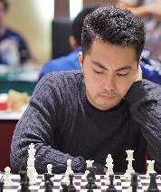
Le Quang Liem vs Sam Shankland
2018 Danzhou Super GM, Rd 6
Queens Indian Defence
1.d4 Nf6 2.c4 e6
3.Nf3 b6 4.g3 Bb7
5.Bg2 Bb4+ 6.Bd2 Be7
7.Nc3 c6 8.Bf4 d5
9.cxd Nxd5 10.0-0 0-0
11.Qc2 Nxf4 12.gxf4 Nd7
13.Rfd1 Qc7 14.e3 Rfd8
15.Rac1 Rac8(a) 16.f5 exf
17.Qxf5 g6 18.Qh3 c5 Junta Ikida
19.d5 Bf6 20.Nd2 Qb8
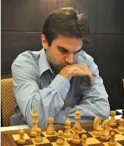
21.Nde4 Bg7 22.Rc2 Nf8
23.Rcd2 Rd7 24.Qh4 Qe5
25.f4 Qe8 26.Kh1 f5
27.Ng5! Bxc3 28.bxc3 Qxe3
29.Nf3 Qxc3 30.Ne5 Rg7
31.Qf6 Re8 32.Re2(b) Qb4
33.Ng4! fxg4 34.Rxe8 Rf7
35.Qe6 c4(c) 36.Rf1! c3?(d)
37.f5 Kg7?(e) 38.f6+ Kg8
39.Qe7! resigns

Sam Shankland
a) 15...g6 would prevent f5
b) The flashy 32.Ng4! Qxf6 33.Nxf6+ Kf7 34.Nxe8 Kxe8 is equal.
c) 35...Qa4 was considered best.
d) 36...Kg7 was necessary - 37.Qe5+ Kh6 38.Be4 Qd2 39.Re7 Nd7 40.Qg5+ Kg7 41.Rxf7+ Kxf7 42.Qxg4 Nc5 43.f5 Bxd5 44.fxg6+ Ke7 47.Bxd5 Qxd5+ 48.Kg1 hxg6 49.Qxg6 Qd4+ =.
e) 37...gxf is best in a losing position - 38.Rxf5 Qb1+ 39.Rf1 Qg6 40.Rxf7 Qxf7 41.Qxg4+ Kh8 42.Re2 b5 43.Rc2 b4 44.Qxb4 Bxd5 45.Kg1 Bxg2 46.Rxg2 Ng6 47.Qxc3+.

TEMUR KUYBOKAROV SIMUL is on this coming Sunday 16 Sept at Leeming Primary starting at 12.40. Whatever your age or standard be one of the 30 players to take on one of Australia's top players and soon-to-be Grandmaster. See cawa.org.au for details on enrolling.

WA LIGHTNING CHAMPIONSHIP (11 rds) Sunday 23 Sept at North Woodvale Primary 12.45 pm. See cawa.org.au

SOLUTION: 1.Qxf7+!! Kxf7 2.Be6+ Kf8 3.Re4 Bf6 or Bd4 4.Bh6+ Bg7 5.Rf4#. Black played 1...Kh8 but lost very quickly.

