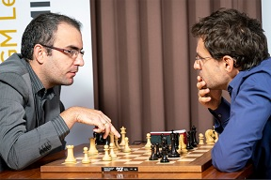
Dominguez vs Aronian
(2018 Champions Showdown):
White to play and win:
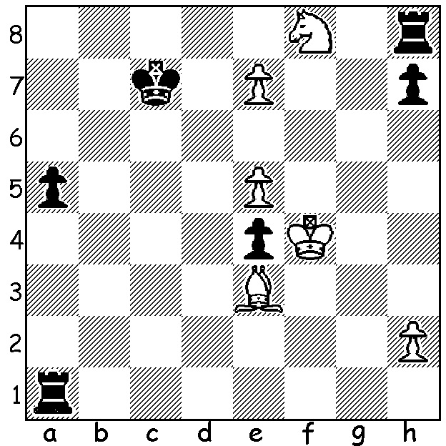

Dominguez (L) & Aronian going over one of their games.

On March 2nd I reported on a 960 chess match between world champion Magnus Carlsen and Hikaru Nakamura. 'What is 960 Chess?' you might ask. It is chess played with the pieces placed in initially random squares on the back lines (White and Black identical as in normal chess) and is sometimes referred to as Fischer Random Chess. Castling is allowed with normal rules applying (in one recent position with K on f8 & R on g8 it was possible to castle 0-0 on move 1). The Champions Showdown in St Louis was
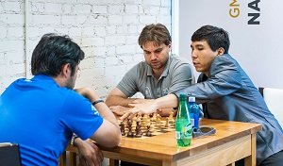
completed within the past week with 10 of
the world's top players competing in five
matches. Results: Nakamura 14 def Peter
Svidler 12, Veselin Topalov 14.5 def Gary
Kasparov 11.5, Wesley So 14.5 def Anish
Giri 11.5, Maxime Vachier-Lagrave 17.5
def Sam Shankland 8.5, Levon Aronian 17.5
def Leinier Dominguez 8.5. Days 1-3 com-
prised 2 Rapidplay (30min + 10sec delay)
and 2 Blitz games (5min + 5sec delay). Days
1-3 had one starting position and Day 4 had 2 The Americans, Nakamura, Shankland & So
starting positions and 8 Blitz games. Players doing some quick preparation on a new position
were given a little under one hour for study
after the initial position was determined before start of play each day (twice on final day).
Rapidplay wins gained 2pts, Blitz wins 1. Total prize money was $US250,000 shared equally among the players. Occasionally an initial position would lend itself to a recognizeable system. Here So sets up a Nimzovitsch Attack formation:
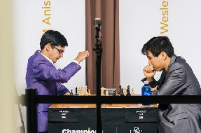
Wesley So vs Anish Giri
2018 Champions Showdown (Blitz)
Starting Position: BRKQNBRN
1.b3 e6 2.Bb2 d5
3.e3 Bd6 4.Nf3 Qe7
5.c4 Nf6 6.Ng3 0-0
7.Qc2 b6 8.Bd3 dxc
9.bxc Ba3 10.0-0 Bxb2
11.Qxb2 Bxf3 12.gxf3 Ng6
13.f4 c5 14.Be2 Qb7
Giri (L) v So

15.a4 Rbd8 16.a5 Rd6 17.axb axb
18.f3 Rfd8 19.Rfd1 Qd7 20.Kf2 Re8
21.Qb5 Qd8 22. Rb2 Qc8 23.Ra2 e5
24.fxe Nxe5 25.Kg2 Ng6 26.Kh1 Nh4
27.Rg1 Red8 28.d3 Qe6 29.Ne4 Nxe4
30.fxe4 h6 31.Qb2 Ng6 32.Rg2 Rxd3!
33.Bxd3 Rxd3 34.Qc2 Rxe3 35.Ra1 Rxe4
36.Rc1 Nf4 37.Rg3 Qc6 White resigns

What are your thoughts on 960 Chess? Do you find the games interesting and would you like to try it out? Do you think it will come to be played a great deal more? By getting rid of intensive opening theory, do you think it will come to replace Chess as we know it?

WA LIGHTNING CHAMPIONSHIP (11 rounds) takes place on Sunday (Sept 23) at N Woodvale Primary starting at 12.45. See cawa.org.au for details and enrolling.

SOLUTION: 1.Kxe4 and Black resigned. Did you pick 1.e8=Q? Then 1...Rxf8+! 2.Qxf8 Rf1+ wins for Black.

