2018 winner of the World Junior (Under 20) Championship held in Turkey was
Iranian Parhan Maghsoodloo. Can you find his winning mating combination
vs Bharathakoti Harsha in Rd 5 (7 moves, 2 variations)?

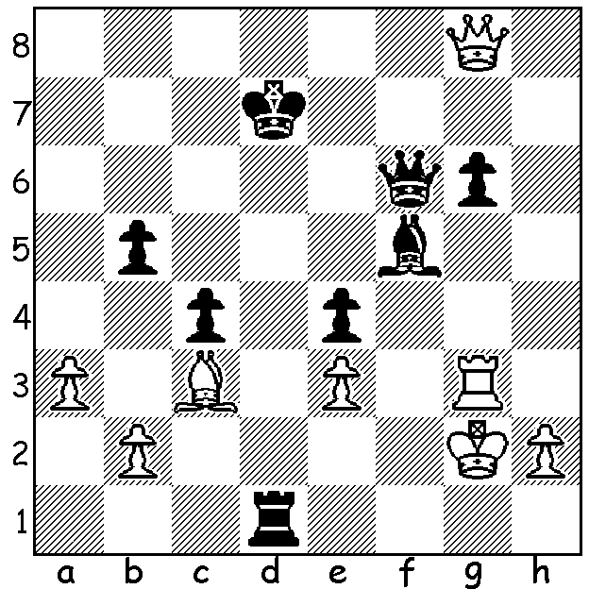
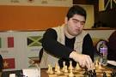

Played a month ago in St Louis, USA, the Sinquefield Cup was a 10 player event with Classic time levels and was the final event of the Grand Chess Tour to find the four players to compete in the final in London in December. Three players, Fabiano Caruana, Levon Aronian and Magnus Carlsen finished on 5.5 pts and it was decided that they share the 1st place rather than have a play-off after eliminating one player by lot. In the final round Wesley So and Caruana drew, Carlsen defeated Hikaru Nakamura and Aronian defeated Alexnder Grischuk (see below). The final totals for all the Grand Chess Tour events resulted in top place to Nakamura on 34.5, followed by Aronian 34, Maxime Vachier-Lagrave 31, Caruana and So 26. Caruana then defeated So 1.5 - 0.5 in two rapidplay games to gain the final place for London.

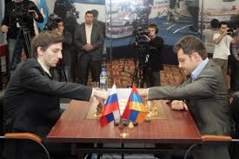
Levon Aronian vs Alexander Grischuk
2018 Sinqufield Cup, Rd 9
Old Indian Defence
1.d4 Nf6 2.Nf3 d6
3.g3 Nbd7 4.Bg2 e5
5.c4 c6 6.Nc3 e4
7.Nh4(a) d5 8.0-0(b) Bb4
9.cxd cxd 10.f3 Bxc3
11.bxc3 0-0 12.Ba3 Re8
13.Nf5 Nb6 14.Nd6 Nc4!
15.Nxc4(c) dxc4 16.fxe Nxe4
17.Qc2 Qd5 18.Rxf7!?(d) Kxf7(e) Aronian (rt) vs Grischuk
19.Rf1+ Bf5(f) 20.g4 g6 21.Qc1 Kg7(g)
22.gxf5 gxf 23.Bxe4 fxe4 24.Qf4 h6
25.Qc7+(h) Kh8?(i) 26.Bd6 Rg8+ 27.Kf2 Rg6
28.Be5+ Kg8 29.Ke3 Rd8(j) 30.Qe7 b5(k)
31.h4 a5 32.h5 Rg5 33.Rf6 Rxe5
34.Rg6+ resigns

a) 7.Ng5 is also good.
b) 8.cxd cxd 9.Qa4 puts pressure on the d pawn (Nf5/e3).
c) If Black gets good play after 15.Nxe8 Qxe8.
d) Needing a win Aronian plays this promising but speculative exchange sacrifice.
e) 18...Qxf7 was possible - 19.Bxe4 Bh3! & not now 20.Bxh7+ Kh8 21.Bg6 Qe6 22.Bxe8 Qe3+ 23.Kh1 Rxe8 24.Rg1 Qf2 wins.
f) Not 19...Kg8? 20.Bxe4! Qh5 21.Rf4
g) 21...Re6 was best defending Black's third rank with the possibility of doubling on the g file.
h) Even better is 25.Kf2!!
i) Better 25...Kg6 (26.Rf4 Rg8 with h5 a possible safe square for the king).
j) 29...Re8 was necessary allowing the queen to retreat to e7 but Black was very short of time. However White is better after 29...Re8 30.h4 Qe6 31.Kd2 Qe7 32.Qxc4 Qe6.
k) If 30...Qd7? Rf8+ wins the queen.

SOLUTION: 1.Bh3#!! (clearance) and if 2.Rxh3 Qf1+ 3.Kg3 Qf3+ 4.Kh4 Qh5+ 5.Kg3 Qg5+ 6.Kf2 Qg1+ 7.Ke2 Qf1#. White played 2.Kxh3 and after 2...Qf5+ resigned (3.Rg4 Qh5+ 4.Kg3 Rg1+ 5.Kf2 Qxh2+ 6.Rg2 Qxg2#)

