Fabiana Caruana (USA) vs Shakrhiyar Mamedyarov (Azerbaijan).
Caruana concludes their Olympiad encounter very quickly:
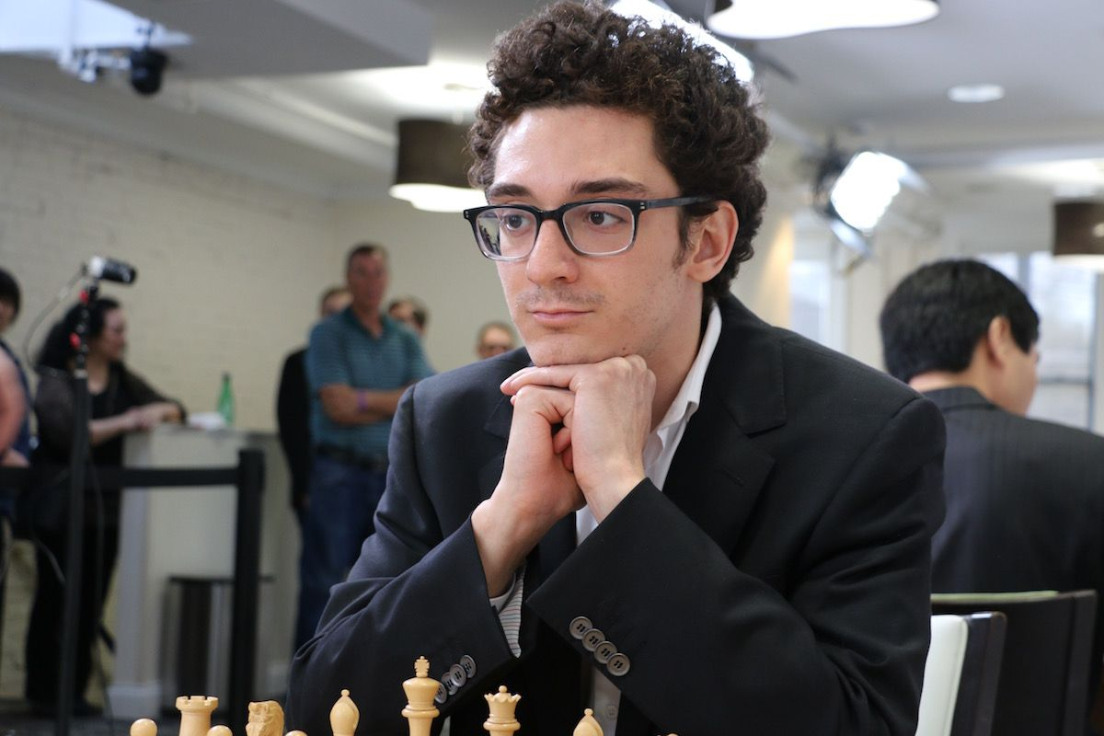
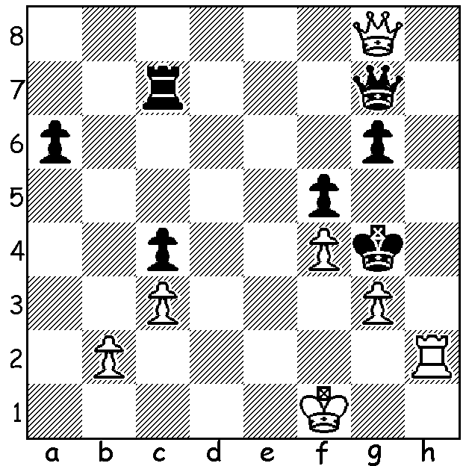
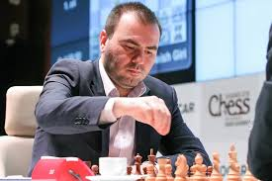

The 43rd Chess Olympiad in Batumi, Georgia, finished dramatically after Rd 10 had left 5 teams, USA, China 17, Poland, Russia, France 16, all with a possible chance of coming top. Round 10 had seen front runners Poland, the only team to beat USA, losing to China and USA defeating Armenia. The final round match between USA and China started with USA ahead on tie break (game scores of all their opponents multiplied by 2 for won match and by 1 for drawn match, omitting lowest finishers of their opponents) but this could change. The match finished with all four games drawn but other results went China's way, giving them top spot ahead of USA and Russia, who defeated France 2.5-1.5 to gain 3rd place. Top scores: China, USA, Russia 18/22, Poland, England 17, followed by nine teams on 16 (150 teams). (In following weeks the Women's event and Australian results).
A hero for China was Ding Liren who gained the Bd 1 gold medal and extended his unbeaten run to over 80 games, this despite still being on crutches after sustaining a broken hip cycling while in Norway in June playing in the Antibox event. Here is Ding's important win in the match vs Poland.

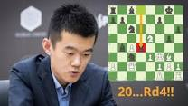
Ding Liren vs Jan-Kryzysztof Duda
2018 Olympiad Rd 10
Queens Gambit, Delayed Acceptance
1.d4 Nf6 2.c4 e6
3.Nf3 d5 4.Nc3 dxc
5.e4 b5 6.e5 Nd5
7.Nxb5 Nb6 8.Be2 Nc6
9.0-0 Be7 10.Qd2 0-0
11.Qf4 Rb8 12.Nc3 f5
13.Qg3 Kh8 14.Rd1 Nb4
15.b3 cxb 16.axb a6

17.Bc4 Nc2 18.Ra2 Nb4
19.Ra1 Nc2 20.Ra2 Nb4
21.Re2 a5 22.d5! exd
23.e6 Bd6 24.Qh3 Qf6
25.Nb5!!(a) dxc4 26.Nxd6 cxd6
27.e7 Re8 28.Ng5 Qg6(b)
29.Rxd6!(c) f4! 30.Qh4 Qb1
31.Re1 Bf5(d) 32.Rd8! Bg6
33.Rxb8 Rxb8 34.Qxf4 Rg8
35.Nf7+ Bxf7 36.Qxf7 Nd7
37.e8=Q Nf6 38.Bg5 resigns

a) A deep positional sacrifice to enable the passed e pawn to advance. If 25.Bg5 Qg6 (not 25...Qxc3? Rc1).
b) If 28...h6 Ding had planned 29.Qh5 (not 29.Rxd6? f4! 30.Qh5 Bg4!)
c) Not 29...Qxd6? 30.Nf7+.
d) Better 31...Bd7 but White can win with 32.f3! (defending the e1 rook) 32...N4d5 33.Bxf4 Qc7 34.bxc Nxf4 35.Qxf4 Nxc4 (freeing the b8 rook) 36.Rh6!! gxh6 37.Qf6+ Kg8 38.Nf7 Qg6 39.Nxh6+ Qxh6 40.Qxh6.

The Mount Lawley Open Junior Tournament will be played on Sunday afternoon (Oct 14) with top prize of $100 plus generous Under 14 & Under 12 top prizes. The format is a 7 round Swiss with a time limit of 12 min + 3 sec increment. The event is to raise money to assist Mt Lawley Primary to compete in the Australian Schools Championshipss in Adelaide. See cawa.org.au for details.

SOLUTION: 1.Kg2! g5 (1...Qxg8 2.Rh4#) 2.Qe8 resigns (mate threatened on h5 & e2).

