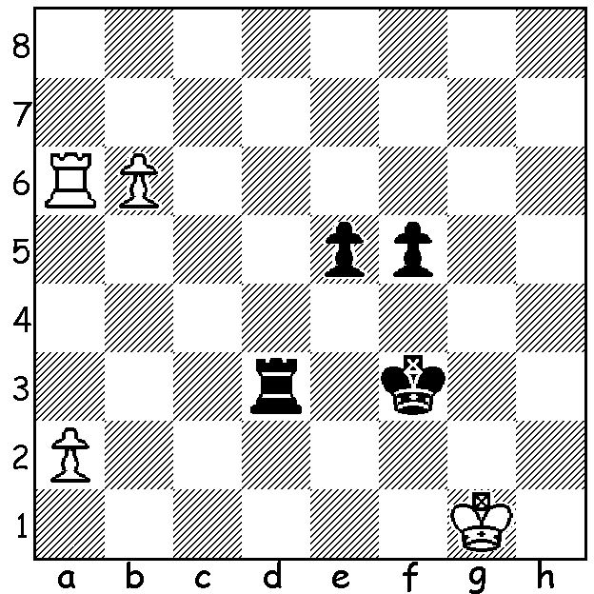

Can you find one of the great moves of the Olympiad?
Gulnar Mammadova (Azerbaijan) looks lost after
Black, Linda Kumina (Latvia) plays 1...e4. However
White plays an amazing move which saves the game
and wins material although not enough to win. Can you
also see what Black should have played on move 1?

The Chinese Women's team victory gave China the double after their men had secured the Open title i the Olympad in Batumi, Georgia. In the final round China looked likely to lose against Russia which would allow Ukraine, victors over USA, to emerge winners on tie break from Russia. Russia had taken a 1.5-0.5 lead and looking like winning the match 3-1. However China secured an unlikely perpetual check on one of the remaining two boards and then in the last game of the Olympiad to finish Womens World Champion Ju Wenjun gained a vital win against Alexandra Kosteniuk in a Q, N & 3p (1 passed) vs Q, N & 2p. China emerged with 18/22, equal with Ukraine but with the better tie-break score. Third was Russia on 17 with nine teams finishing on 16. Report on Australia's teams next two weeks.
Here's an exciting game in which China's top board for the day comes close to losing to an unfancied Columbian who misses an amazing continuation. The opening, a Benko Gambit, sees Black gain persistent queenside pressure for the pawn.

Shen Yang vs Melissa Castrillon Gomez
2018 Women's Olympiad, Rd 2
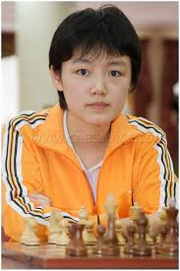
Benko Gambit
1.d4 Nf6 2.c4 c5
3.d5 b5 4.cxb a6
5.bxa g6 6.Nc3 Bg7
7.Nf3 0-0 8.e4 Qa5
9.Nd2 Bxa6 10.Bxa6 Qxa6
11.a4 Ra7 12.Qe2 d6
13.Nb5 Rb7 14.0-0 Ne8
15.Re1 Nc7 16.Nxc7 Rxc7
17.Ra3 Rb7 18.Nc4 Nd7
19.Bg5 Nb6 20.b3 h6
21.Bd2 Nxc4 22.Qxc4 Qxc4
23.bxc4 Rb2 24.Rd1 Rfb8
25.Kf1 Rc2 26.a5 Rbb2
27.Ke2 Bc3 28.Kd3 Bxd2
29.a6 Ra2(a) 30.Ra1 Rc3+
31.Rxc3 Rxa1 32.Kxd2 Rxa6 Shen Yang
33.Ke3 DRAW

a) There is the amazing continuation 29...Bf4!!! 30.a7 Rxf2! 31.a8=Q+ Kg7 (with threat of 32...Rbe2 / 33...Re3#) 32.Qa5 (32.Kc3 Be5+ 33.Kd3 Rbe2 - with ...Bd4 / Re3# threatened - 34.Rf1 Rd2+ 35.Ke3 Bd4# or 32.Re1 Rfd2+ 33.Kc3 Be5#) 32...Rbe2 33.Kc3 Re3+ 34.Rd3 Be5+ 35.Kb3 Rxd3+ 36.Ka4 Rxa3+ 37.Kxa3 Rxg2 and with rook, bishop and two pawns for queen Black should win.


WFM Kathryn Hardegen from the Southern
Suburbs Club in Leeming will be Oceania's
representative in the Womens World Championship
next month in Russia. She is drawn against current
Womens World Champion Ju Wenjun in Round 1
(64 player KO).

Last Sunday over 70 competitors played in two
junior fundraising events to assist Mt Lawley
Primary compete in the Australian interstate Kathryn Hardegen
schools competition later this year. Raffles and
a fine spread of foods helped augment the amount contributed. Thanks to all the donors and ladies in the kitchen as well as DOP Jay Lakner. The Under 18 event was won by nine year old Harry Jeronimo while there was a triple tie in the Under 10s, split by play-offs (I don't have names).

SOLUTION: 2.Ra3!! and Black has only one good reply 2...Rxa3 enabling White to queen. However a draw resulted after 3.b7 Rxa2 4.b8=Q Rd2 with White unable to make any progress. Black should have played 1...Rd1+ (avoiding the pin) 2.Kh2 e4 winning.

