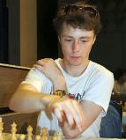
James Morris vs Guy West
(Thailand Open 2011):
White to play and win:
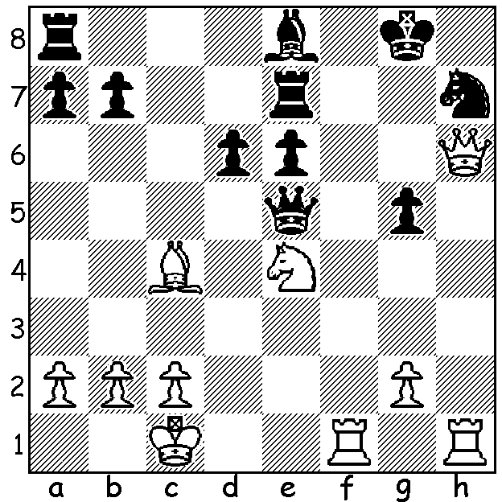

Another look at Australia's Open team at the Olympiad in Batumi, Georgia, where they finished =25th to 38th (ranked 41st) with 14/21 (6 wins 2 draws 3 losses). IM James Morris, born 1994, was the 5th player in the Australian team and scored +4 =3 -1, an excellent result in his first Olympiad. Here are two of his games:

James Morris vs Martin Poulsen
2018 Olympiad, Australia vs Faroe Is.
Scandinavian Defence
1.e4 d5 2.exd Qxd5 3.Nc3 Qd6
4.d4 Nf6 5.Nf3 Bg4 6.h3 Bxf3
7.Qxf3 c6 8.Be3 e6 9.0-0-0 Nbd7
10.Kb1 Qc7 11.g4 Nd5 12.Bd2 Bd6
13.Ne4 b5 14.g5 Bf4 15.Be1 Rb8
16.h4 h5 17.g6 f5 18.Ng5 Bxg5
19.hxg5 Qf4 20.Qe2 Nf8 21.Rxh5 Rg8
22.a4 Qd6 23.axb! Nf4 24.Qf3 Nxh5
25.Qxh5 cxb 26.d5! exd 27.Bxb5+! Ke7(a)
28.Qf3 d4 29.Qxf5 Nxg6 30.Qe4+ Qe5
31.Bb4+ Kf7 32.Bc4+ Ke8 33.Qxg6+ Kd7
34.Rxd4+! Qxd4 35.Qe6+ Kc7 36.Ba5+ Rb6
37.Bxb6+ axb6 38.Qxg8 and wins -
a) If 27...Rxb5 28.Qe2+

James Morris vs Tun Win
2018 Olympiad, Australia vs Myanmar
Reti Opening
1.Nf3 Nf6 2.g3 g6 3.Bg2 Bg7
4.c4 0-0 5.0-0 c6 6.Qc2 d5
7.b3 Bf5 8.d3 a5 9.Bb2 Na6
10.a3 Qb6 11.Nbd2 Rfd8 12.Rac1 a4
13.Bd4 c5 14.Bxf6 axb 15.Nxb3 Bxf6
16.Nfd2 d4 17.Rb1 Qc7 18.Na1 Ra7
19.Rb5 Bd7 20.Rfb1 Bc6 21.Qb3 Bxb5
22.cxb5 c4 23.Nxc4 Nc5 24.b6 Qd7
25.Qb5 resigns. Black loses a piece.

The final two WA Grand Prix events of 2018 will be played this month. Firstly, the Kingsley Open, Sat 17 & Sun 19 at N Woodvale Primary and, secondly, the Christmas Open the following weekend, Sat 24 & Sun 25 at Leeming Primary, both starting at 10.30. Full details and registration cawa.org.au

SOLUTION: 1.Nf6+! (deflection & interruption sacrifice) 1...Nxf6 2.Qh8+ resigns (2...Kf7 3.Rh7+ Kg6 4.Rh6+ Kf7 5.R(either)xf6+ Qxf6 6.Rxf6#).

