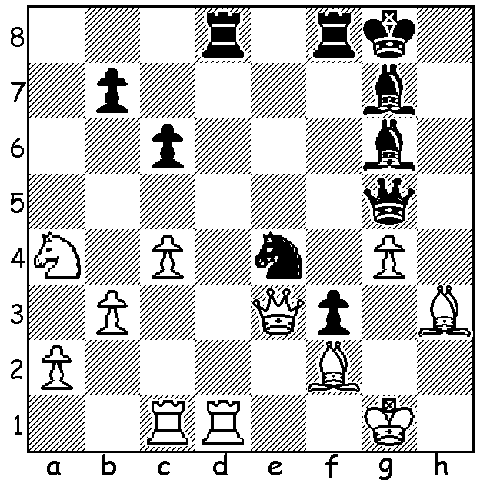

Sabina Foisor vs Andreina Quevedo
(Womens Olympiad 2018):
Black to play and gain a winning advantage
(3 moves including 2 pseudo-sacrifices):

In the Women's Olympiad in Georgia Australia finished roughly on par with their initial ranking of 33rd out of 150 with a score of +6, =1, -4, coming =32nd to 48th. Heather Richards on top board had a disappointing tournament scoring 2/7 (+1 =2 -4) although she did face the best players in the opposition teams. Other scores (in board order): Julia Ryjanova 5.5/10 (+3 =5 -2), Zhang Jilin 7/9 (+5 =4), Nguyen Thu Giang 4.5/9 (+3 =3 -3), Irina Berezina 5/9 (+3 =4 -2). Interestingly all the team had been born overseas. Zhang, born in 1986, became a WGM (Womens Grandmaster) in 2007 and moved to Australia from China with her family in 2016. Here is a game of hers from the Olympiad where she gains a positional advantage in the late middle game based on a powerful centre and two bishops but is forced to win a rook ending with equal pawns:

Tamari Esadze vs Zhang Jilin
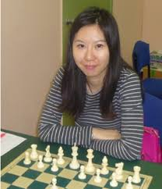
2018 Womens Olympiad (Georgia 3 vs Australia)
Sicilian Najdorf
1.e4 c5 2.Nf3 d6
3.d4 cxd 4.Nxd4 Nf6
5.Nc3 a6 6.Bg5 e6
7.f4 Qc7 8.Qf3 b5
9.a3 Nbd7 10.Bxf6 gxf6
11.0-0-0 h5 12.g4 Bb7
13.gxh f5 14.Bg2 Nf6
15.Qd3 Nxh5 16.Nde2 Qc4
17.Kb1 Nf6 18.Qxc4 bxc4
19.Rd4 Rb8 20.Ng3 fxe
21.Ngxe4 Nxe4 22.Nxe4 d5
23.Nc3 Bg7 24.Rdd1 Bxc3
25.bxc3 d4 26.Bxb7 Rxb7+ Zhang Jilin
27.Ka1 dxc3 28.Rd4 Rc7
29.h4 Rh5 30.Rh3 Ke7
31.Rxc3 Rxh4 32.Rcxc4 Rxc4 33.Rxc4 Kf6
34.Ra4 Kf5 35.Rxa6 Rxf4 36.Kb2 e5
37.a4 e4 38.Kc3 Rf2 39.Ra7 f6
40.Re7 Rf3+ 41.Kb2 Rh3 42.a5 Kf4
43.a6 f5 44.a7 Rh8 45.Rh7 Ra8
46.Kc1 Ke3 47.Kd1 f4 48.Ke1 f3
49.c4 Rg8 50.Rh1 Rc8 51.Rh4 Ra8
52.Rh7 Rg8 53.Rh1 Kd3 54.c5 e3
55.c6 f2+ 56.Kf1 Kd2 57.c7 Rf8
58.c8=Q e2+ 59.Kg2 f1=Q+ White resigns

The final two WA Grand Prix events of 2018 will be played this month. Firstly, the Kingsley Open, Sat 17 & Sun 19 at N Woodvale Primary and, secondly, the Christmas Open the following weekend, Sat 24 & Sun 25 at Leeming Primary, both starting at 10.30. Full details and registration cawa.org.au

SOLUTION: 1...Nxf2! 2.Qxd2 (2.Qxg5 Nxh3+) 2...Bd4! 3.Rxd4 Qxc1+ (cont. 4.Kh2 Rxd4 5.Qxd4
f2 6.Kg3 Qg1+ 7.Kh4 f1=Q White resigns).

