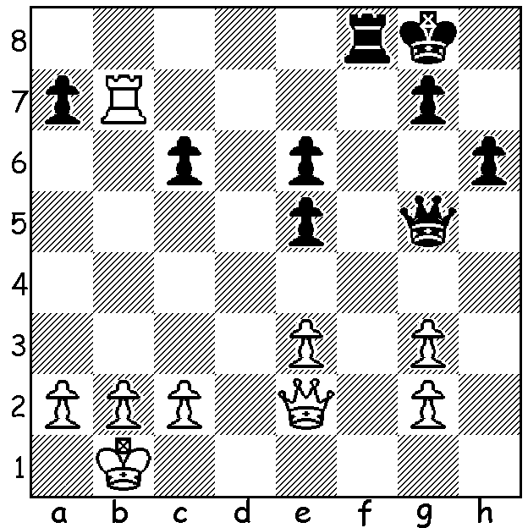

Anne Haast vs Alexandra Kosteniuk
(Womens Olympiad 2018):
Black to play wins White's queen (5 moves):

In our final review of Australia at the 2018 Olympiad in Georgia we look at our most experienced international Irina Berezina, originally from Ukraine, who has played for Australia in at least eight Olympiads, seven as Bd 1. Her past achievements include Australian Womens Champion and five-time Oceania Womens Champion. She became an IM in 1999 and has competed in three Womens World Championships.

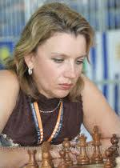
Irina Berezina vs Essa Matiam
2018 Womens Olympiud
Reversed Grunfeld
1.d4 d5 2.Nf3 e6
3.g3 c5 4.Bg2 Nc6
5.0-0 cxd 6.Nxd4 Bc5
7.Nb3 Bb6 8.a4 Nge7
9.Na3 0-0 10.c4 a6
11.c5 Ba7 12.Bd2 e5
13.Rc1 Be6 14.e3 Qd7
15.Nb1 Rac8 16.Nc3 Nb4
17.Nb5! Nd3 18.Nxa7 Ra8
19.Rb1 Rxa7 20.Ba5 Bf4
21.Bb6 Raa8 22.Nd2 Qc6
23.b4 Qg6 24.Nf3 Bg4
25.Nh4 Bxd1 26.Nxg6 fxg6 Irina Berezina
27.Rfxd1 e4 28.Rd2 Nc6
29.Rxd3! exd3 30.Bxd5+ Kh8 31.f4 Rad8
32.Bxd8 Rxd8 33.Bxc6 bxc6 34.Kf2 Kg8
35.Ke1 d2+ 36.Ke2 Kf7 37.Rd1 Rb8
38.Rxd2 Rxb4 39.Rd7+ Ke6 40.Rd6+ Kf5
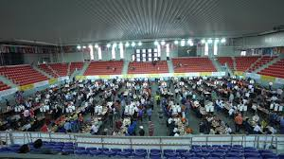
41.Kf3 h5 42.h3 Rxf4+ 43.gxf4 resigns

Irina Berezina vs Diana Lomaia
2018 Olympiad
Kings Indian Defence
1.d4 Nf6 2.c4 g6 3.Nf3 Bg7
4.Nc3 0-0 5.g3 d6 6.Bg2 Nc6
7.0-0 a6 8.b3 Rb8 9.Bb2 b5
10.cxb axb 11.Rc1 Bd7 12.d5 Na5
13.Nd4 e6 14.e4 e5 15.Nc2 Ne8
16.Nb4 f5 17.Rc2 f4 18.f3 fxg
19.hxg Qg5 20.Qe1 Rf7 21.Bc1 Qf6
22.Be3 g5 23.Qd2 h6 24.Ne2 Ra8
25.Nd3 Nb7 26.f4 exf 27.gxf gxf
28.Rxf4 Qg6 29.Rxf7 Kxf7 30.Ndf4 Qg4
31.Ne6! Rc8 32.N2d4 Nf6 33.Qd3 Kg8
34.Nf5 Bxe6 35.dxe6 Kh8 36.Rf2 Rf8
37.e7 Re8 38.Nxg7 Kxg7 39.Bd4 resigns

The final two WA Grand Prix events of 2018 will be played this month. Firstly, the Kingsley Open, tomorrow Sat 17 & Sun 19 at N Woodvale Primary and, secondly, the Christmas Open the following weekend, Sat 24 & Sun 25 at Leeming Primary, both starting at 10.30. Full details and registration cawa.org.au

SOLUTION: 1...Qg4! 2.Qe1 (2.Qxg4 Rf1+ mates) 2...Qxg3! 3.Qe2 Qg4 White resigns (4.Qe1 Qxg2 with 5...Rf1 to come).

