While abroad on holiday I received a message from the West informing me that it would be discontinuing the Chess column in order to cut editorial costs. This was naturally a big disappointment having the contract with the paper terminated at the end of this month. The paper has included a Chess column for many years before I took over with my known predecessors being Paul Foster and Mike Partis. My first column was published on April 29, 1995 and I have now contributed nearly 1200 columns. The Chess Association regrets the culling of the column but expresses thanks to the West for enabling Chess to have a voice in the community and also for providing valuable funding to the Assocation over many years.

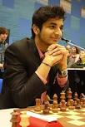
Vidit vs Das Debashis (I of M 2018, Rd 2):
White has sacrificed a knight and offered a bishop.
Now he concludes with a brilliant deflection
sacrifice to mate (3 moves):
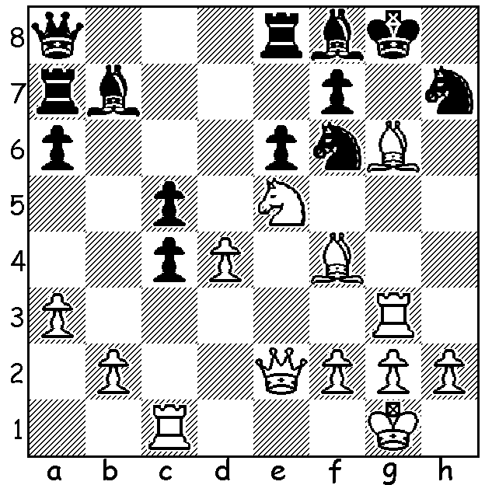

David Eggleston vs Antosh Gujrathi Vidit
2018 Isle of Man Open, Round 1
Giuoco Piano
1.e4 e5 2.Nf3 Nc6 3.Bc4 Bc5
4.c3 Nf6 5.d3 d6 6.0-0 0-0
7.a4 a5 8.Bg5 h6 9.Bh4 g5
10.Nxg5!? hxg5 11.Bxg5 Kg7 12.Qf3 Rh8
13.Nd2 Qe7(a) 14.h4 Bd7 15.Bd5(b) Rag8
16.Nc4 Nxd5!(c) 17.Bxe7 Ndxe7 18.Ne3(d) Rxh4
19.g3 Rh6 20.Rfc1 Rf8 21.Kf1 f5
22.Ke1 fxe 23.Qxe4 d5 24.Qg2 Bh3
25.Qg1 Bxe3 26.fxe3 Rhf6 27.Ke2 Bg4+
28.Ke1 e4 29.d4 Rf3 30.c4 Nb4
31.Kd2 Rf2+ 32.Kc3 R8f3 33.Kb3 Rxe3+
34.Rc3 dxc+ 35.Kxc4 Be6+ 36.d5 Bxd5+
37.Kd4 Nc2+ 38.Kc5(e) Rxc3+ 39.bxc3 Rf6
40.Kb5(f) Nxa1 41.Qxa1 e3(g)

a) 13...Kg6! was played by Nakamura vs Caruana.
b) If 15.Qg3 Nh5 16.Bf6+! Kh7! (not 16...Kxf6 17.Qg5#).
c) With this sacrifice Black turns defence into attack.
d) 18.g3 keeping his h pawn was better.
e) If 38.Rxc2 Rd3+ mates.f) Else 40...Rc6#.
g) With an easy win for Black (42.c4 Bc6 43.Kxa5 Kf7 44.g4 Bf3 45.c5 Nc6+ White resigns). Queen sacrifices by Vidit in the two opening rounds - wow!

The World Championship match between defending champion Magnus Carlson and Fabiano Caruana has so far seen seven successive draws with Caruana generally having the better chances.

WFM Kathryn Hardegen has recently returned from Siberia where she competed in the Womens World Championship. She was eliminated in RD 1 by the defending champion Ju Wenjun (China) who progressed to the final where she faces Kateryna Lagno (Russia).

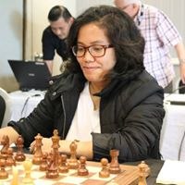
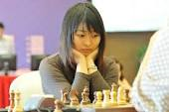
Ju Wenjun Kathryn Hardegen

Yihe (Rebo) Fu also travelled north to his country of birth where he won the Chinese Under 12 Blitz Championship - a great achievement!

SOLUTION: 1.Qh5!! Black resigns (1...Nxh5 2.Bxf7+ Kh8 3.Rg8#).

