This will be the last Friday chess column in the West Australian but from next week chess news and problems will be included in Saturday issues.
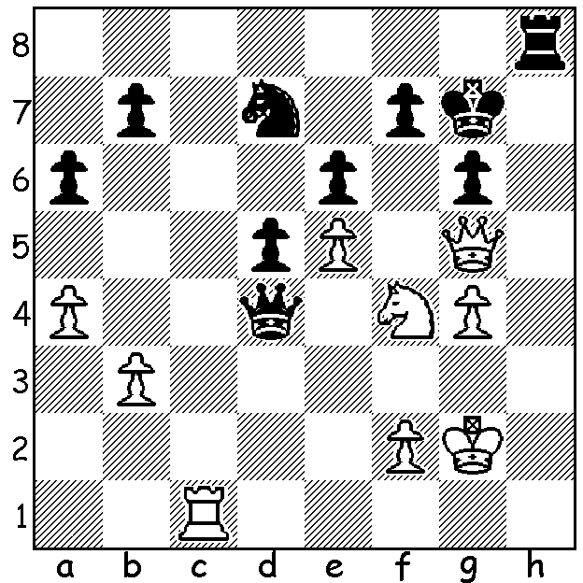

Ju Wenjun vs Anna Zatonik 2012:
White mates in 4.

While world champion Magnus Carlsen (Norway) and challenger Fabiano Caruana (USA) were drawing all 12 games of their London match, necessitating a rapidplay tiebreak, the Womens World Championship was being played in Khanty-Msiyak, Russia, with a 64 player knock out tournament with the final contested between Ju Wenjun (China) and Kateryna Lagno (Russia). Tweny-seven year old Ju had won the title in May by defeating defending champion Tan Zhongy (China) and had little trouble progressing to the final playing just 10 games while Lagno with 21 games had faced a number of play-offs including one Armageddon game to win 5-4 in Rd 3. Lagno took the lead winning Game 2 only for Ju to win Game 4 to take the match into tiebreaks. After two draws Ju won the next two games to retain her title.

Ju Wenjun vs Kateryna Lagno
2018 Womens World Championship Final, Game 4
Sicilian, Rossolimo Attack

1.e4 c5 2.Nf3 Nc6
3.Bb5(a) g6 4.0-0 Bg7
5.Re1 e5 6.a3 Nge7
7.Nc3 0-0 8.Bc4 d6
9.d3 h6 10.Nd5 Kh7
11.c3 f5 12.exf gxf5
13.b4(b) Ng6 14.b5?(c) Na5
15.Ba2 Be6 16.Qa4 b6
17.Bd2 Rg8 18.Rad1 Qd7
19.Nh4?d) Bh8 20.Nxg6 Rxg6
21.Qh4 Rag8 22.g3 Qf7
23.c4 Bf6 24.Nxf6+ Rxf6
25.f4 Rg4 26.Qh3 Rfg6
27.Rf1 Qg7 28.Kh1?(e) Bc8
29.Qh5 Bb7+ 30.Kg1 Rxg3+!
31.Kg1 Rxg2+ White resigns(f)

a) Also played by Caruana vs Carlsen in his first three Whites, continuing with (3...g6) 4.Bxc6.
b)13.Ng5+! Kg6 14.Nf3 would force Black to play a number of moves with the king on Kg6 to avoid repetition.
c) A mistake, releasing the pressure on the queenside.
d) An error as Black could increase her advantage with 19...c4! 20.Nxg6 Bxd5 21.dxc Be6 22.Nh4 Bf6 23.Nf3 Qb7 24.Re3 f4 25.Rd3 Kh8 (25...e4 26.Bb1!) 26.Ne1.
e) The only move is 28.Qh5.
f) 32.Ke3 Qg3+ 33.Rf3 exf#


Ju Wenjun and Kateryna Lagno

SOLUTION: 1.Nxe6+! Black resigns (1...fxe6 2.Qe7+ Kg8 (2...Kh6 3.Rh1#) 3.Rc8+ Nf8 4.Rxf8#).

