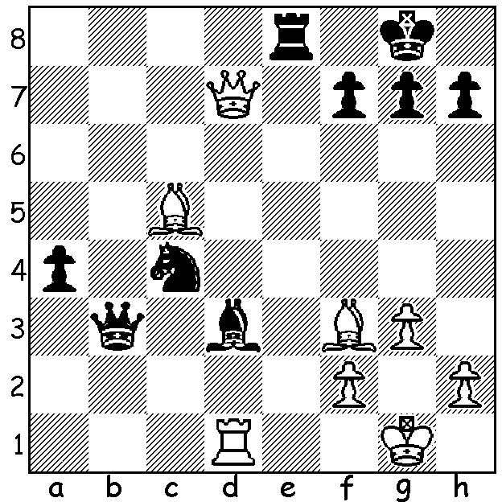

It's appropriate to show a brilliant finish
by still world champion Magnus Carlsen,
Black v Wesley So. With both rook and
bishop under attack Black pulls a rabbit
out of the hat to mate or win decisive
material (4 or 5 moves / two variations):

All 12 games of the World Championship match in London between champion Magnus Carlsen (Norway) and his challenger Fabiano Caruana (USA) were drawn. However in the subsequent 4 game rapidplay Carlsen showed his mastery in this format, retaining his title by winning 3-0. Former champion Gary Kasparov had critisised Carlsen for offering a draw early in the 12th game when in a better position but had to admit it was a wise decision and opined that Carlsen's ability in rapidplay was at least 85% of that in the slower Classic games.

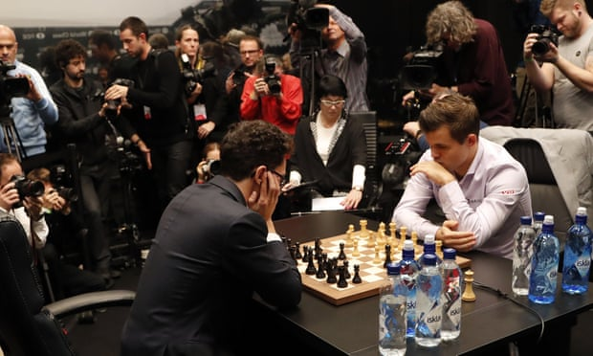
Fabiano Caruana (Black) vs Magnus Carlsen (World Championship)

The CAWA CHRISTMAS LIGHTING tournament will be played Sunday 16 December at Leeming Primary. Details cawa.org.au

SOLUTION: 1...Qxd1+! 2.Bxd1 Re1+ 3.Kg2 Bf1+ 4.Kf3 (4.Kg1 Bh3#) 4...Ne5+ / 5...Nxd7.

