For a number of weeks problems will feature finishes by former world champions, starting with Viswanathan Anand. Anand failed in his first title match in 1995 against Gary Kasparov but in 2007 took the title in a seven player tournament. He successfully defended his title against Vladimir Kramnik (2008), Veselin Topalov (2010) and Boris Gelfand (2012) before losing to Carlsen (2013) and again as challenger in 2014. He and Carlsen are the only players to have been world champion in Classic, Rapid and Blitz chess. Now 49, Anand remains one of the top ten players in the world.
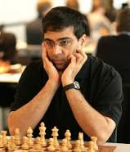
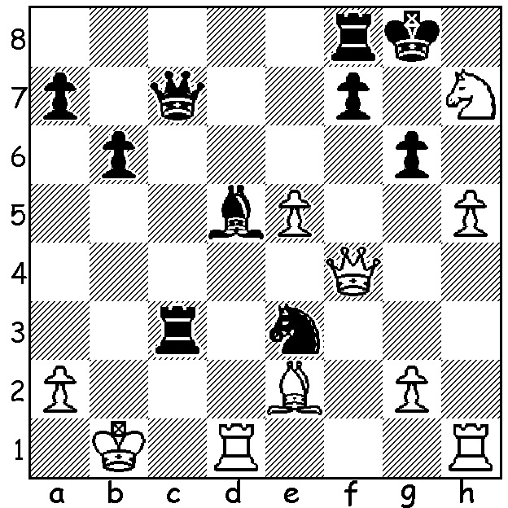
Alexander Beliavsky vs Viswanathan Anand 1991.
With both sides' kings in danger Anand, Black,
gets in first, mating in 5:

The CAWA CHRISTMAS LIGHTING tournament will be played tomorrow, Sunday 16 December, 1.00 - 4.00pm at Leeming Primary. Details cawa.org.au and enquiries 0439912234.

Recent Results: Kingsley Open (WA Grand Prix) - 1.Adam Kelly (5/6), 2.Tristan Boyd (4.5), 3.Andrew Hardegen, Jay Lakner, Ned Tomic (4): Christmas Open (WA GP)- 1.Syakir Shazmeer (5.5/6), 2.Ihsan Ferozkohi (5), 3.Kathryn Hardegen (4.5); Under 1800 - Ignatius Yap, Brent Geronimo, Tjeremin Gunawan (3.5), Under 1450 - John Prince & Harry Geronimo (3).

SOLUTION: 1...Rb3+! (clearance sacrifice) White resigns - 2.axb3 Qc2+ 3.Ka1 Qc3+ 4.Kb1 Qxb3+ 5.Kc1 Qc2# or 5.Ka1 Qa2#.

