A second look at the brilliance of former world champion Viswanathan Anand, Black vs Peter Svidler 2013: how does Black mate in 3 (move 2 is the difficult one)?
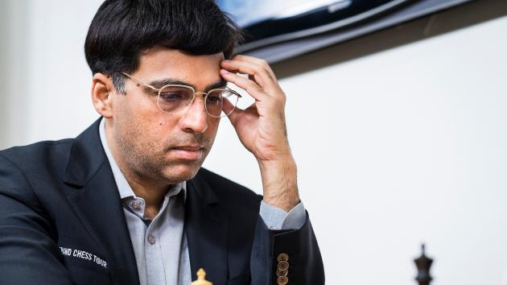
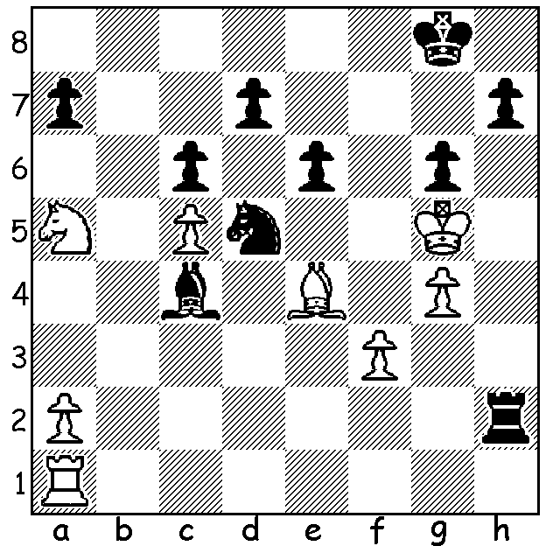

Watching the second cricket test between Australia and India, I heard a commentator inform watchers that the Indian captain Virat Kohli had been included among Time Magazine's 100 Most Influential Persons of 2018. I checked out Vishy Anand and although he had not achieved a similar honour he had been Indian Sports Star of the Year, winning the Rajiv Gandhi Khel Ratna award in the year 1991/92. However world champion Magnus Carlsen, who wrested the world title from Anand, was named in Time's 2013 list. Anand and Carlsen will both be competing this month in the World Rapidplay and Blitz Championships in St Petersburg where Anand will be defending his Rapidplay title and Carlsen the Blitz.

The WA Christmas Blitz was played last Sunday at Leeming. Joint winners with 8.5/9 were Patrick Gong and Tom Donaldson. Other prize winners: Under 1800 - Ian McAteer and Marcus Simmons (5); Senior Eugeniy Konovalov and Marcus Simmons (5); Junior - 1st Kundan Dharmapuri (5), 2nd Sri Krishnan Dharmapuri (4.5). Patrick Gong had very recently returned from Adelaide where he had been competing in the Lidums Young Masters. He defeated the top seed GM Frode Urkedal (Norway) in Rd 1 but just failed to achieve an IM (International Master) norm, scoring 4/9.
Patrick will be among a group of Western Australians competing in the Australian Championships and Australian Junior Championships after Christmas. Good luck to all.

SOLUTION: 1...Kg7 (an obvious move threatening 2...h6#) 2.Bxd5 (hoping to escape via f4) 2...e5! (once more closing the escape route). White resigns.

