Black to play and win (4 moves):
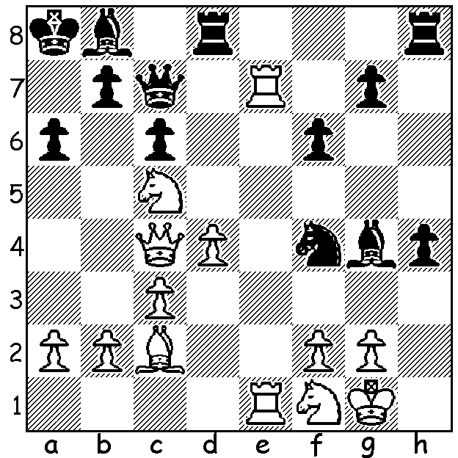

The Asian Continental Championship, a nine
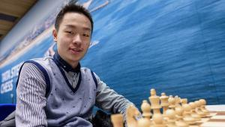
round swiss played in the Philippines earlier
this month, was won by Chinese star Wei Yi
in a tie break after finishing level on 6.5/9
with M. Amin Tabatabaei (Iran) and Le Quang
Liem (China). Our position shows one of the
favourites losing to an outsider in Rd 1. Le
Quang Liem vs Paulo Bersamina (Philippines):
White has just played the seemingly decisive
1.Re7 but Black calmly continues with his own
attack (4 moves): Wei Yi

The London Classic, played at the Earls Court Exhibition Centre, London, earlier this month, was the final leg of the 2018 Grand Tour and comprised a KO between the top four qualifying players. In the semis Hikaru Nakamura (USA) defeated Fabiano Caruana (USA) and Maxime Vachier-Lagrave (France) defeated Levon Aronian (Armenia), both in Rapidplay after their two Classic games were drawn. In the final it wasn't until the 8th game that Nakamura finally won after draws in Classic, Rapidplay and Blitz. (Caruana defeated Aronian for 3rd place). Among the many other events held concurrently was the British KO Championship with Gawain Jones defeating David Howell in the semi and Luke McShane in the final with Michael Adams beating Howell for 3rd place.
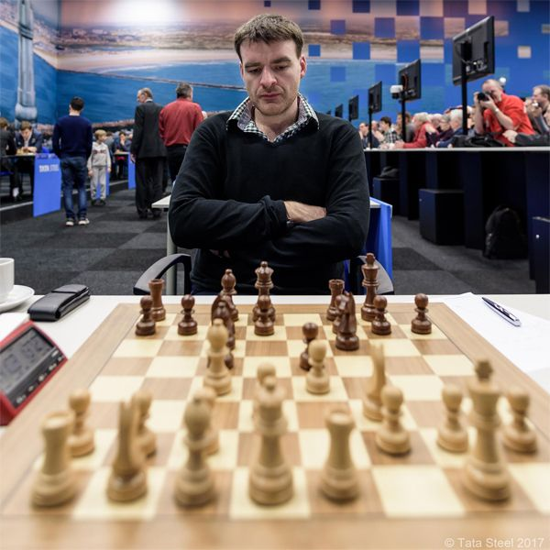
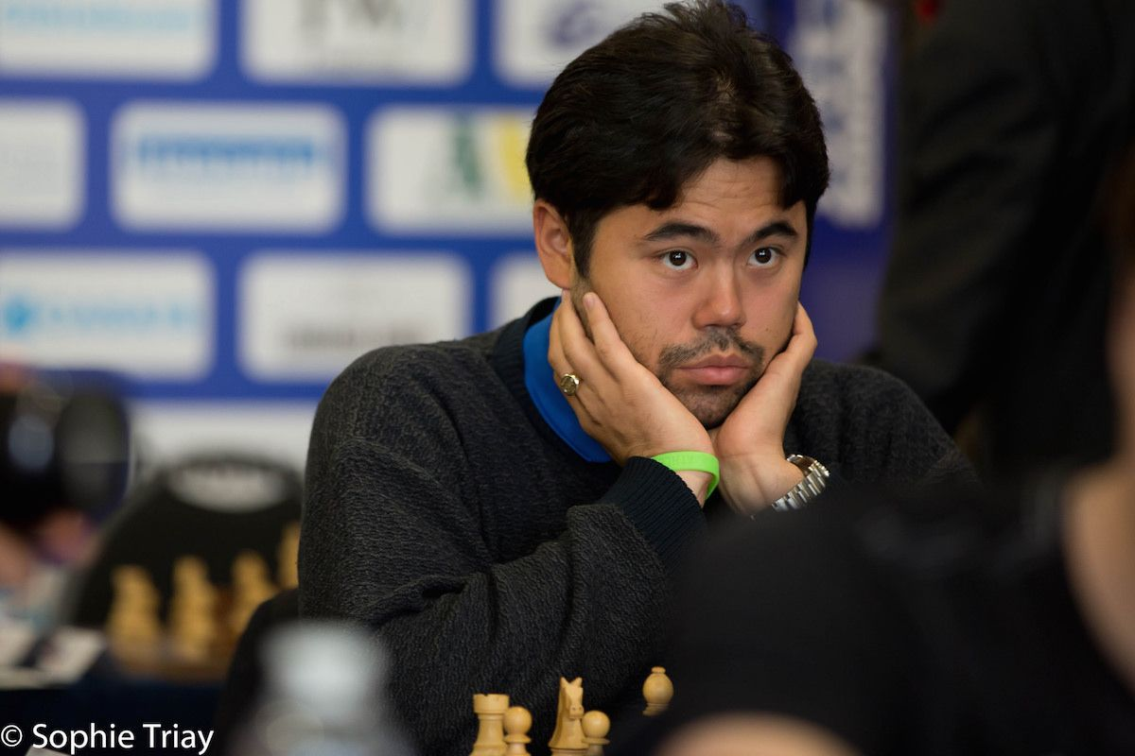

Hikaru Nakamura & Gawain Jones

SOLUTION: 1...h3!! 2.Rxc7 hxg!! 3.Nh2 Bf3 White resigns in the face of ...Nh3# (1...Ne2+ fails to 2.Kf1! Qh2 3.f3).

