Peter Svidler vs Dmitry Andreikin (2018 World Rapidplay Championship):
A winning mating attack is much more difficult to find if it involves a 'quiet'
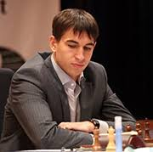
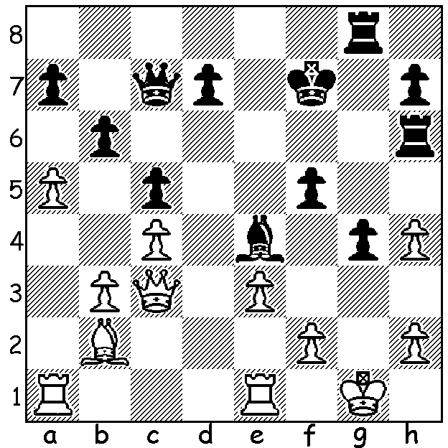
(non-forcing) move. Here Black mates in 6 with an explosive start:
Dmitry Andreikin (above) & Daniil Dubov.

The World Rapidplay Championship (15min + 10sec)
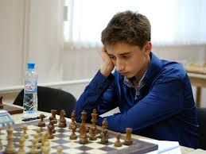
with 203 competitors was played last month in St
Petersburg, Russia, and was won by a 22 year old
Russian Daniil Dubov with 11/15, the only unbeaten
player. Favourite, world champion Magnus Carlsen,
could not make up sufficient ground after losing his
first two games (the first after missing a winning move
and the second on time when winning in an endgame
2R +2p v Q + 1p) and finished =2nd together with
Shakhriyar Mamedyarov and Hikaru Nakamura on 10.5. Defending champion Viswanathan Anand managed 9.5 while Levon Aronian fared much worse with 7.5.
The tournament was then followed by the World Blitz
Championship (report next week).

SOLUTION: 1...Qxh2#!! 2.Kxh2 Rxh4+ 3.Kg3 (3.Kg1 Rh1#) 3...Rh3+ 4.Kf4 Rf3+ 5.Ke5 Rg6! and White resigns as he is unable to prevent 6...Re6#.

