Igor Goldenberg vs Anton Smirnov (Rd 7, 2019 Australian Open): White's last move 1.Be4!
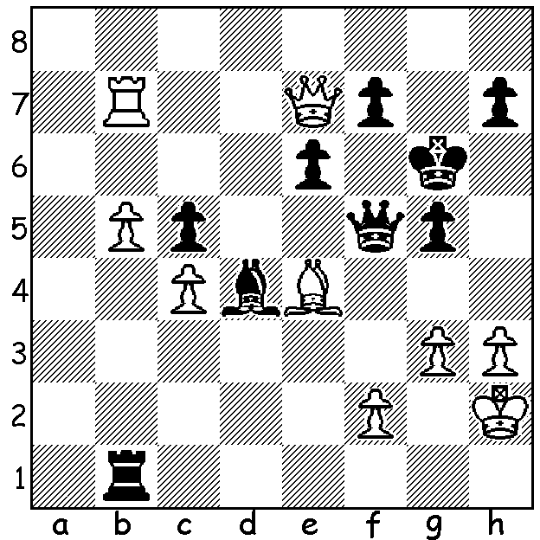
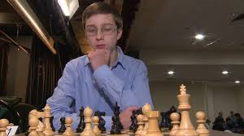
seems to force 1...Qxe4 allowing 2.Qxf7+ with a drawing repetition (2...Kh6 3.Qf8+ Kg6 4.Qg8+ Kh6). However Black had a surprise winning move instead of the played 1...Qxe4. Can you find it?
Top rated Anton Smirnov

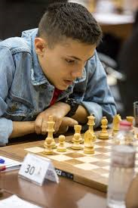
AUSTRALIAN OPEN TITLE COMES TO WA.

Eighteen year old Temur Kuybokarov has won the 2019
Australian Open Championship, played at the Box Hill
Club in Melbourne (88 competitors). Going into the last
round tied with five others players, Temur defeated Russian
Grandmaster Vasily Papin to claim the title with 7.5/9
(+6 =3). Temur, who came to WA from Uzbekistan over two
years ago with his family, is ranked 3rd in Australia and in
the very near future will become the 9th Australian to receive
the title of Grandmaster. Other WA scores: Jay Lakner, Yita
Choong, Adam Kelly all 5/9.

A BLITZ TOURNAMENT (11 rounds, 3min + 2sec) will be played at the Rhein-Donau Club, Myaree, on Sunday January 20 between 1 and 4pm. The Club has a bar and restaurant and it is hoped many contestants and families will avail themselves of the
club's fine facilities. Details and entry cawa.org.au Temur Kuybokarov

SOLUTION: 1...Rh1+!! (a tempo gaining deflection) 2.Kxh1 (2.Bxh1 Qxf2+ 3.Bg2 Qg1#) 2...Qxe4+ 3.Kh2 Qf5 (switchback) and with his two attacking pieces marooned upboard White is helpless (4.f4 Qc2+ 5.Kh1 Qd1+ 6.Kg2 Qe2+ 7.Kh1 Qf1+ 8.Kh2 Qg1#).

