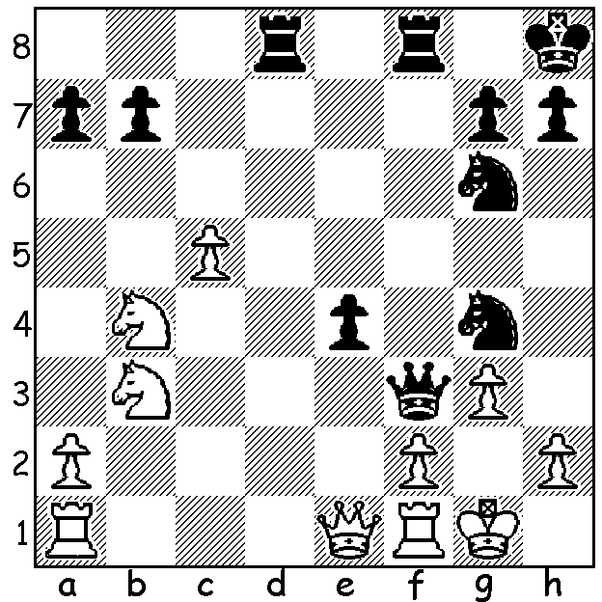

Hikaru Nakamura vs Anton Korobov
(2018 World Blitz): Korobov (Black)
dents Nakamura's chances with an
unstoppable mate:

Last week's report on eighteen year old Temur Kuybokarov bringing the Australian Open title to WA meant the article on the World Blitz Campionship was postponed to this week. The Championship with 201 contestants was played, like the World Rapidplay which preceeded it, in St Petersberg, Russia. World champion Magnus Carlsen (Norway) was able to improve on his winning score of the previous year to go through undefeated with 17/21. He was pushed hard by runner-up Jan-Krystof Duda from Poland (16.5) while Hikaru Nakamura (USA) was a distant third with 14.5.

CONGRATULATIONS to Norbert Muller who was awarded the 2018 Australian Chess Federation Koshnitsky Medal for his outstanding contribution to Australian Chess. Norbert held the position of WA Chess Association Secretary and was President of the Junior Chess Council, both for a number of years. Besides running a junior club in Woodvale over a long period of time, he has been Director of Play in WA Championships and Australian Open, Australian Junior and Australian Schools Championships when held in Perth.

A BLITZ TOURNAMENT (11 rounds, 3min + 2sec) will be played at the Rhein-Donau Club, Myaree, tomorrow, Sunday January 20 between 1pm and 4pm. The event is open to all players, including non-members. The Club has a bar and restaurant and it is hoped many contestants and families will avail themselves of the club's fine facilities. Details and entry cawa.org.au

SOLUTION: 1...Nf4! White resigns (2.gxf4 Qxf4 / 3...Qxh2#).

