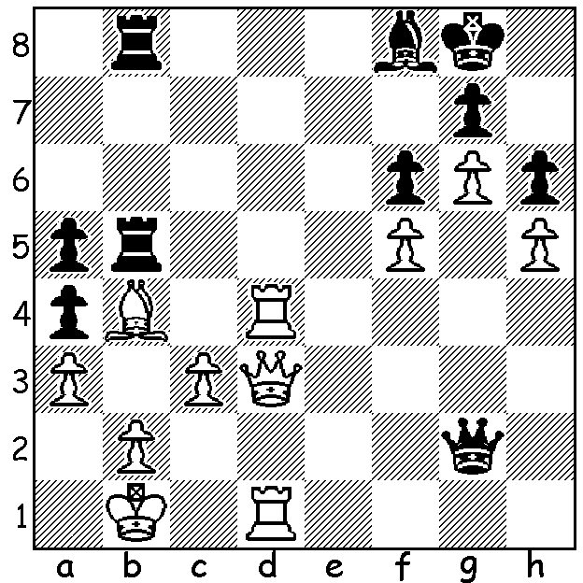

Andrey Espenko vs Vincent Keymer
(2019 Tata Challengers):
Black's last move 1...a5 appears to win
the bishop but White finds a stunning
combination to mate (5/6 moves):

A QUESTION:
Who was the first chess player with their photo on the front cover of Sports Illustrated?
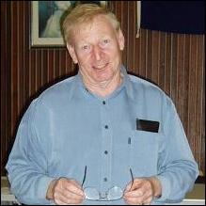

CORRECTION: Norbert Muller was awarded
the 2018 Australian Chess Federation Koshnitsky
Medal not the Purdy Medal for his outstanding
contribution to Australian Chess. Koshnitsky was
Australian Champion in 1933 and 1939 while his
great rival Purdy was Australian champion 1935,
1937, 1949 and 1951 as well as World Correspondence
Championship in 1938 and 1951. I had the privilege of
playing 'Kosh' in the the 1976 Australian Championship
(61 move draw).

IS CHESS A SPORT? The Sports Illustrated
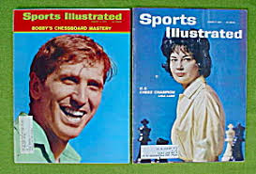
certainly thinks so with, according to google,
nearly 40,000 references to Chess. While Bobby
Fischer was featured on the front cover after
winning the world title in 1972 Lisa Lane
appeared on the front cover about ten years
earlier after winning the US Women’s Championship twice (the first at 21 after taking up the games only a few years earlier). I imagine Fabiano Caruana would also have made it had he wrested the world title from Magnus Carlsen last year. On the local scene the WA Chess Association is a member of the WA Sports Federation and makes nominations for Sports Star and Junior Sports Star of the Year.

SOLUTION: 2.Qc4+! Kh8 3.Qxb5!! Rxb5 4.Rd8: Black now played the spite check 4...Qe4 + but unable to prevent 6...Rxf8# resigned after 5...Ka2. Report on Tata events next week where world champion Magnus Carlsen is competing.

