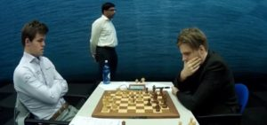
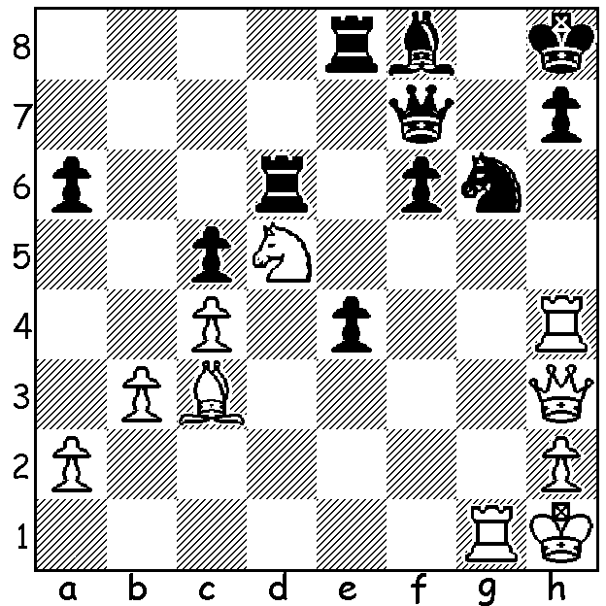
Magnus Carlsen vs Richard Rapport (2019 Tata Steel). The world champion has built up a strong attack with all 5 pieces aimed at Black's broken castled position. With an explosive series
of moves he gains a winning material advantage (White to play, 5 moves).

WORLD CHAMPION GOES 21 GAMES WITHOUT A WIN.
Hard to believe but Magnus Carlsen went 21 games of Classic Chess without a win, drawing all 21. This run included his December 12 game world championship match with Fabiano Caruana (he won the match comfortably 3-0 in rapidplay). It wasn't until Rd 5 of the prestigious annual Tata Steel 14 player event in Wijk aan Zee, Netherlands, that Carlsen's drawing run ended. He then won 5 of his remaining 9 games to win the event (for the 7th time) with 9/13, a half point ahead of Anish Giri with whom he drew in the final round. Ian Nepomniachtchi, Liren Ding and 5 times winner and ex-world champion Viswanathan Anand were all a point behind Giri with 7.5. Another former world champion Vladimir Kramnik was a surprising last, due to over adventurous play.

RIP MARY JO FAGAN.
CAWA was saddened to hear of the recent death of Mary Jo Fagan who was known within the chess community for her volunteer work with the Kingsley Junior Club from near its inception assiting Norbert Muller in teaching beginners and acting as club treasurer for 38 years. She was also treasurer of the Junior Chess Council of WA from 1983 to 1992. It wasn't until after she reached the age of 100 that she resigned her position at Kingsley due to failing eyesight. She played little competitive chess but did win the WA Womens Championship in 1995.

PERTH OPEN Sat 9 / Sunday 10 Feb. Check cawa.org.au

SOLUTION: 1.Bxf6+!! Rxf6 2.Qxh7+! Qxh7 3.Rxh7+ Kxh7 4.Nxf6+ / 5.Nxe8.

