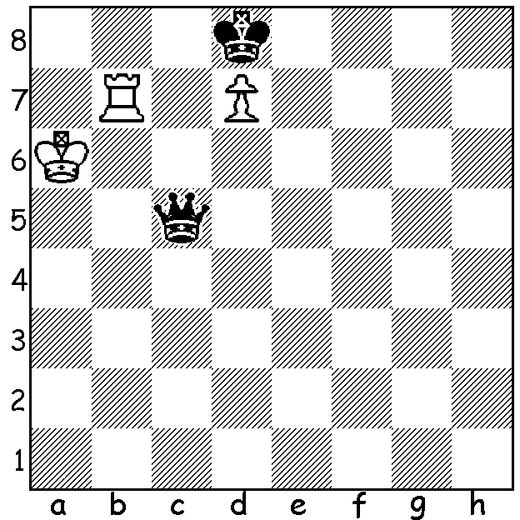

Le Quang Liem vs Fernando Peralto
(Gibraltar 2019):
Black's 1...Qc5 appears to give him a won
position. However White finds an ingenious
quick draw (3 variations):

YOUTH TRIUMPHS AT GIBRALTAR
The annual Gibraltar Masters attracted over 250 entrants while various lower ranking events more than doubled the number of competitors. Winner was 20 year old Russian Vladislav Artemiev (8.5/10) with another 20 year old, Indian Murali Karthikeyan 2nd with 8. Among Artemiev's victims was four times winner American Hikaru Nakamura (his first loss on the Rock for ten years). Nakamura finished on seven as did other favourites Maxime Vachier-Lagrave (France) and Wesley So (USA). 2018 winner Levon Aronian (Armenia) scored 6.5.

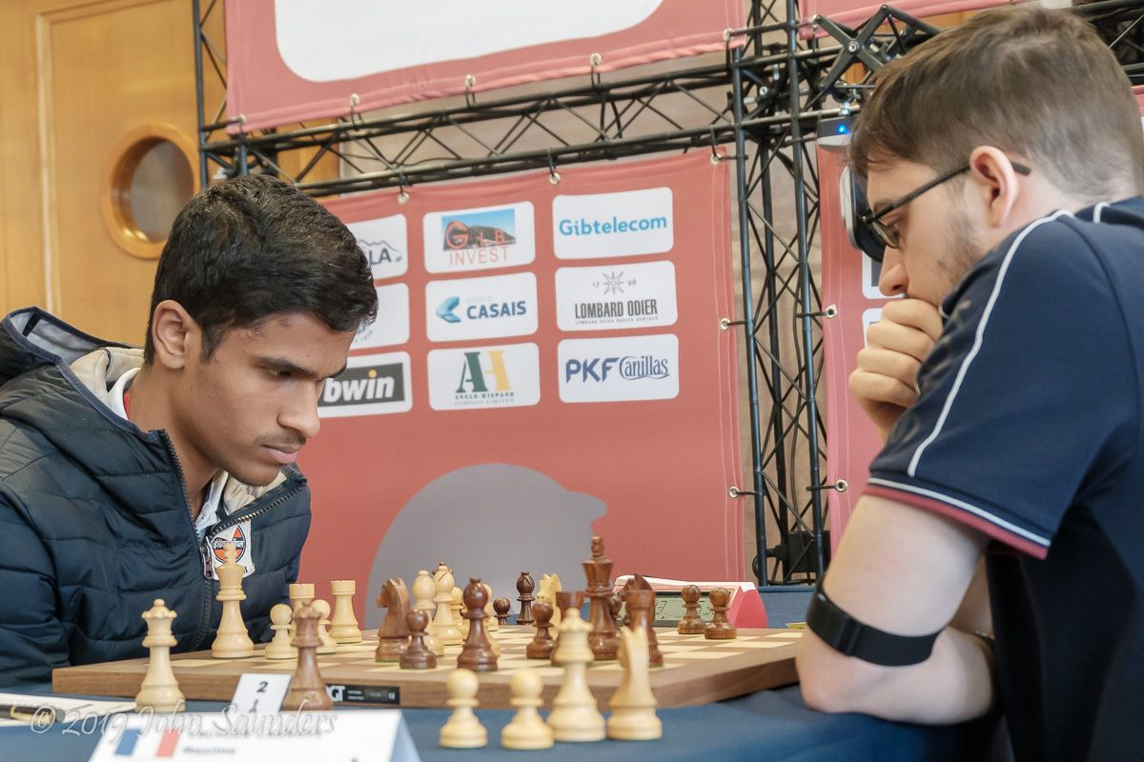
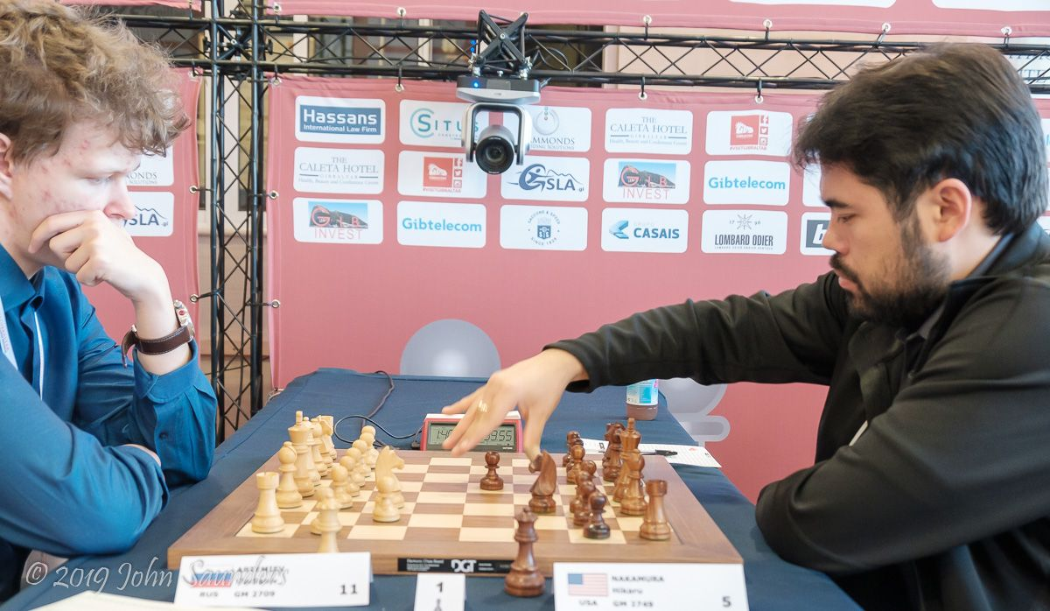
Artemiev defeats Nakamura Karthikeyan defeats Maxime Vachier-Lagrave

PERTH OPEN
I hope you have entered the Perth Open (WA Grand Prix), today & tomorrow starting 10.30. If not check cawa.org.au for entry details.

SOLUTION: 2.Rb8+! Kxd7 3.Rb7+ when Black has 3 possibilities: a) 3...Kc8 4.Rb8+!! Kxb8 stalemate: b) 3.Kc6 Rc7+!! 4.Kxc7 stalemate: c) 3.Kd6 Rb6+ 4.Kd5 Rb5 pinning the queen.

