Boris Gelfand vs Vladimir Kramnik (Berlin1996): with knight,
rook and queen attacked Black brings off a spectacular mate in 3:

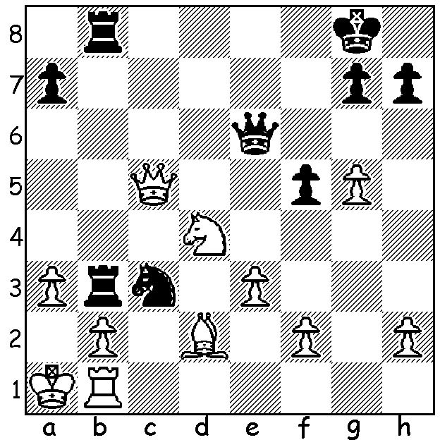
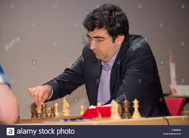

BIG VLAD RETIRES

After the Tata Steel event in the Netherlands former world champion Vladimir Kramnik, who finished equal last, announced his retirement from top-level chess at the age of 43, although he will remain committed to the sport. Called Big Vlad for his height of 1.95m, Kramnik was born in Tuapse on the shores of the Black Sea, Russia, in June 1975. He became world champion in 2000 when he defeated Gary Kasparov 8.5-6.5 (+2 =13). His participation in the match was fortuitous as Alexi Shirov had beaten Kramnik in the Candidates final but the intended Kaparov-Shirov match was unable to attract sufficient sponsorship. He retained the title in 2004 with a final game win to draw 7-7 with Peter Leko. In a re-unification match in 2006 he defeated Veselin Topalov 2.5-1.5 in a rapid tie-break after the match had been drawn 6-6. Readers may recall the ill-tempered match being labelled Toiletgate after the Topalov team protested about what they deemed the suspiciously frequent use of the toilet by Kramnik. He lost the title in 2007 when he came second in a tournament to top-placed Viswanathan Anand. He challenged Anand in 2008 but lost 4.5-6.5 (+1 =7 -3). Throughout his career he gained a multitude of tournament successes and excelled in his regular participation for Russia in the Olympiads. He was diagnosed with a painful form of arthritis in 2006 which resulted in his withdrawing from chess for a period while he received treatment. His contribution to chess theory is considerable with perhaps his resurrection of the Berlin Defence against the Ruy Lopez, which he employed in the Kasparov match, being the most significant (main line - 1.e4 e5 2.Nf3 Nc6 3.Bb5 Nf6 4.0-0 Nxe4 5.d4 Nd6 6.Bxc6 dxc6 7.dxe5 Nf5 8.Qxd8+ Kxd8).

SOLUTION: 1...Rxb2!! 2.Rxb2 (2.Nxe6 Ra2#) 2...Qa2+!! 3.Rxa2 Rb1#.

