Bela Khotenashvili (pictured) vs Irina Krush (2019 Cairns Cup, St Louis): White to play and win (3 moves): one should always be prepared to change the focus of one's attack
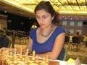
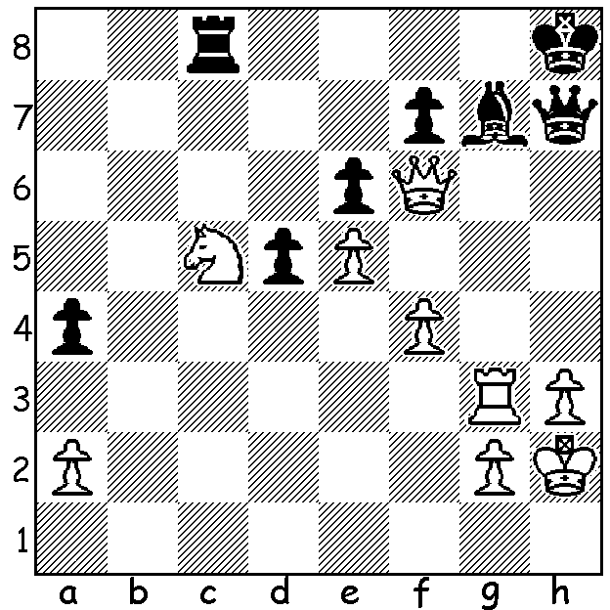

WOMEN SHINE IN ST LOUIS
The position above comes from a recently completed event in St Louis, the Cairns Cup, a new all female 10 player tournament. Winner was Valentina Gunina (Russia, formerly Ukraine) who drew with her main rival, former women's world champion Alexandra Kosteniuk, in the final round. Leading scores: Gunina 7/9, Kosteniuk 6.5, Irina Krush (USA) 5.5. Top female players not participating included Hou Yifan (China), world women's champion Ju Wenjun (China) and Kateryna Lagno (Russia). The latter two played a short rapidplay match in Beijing which had a local TV audience of 60 million - WOW! Ju, who had beaten Lagno in the women's world championship final, again prevailed, this time in an Armageddon game after the first two games had been split 1-1.

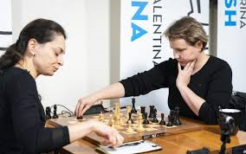
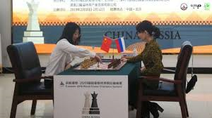

Kosteniuk (White) vs Gunina in St Louis Ju Wenjun (White) vs Kateryna Lagno in Beijing

LOCAL NEWS
The twenty player Perth Open, played a fortnight ago at Leeming, was won with 5.5/6 by Sam Marin, a Canadian residing in China and on holiday in WA. Equal second on 4.5 were former WA champion Tim Hare together with another visitor Jens Mueller from Germany who had also participated in 2018. Rating prizes: Under 1900 - Ned Tomic and Derek Roebuck (4): Under 1500 - local juniors Kundan Dharmapuri and Alex Pimenov (3).

SOLUTION: 1.Qxf7! Rxc5 (1...Rf8 2.Qe7 / 3.Nxe6) 2.Rg5 (changing the focus of the attack from the f to the g file): now 3.Rh5 wins the queen.

