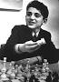
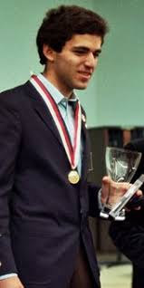
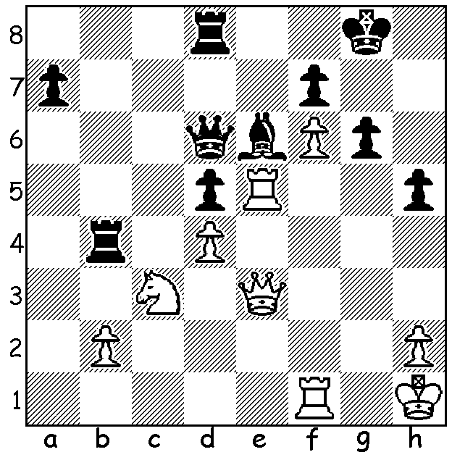
Garry Kasparov vs Leonid Yutaev 1981: Kasparov as child and youth
White to play and win:

IS GARRY THE GOAT?
Continuing our look at world champions, after Viswanathan Anand and Vladimir Kramnik we come to Kramnik's predecessor Garry Kasparov, considered by many to be the most charismatic and greatest (player) of all time (GOAT). Born in Azerbaijan in 1963, Garry travelled Moscow to study at the Botvinnik Chess School at the age of seven. He became a IM (International Master) in 1978 and a GM (Grandmaster) in 1980, the year he won the World Junior Championship. He came =1st in the USSR Championship of 1981-2 and also qualified for the 1982 Candidates tournament. After winning the Candidates, a knock-out event in which he defeated Alexander Beliavsky, Viktor Korchnoi and former world champion Vassily Smyslov, he qualified to challenge world champion Anatoly Karpov. (More next week.)

WA ALLEGRO CHAMPIONSHIP
The WA Allegro Championship (9 rds) will be held on Sunday 17 March at the Maccabi Junior Club, Woodrow Ave., in Yokine with time limit of 15min + 2sec. Please check cawa.org.au for details and enrolment (at site entries close at 10am).

SOLUTION: 1.Rxe6! (deflection) 1...fxe6 (1...Qxe6 2.Qh6) 2.Qh6 Rb7 and resigns (3.Qxg6+ Kh8 - 3...Kf8 4.Rg1 - 4.f7 e5 5.Rf6 or 4...Qf8 5.Qxh5+ Kg7 6.Rg1+ Kf6 7.Qg5+ Kxf7 8.Rf1+ wins queen). White's initial position is so strong he could also win with 1.Rxh5! gxh5 2.Ne4!! (preventing ...Rg4).

